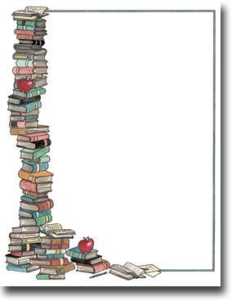



***River Friends of the Library***

***Fall***

**Book and Bake Sale**

**September 19-22, 2018**

**Wednesday**

**10 a.m. to 7 p.m.**

**Thursday through Saturday**

**10 a.m. to 5 p.m.**

**Saturday**

**$5.00 Bag Sale**

**Guerneville Regional Library**

**14107 Armstrong Woods Road**

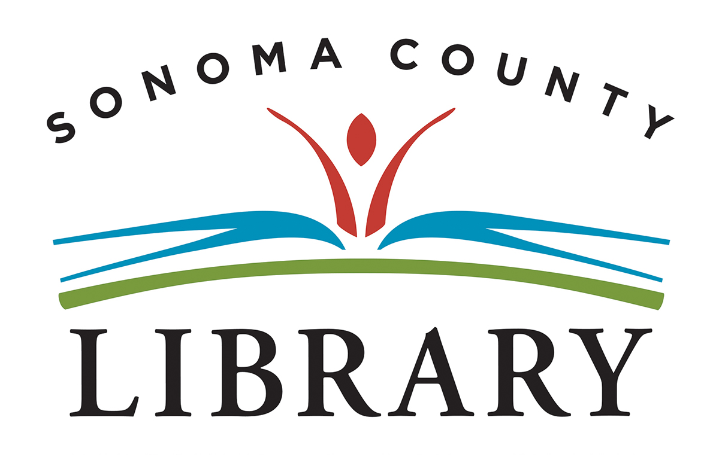

[**www.riverfriendsofthelibrary.org**](http://www.riverfriendsofthelibrary.org)