A Month at Love Lane

All coffee mornings will be on a Saturday between 10.00am and 12.00 noon in the foyer unless stated differently

3rd January Boiler Fund Caroline
10th January Community Connex Jeremy
17th January Cancer Research Carol
24th January St.Luke’s Hospice Coralie
31st January TBC

This month’s special events

7th 2.00pm The Wesley Group will meet in the foyer. All are welcome to join this Bible study group
11th January 4.00pm PAC Worshiping Together at Baptist Church Paines Lane
18th January 11.00am This service will include the rededication of Pastoral and Youth Leaders as well as Holy Communion
26th January 4.00pm at St. Luke’s Service for Christian Unity
Every Thursday Soup and Natter from 12.30 to 2.30pm A warm space, come and join us for soup and a roll, a cup of tea or coffee and a piece of cake, either as a volunteer or to join the diners or both Not 25th December or 1st January
Congratulations, we have reached our target of £25,000 for the boiler fund Thanks to our hirers and friends for their generous donations

If you would like to donate the flowers on11th January Please see Heather Morris as soon as possible

Charity Coffee Mornings in Pinner
1st Thursday of the month coffee morning at Cannon Lane Church H12 to Rayners Lane passes the door.
Friday 10.30am PAC Coffee Mornings at St. Luke’s All are most welcome to attend. If you feel you could help on a rota please contact the parish office, or talk to Ann-Marie on Friday.
Donations to the food bank with a shelf life of at least 6 months can be left in the foyer
If you could help with running the coffee morning here, one Saturday. Please contact Betty Steggals This is a way of raising funds for your favourite charity
Zoom Services and Meetings, Contact Lynita for entry codes to
Sunday at 9.30 am from Eastcote and 6.00pm Thursday Prayer Meeting also from Eastcote

Pinner Methodist Church
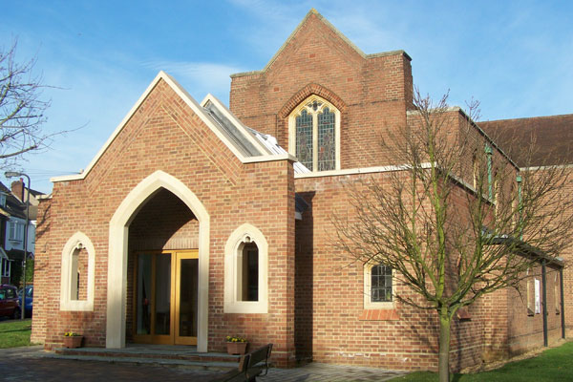
Reverend Dr. Lynita Conradie
tel 020 8866 1743

Church Office
e.mail office@pinnermethodist.org.uk
Love lane Pinner HA5 3EE
020 8868 0353

Welcome to Worship in

January 2026

Preachers at 11.00am in January
4th January . Holy Communion Revd.John Swarbrick
11th January Ms. Helen Schoon
18th January Holy Communion Revd. Dr. Lynita Conradie
4.00pm PAC@ Baptist Church, Paines Lane
25th January 9.30am Reflective service Ms. Caroline Steggals
26th January Dr. Joy Barrow

Readers Rota

4th January Heather Morris Ian Murray
11th January Colin Nunn Jean Edwards
18th January Sylvia Agyare David Salkeld
25th January Kofi Agyare Helen Clifford

Flower Rota

Donor Arranger
4th January Mrs. June Parry June
in memory of Pam and Eric Ridgeway
11th January TBA Heather

18th January Mr. Colin Nunn Colin
in memory of his parents
25th January Mrs. Heather Morris Heather
in memory of Tim

If you would like to donate the flowers then please contact Heather Morris. There are a number of dates throughout the year that are available

If you would like prayer following the service, please speak to the Minister or the Steward on Duty.

Do join us for a cup of tea or coffee after the service.

General Information

Young Followers, from the ages of 3 to young teenagers meet on Sunday mornings at 11.00am in the Foyer Please come and join us,
If you wish to add names to the Prayers of Intercession please talk to the steward on duty.

Gift Aid Envelopes are available in the foyer for tax payers wishing to increase the value of their donation to church funds.

To book one of the church halls contact Jo in the office Monday – Friday mornings. Tel 020 8868 0353

Pinner Playtime for pre-school children from 10.00am – 11.45am weekdays during the school term. Closed for the Christmas from 15th December to 5th January

Coffee Mornings. Contact Betty Steggals on 020 8866 6118 to book a date if you are able to run a Saturday Coffee Morning. This is a good way of raising funds for your favourite charity.

The Youth Club for children 8 - 12 years (Y3 – Y7) meets on Friday evenings in the Church Hall from 6.00pm – 7.30pm during the school term, January 9th to March 27th Closed for half term 13th and 20th February Leader Mrs. Philippa Nunn 0208 428 9439 email: llyc2014@outlook.com .

Please do not forget the Food Bank box donations should have a 6 month shelf life Also the box for Firm Foundation

Do please keep these notices to hand, this is especially important for those who are on any of the various rotas. If you are on duty and have not had confirmation of, say a reading, please check with the office

Notices for next month to jean Edwards by 18th January tel 0208 429 4601

