1989-1991 Dam Repair Project
The following pictures depict some of the dam repair project that occurred from 1989 to 1991. Unfortunately the pictures are not clear because a rudimentary procedure was used to digitize them. A VHS tape was turned into a DVD. Then while playing the DVD on a computer, a "screen capture" was used and saved as a "pict" file for editing and to save space. Then the final was converted to a "JPEG" format for use on the web site. Some information is added from memory and I apologize for grammatical errors, I flunked 12th grade English. Thank goodness for spell check.
In the late 1980’s, the NYS division of canals and waterways controlled the reservoir water level. Many issues had built up over time regarding the safety and integrity of the dam.
1- Many leaks developed through the overflow spillway that allowed large amounts of water out and more importantly, possibly breaching of the spillway. This would have caused a permanent 3-foot drop in the reservoir. The spillway on the backside of the dam was filled with junk and in disrepair.
2- The underground drainage tiles were not functioning causing some "wet" areas and some manholes needed to be replaced or reset. Wet areas surfacing indicated that the normal leakage through an earthen dam was not being collected and funneled away from the soil which could eventually erode and cause a breach in the dam. With some of these areas being 20 to 30 feet below the crest elevation, the reservoir would have permanently been lowered by that amount. You think the 3-foot winter drop is a lot?
3- The outlet gates were in bad shape. The middle gate could not be closed completely causing a large loss of water during the summer. The other 2 were difficult to move. These 3 twelve inch gates were installed around 1932 and attached to the original 20 inch valve bodies that were installed around 1862 during construction of the reservoir. At that time, 1932, it is thought that the stems, gates and bonnets were removed from the original 20 inch valves and blank flanges were added in their place.
During the planning of this project, state engineers in Albany wanted to lower the lake by 20-30 feet to prevent a major breach when the drainage system was repaired. Fortunately, the local canal engineer, Mr. John Baldwin, convinced his higher ups that it could be repaired safely without a big drop. If needed, sheet piling could be used. Also it wasn’t clear if the inlet pipes in the lake, approximately 50 feet below the surface, could be capped so the old valves could be replaced.
The following pictures

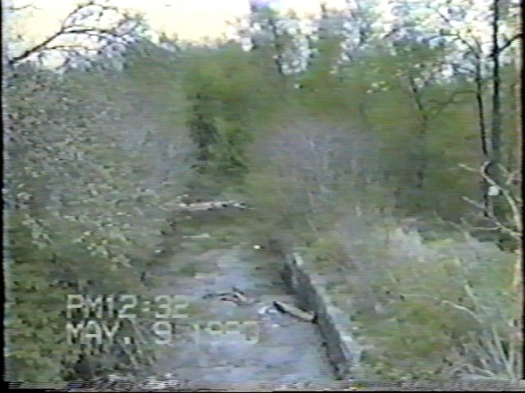Spillway Before Cleaning 5-9-90

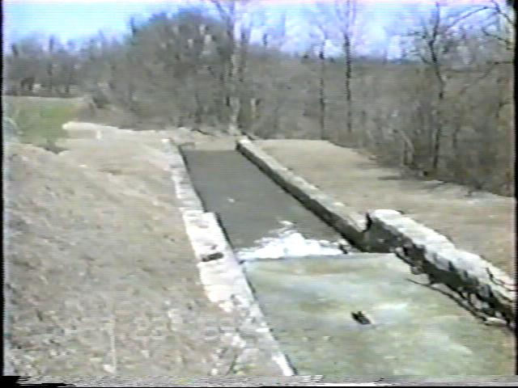

SPILLWAY AFTER CLEANING - APRIL 23, 1991

OVERFLOW SPILLWAY LEAKAGE REPAIR

The overflow was sealed using hydraulic pressure grout. The truck and equipment was set up in the parking area and the high pressure hoses were run under the road. About 18 2 inch holes were drilled down through the overflow to the base and then filled with a hydraulic grout/cement. The pressure forced the grout into the fissures inside the overflow thus stopping any flow through it.

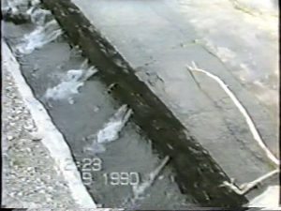

OVERFLOW LEAKAGE PRE REPAIR - MAY 9, 1990

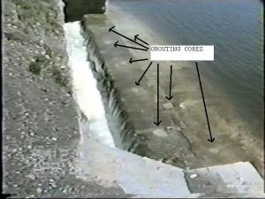

OVERFLOW SEALED POST PRESSURE GROUT - APRIL 23, 1991

UNDERWATER DIVER WORK

The state hired an underwater diver, Bob Bouck from Fulton, to check the condition of the inlet pipes and cribbing 50+ feet down in the lake. The initial dive was done on 9-14-89 in order assess the condition of the pipes to see if they could be blocked using "pie plates". If plates couldn't be used, the only other way was to completely empty the reservoir so the outlet gates could be replaced. We could have been without a lake for 2-3 years.

Once the project was finalized for bid, it was determined that pie plates could be installed safely to eliminate the flow while the gates were replaced. The 2 little valves pictured were to equalize the pressure in the pipe once the new valves were installed so the plates could be removed easily. The diver was in the lake 3 times over a period of 3 years. First for the initial recon, then to install the plates and third time to remove them after the new gates were installed.

The diver states that some timbers are loose in the cross sections but seem stable. Most timbers are worn to a point on the front from water flow over 140 years. The back side of the timbers are approximately 2 inches. The timbers shown have about a 1 foot spacing between them. The headwall of the dam is about 5 feet off the bottom. The pipes are about 1 foot above the bottom of the crib at 54 feet below the surface. The top of the crib is about 12 feet above the headwall of the dam. Unfortunately, I had purchased the bid documents when the project was put out to bid. I think I lent them to someone but can't remember. If found, they give the details of the original dam and crib. If found will update this page.

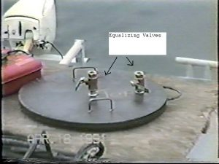

1 of 3 pie plates used to block inlet pipes
The equalizer valves were used to equalize
the water pressure after the new gates were
installed downstream.

1862 Original cribbing - 4 timbers shown

Timbers in cross brace. Divers glove lower right

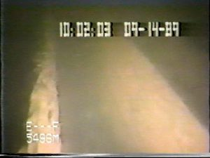
Worn Timber on left to a point back 2 inches. Westside of crib.

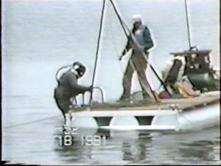 Diver Up

GATE REPLACEMENT PROJECT
Sometime around 1932, 3 gate valves were installed on the 1862 original 20-inch valves. At that time, it is believed that the lake was either lowered or pipes were blocked off for this repair. The 20 inch valve stems and gates were removed and covered with a blank flange leaving the bodies to bolt the new valves onto. Over time, the 1932 valves began to malfunction. The center one could not be closed and the other 2 worked very hard. Replacement was the only option.

As mentioned earlier, once the flow was shut off with the pie plates and it was determined safe, the original 1862 valve assemblies were removed. Three special adapter flanges had to be fabricated to match up to the bolt patterns of the new 12-inch valves with the 1862 pipes that go into the lake.
The slippery old wood floor was removed and 6 new 12-inch gate valves were installed. Each pipe got 2 new valves. The 3 valves closest to the lake would remain wide open and the 3 furthest from the lake would be used to control the flow. Using this procedure, in case the control valves ever needed replacement, the upstream valves could be closed. This would eliminate the need for a diver to install pie plates or worse to empty the lake. The following pictures document the work.
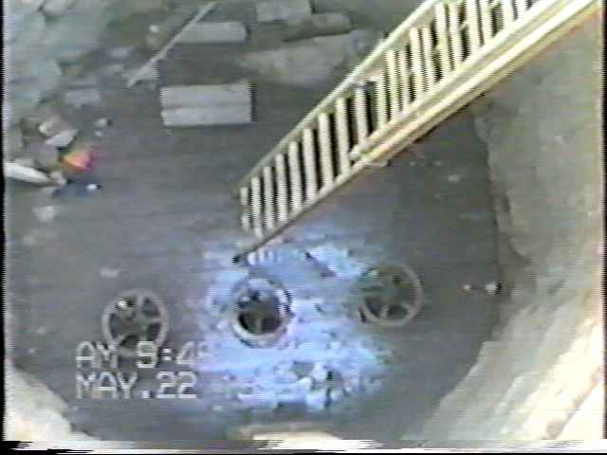
Old valves and wood planking floor that was extremely slippery due to water spray and scum build up. The middle valves were unusable.

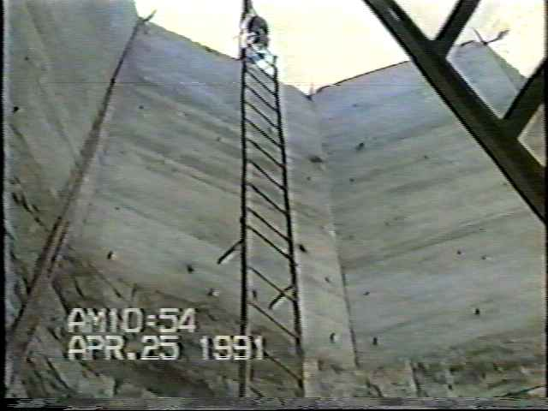
Valve house with cover removed showing old deteriorated unsafe steel metal access ladder. Note broken rung 4th up from bottom.

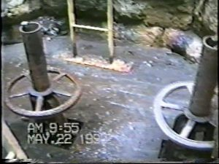

Close up of old 1932 valve assemblies and plank floor scheduled for replacement.

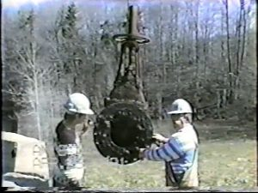

One of the 1932 12 inch gate valves removed with scale build up.

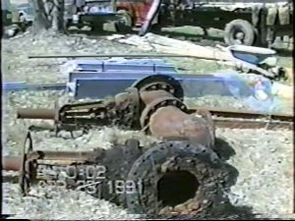

Old 1932 12 inch valve assemblies removed.

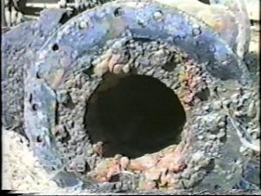

Close up of the 1932 12 inch gate valve removed with hardened scale built up in the seat area causing inability of valve to open or close to stop flow.

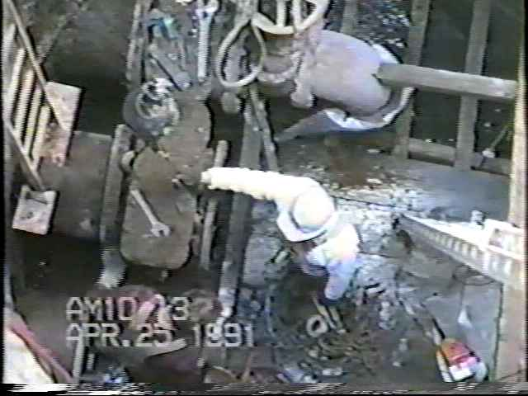

Original 20 inch valve body readied for removal.

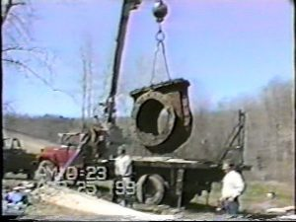

Original 1860's 20 inch valve body being hoisted out of valve house.

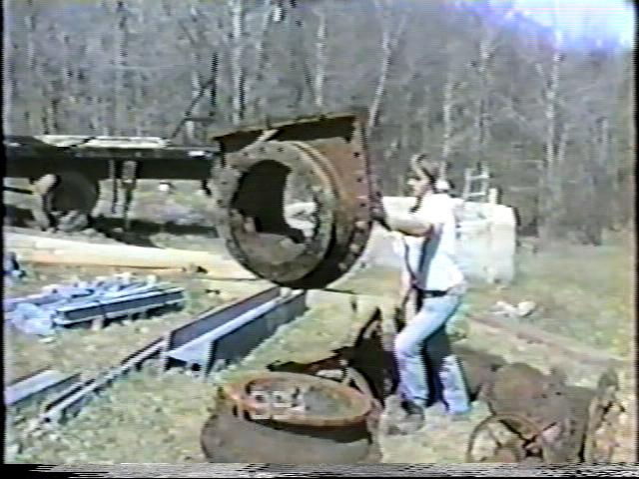

The original middle 20 inch valve body with bonnet and the old 12 inch bolt pattern removed. Note sediment build up due to non use.

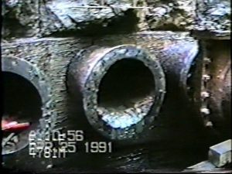

With the pie plates installed upstream on the ends of the 3 original discharge pipes in the lake approximately 50 feet below the surface this picture shows the original bolt patterns that adapter plates needed to be fabricated to accept the new 12 inch bolt pattern for the new valves. Not the middle pipe is filled with sediment due to old control valve was not functioning.

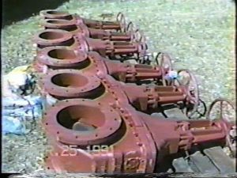

6 new 12 inch gate valves before painting and installation.

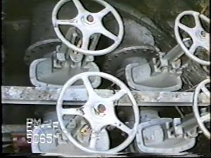

Close up of 2 of 3 new 12 inch valve assemblies bolted to original 20 inch pipes

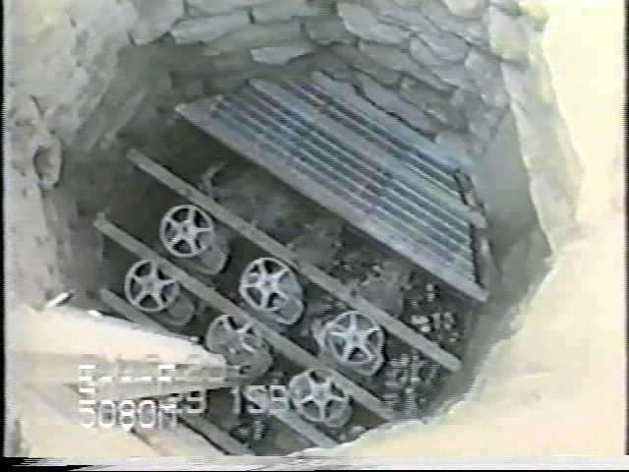

New valve assemblies installed with partial new floor grating.

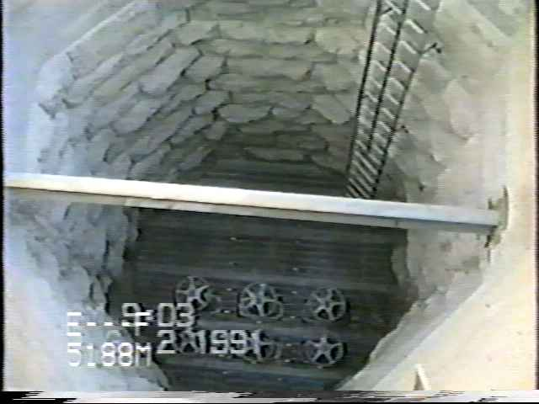

Completed Valve House with new valves, grating floor, safety ladder and lifting beam.

