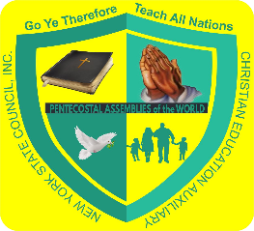
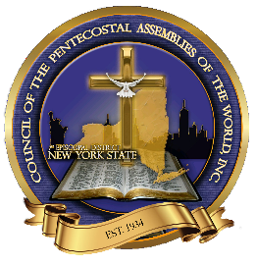
NEW YORK STATE COUNCIL
1ST EPISCOPAL DISTRICT
THE EMPIRE STATE OF THE UNION
SUNDAY SCHOOL AUXILIARY OF CHURCHES BLANK
March Council
June Council
October Council

Name of Church:
Address of Church:

City State Zip Code

Telephone # of Church: ( )
Name of Pastor: Telephone # of Pastor: ( )

Attendance Check Tally =
Total Number in Sunday School =
Total Number of New Members =
State Sunday School Dues: ($1.00 per member on your church Sunday School Roster
$
National (Sunday School) Dues (International Assessment) ($17.34 per Council Session)
$
Regional Love Offering ($3.35 each Council Session)
$
Love Offering to Regional Rally ($5.00 each Council Session)
$
Love Offering to Auxiliary ($10.00 each Council Session
$
State Ways and Means ($5.00 each Council Session)
$

Total Offering: $
Name of Superintendent:
Name of Field Worker:
Name of Church Director of Christian Education:
Name of Delegate reporting for this Council Session:

