Ackerman Annual Family Letter 2017
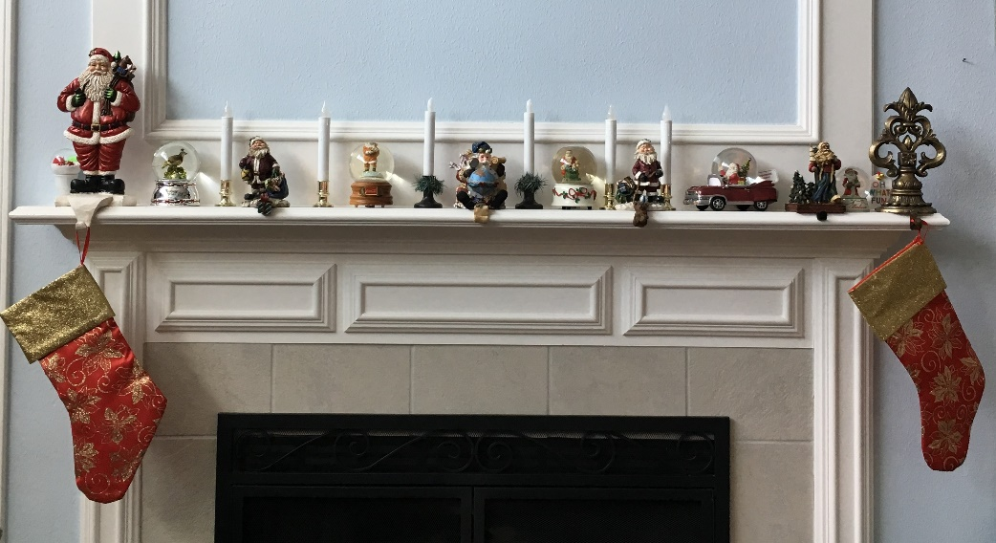

ACKERMAN FAMILY 2017
CHRISTMAS LETTER
To our many friends and family members around the world, we greet you with love in the Name of Jesus Christ our Savior - who is the Alpha and the Omega - who came into this world and took on flesh, and whose birthday we celebrate throughout these Twelve Glorious Days - from December 25 until January 6, Grace and Peace in Jesus Christ.

Bishop Keith and Joann Ackerman
I think that the highlight of our year was the joy of celebrating 50 years of marriage, renewing our vows in a church in Rome, and seeing parts of Italy, Sicily and Greece which would have been known by countless generations of Jo’s family.

In November of 1962 we met, fell in love, and waited (in every conceivable way) until August 19, 1967 when we were married at St. Mary’s Church in the Oakland section of Pittsburgh. The Altar from the Marian Chapel, where Jo placed a bouquet of flowers during the Singing of the Ave Maria, now is the Altar in our own Chapel of Our Lady of Walsingham in our home in Keller, Texas (Dovehaven2).

We actually had two anniversary celebrations this summer - one with our children and grandchildren at a Lake, and one in Italy, Sicily and Greece, boarding a ship on the actual day of our 50th Anniversary. There are no words available to express the joy, but hopefully some of the pictures will help!

Jo has had another extraordinary year, and in spite of the health problems of which most of you are aware, God has blessed her mightily, and no one believes that she is 72 years old. But, sadly, this has been a year of great losses in terms of the deaths of dear close friends and relatives. This loss has caused her to continue to seek God’s consolation, and to read, “Seven Lessons from Heaven: How Dying Taught Me to Live a Joy Filled Life.” Her passions include her family and her parish church (St. Timothy’s), and she continues to make the Parish Press a magnificent resource to customers around the world.

http://www.theparishpress.com

Bp. Keith continues to serve on numerous Boards, and in addition to a number of offices that he holds, he particularly enjoys being a Vicar of a growing church in Fort Worth. Some of you have responded generously to reports you have seen regarding break ins at St. Timothy’s, and, as a result the church is becoming increasingly secure. www.sttimothyacc.com

Keith and Donna Ackerman
Keith and Donna live near us in Arlington, and our grand pets continue to be a blessing. The Union Gospel Mission where Keith is the Chief Operations Officer, has been in the news by virtue of the movie “Same Kind of Different as Me” which we hope will highlight the devastation of hunger and homelessness. I still have happy memories of Keith riding with me in Charleroi PA delivering food baskets to people in need. He has never lost that passion for ministering to the needs of others. He and I continue to restore the 1965 Corvair Convertible - which is looking more and more like the one Jo and I had when we brought Keith home from the hospital in 1971! I must say that seeing Keith in the pews with his mother Sunday after Sunday warms our hearts. While I am not surprised, knowing that our children are faithful means more than I can possibly say. Keith is the consummate Uncle, and each gift that he and Donna gave this year to their three nieces and one nephew involves some form of interaction.
Donna had a great time at her 30th year High School graduation - back in Pennsylvania - and Keith enjoyed it with her. Together they hosted cousins Missy and Lindsey for a fantastic trip to Waco to explore the Magnolia Silos: market place of the hosts of the TV show, “Fixer Upper.” Donna and Keith loved the trip in April to Mexico - a much appreciated getaway. Donna started classes to become an Animal Behaviorist focusing on cats. The next time you visit them in Arlington Texas you will see extraordinary floors in their home- all of which they have had done this year.

Ethan, Renée, Ellie, and Dominic Norris
Ethan, after a difficult accident over a year ago, is gaining range of motion in that affected knee, but is otherwise fully recovered. He was given ligament tissue by an organ donor’s family. The good that came out of this difficult accident is that he was asked to speak for the Donor Families Thanksgiving Dinner at the Transplant Services Center at the University of Texas Southwestern Medical Center. This year in his acting career he played Ford, in “The Merry Wives of Windsor” at Shakespeare Dallas, and was written in reviews as demonstrating a “delicate comedic balance.” He continued with “Staged Readings” of “The Tempest,” “King Lear,” “Cymbeline,” “All’s Well that Ends Well,” and ended with “Sonnets.” He received an award for being in 23 of the 40 readings over 5 years!

Renee is in a perpetual motion mode, and in the Theatre World, she has added another teacher to her program. By adding Musical Theatre back into her day, she enjoys every day even more! The Musical this year is “In the Heights,” and it is moving ahead to its premiere in just a few weeks. This year she produced an Alumni Show which received rave reviews. On a recreational level - it’s all about family! She loved the Family Trip to Lakeview Texas to celebrate our 50th, and she was absolutely thrilled to reconnect with her almost life-long friend, Linda, whom she first met in 1974 when we lived in Long Island!

It should be no surprise to anyone that Ellie is following in her family’s footsteps - a fourth generation “performer.” So.....first she is being Confirmed on January 7. The Diocesan Bishop of Fort Worth has asked PaPa to Confirm “Helen Elizabeth” that day!!!!!! This year Ellie played Teen Fiona in “Shrek the Musical” at her Middle School. She received a superior rating with her UIL OAP- Red Noses. She Narrated “The 39 Steps” for the Fall Show, and she is also a member of her Show Choir - Vivace; they tour nursing homes and elementary schools and have great performances at their school concerts. She has spent her 8th Summer at Camp Crucis, the Camp of the Diocese of Fort Worth, and continues to count those friendships made there as the most meaningful. Jillian Jensen continues to be her very best friend, and Jillian, her mom, Kimla, Renee and Ellie all went on their annual girl’s trip - this year exploring Waco, TX! Highlights were visiting Baylor University, Magnolia Silos, and late-night Apples to Apples. Unbelievable as it may seem to be, Ellie will be entering High School this coming August, and can’t wait for her mom to be her theater teacher!! Ellie and her daddy have been binge watching several TV series and having impressive conversations!

This has been a year of transitions for Dominic. One of his greatest dreams was realized - a beautiful Black Labrador - Australian Shepherd named Dahlia. While she is the family pet - Dominic has been praying (and being extra good) for years to prove that he can take care of a dog. The GATE program (gifted class) that he is in provides many opportunities for him. By virtue of that program he goes to a new school once a week, is learning Latin, and is having great “hands on” experience with projects like animation and film making. Dominic attended Extreme Youth Leadership camp with Mommy this year. While there he was able to perform a song from “Hamilton” - dressed in full costume, and was able to learn a great deal about himself and life choices. He made wonderful young adult friends who became wonderful mentors. He was also able to become a Webelos Scout. He is currently inventing unique types of tree swings, and is turning his room into New York City. His Christmas present this year is that he will spend his 11th birthday with his Mom in New York City seeing “Dear Evan Hansen” on Broadway.

Rob, Lynne, Natalia, and Betty Shattuck
Rob continues to do well with Fidelity! He has studied and passed the Series 9/10 Management Licenses, and is a Relationship Manager at Fidelity Investments. Naturally, there is the Church.... He is a member of the Vestry, he is in the Choir, on the Membership Committee, the Communications Committee, and is active in the St. James Brotherhood. He will always be a part of Camp Crucis, and he volunteers there, cooking on Sundays during Summer Camp Season, playing the guitar for various groups throughout the retreat season, and washes dishes during summer camp and retreats on occasion. He volunteered during the Women’s Retreat - built bonfires (way to go Eagle Scout) helped with set up, provided tours, and...............told ghost stories! As Lynne’s extensive activities have increased, Rob has taken on cooking dinner......and he is really good at it!! (Plus, he enjoys it!)

Lynne is 41. Wow! She is, like her siblings, constantly on the move in many [mostly volunteer] areas. She is in her second year as Assistant Principal of Pre-K Partnerships in the Dallas Independent School District. The Partnership has grown to 120 teachers at 27 locations, 3 Data Controllers, 2 Community Liaisons, 2 Clerks, 1 Office Manager, and 3 Administrators. It is considered to be the largest Elementary School in Dallas even though it is a “virtual” school! Of course, Church is her main focus apart from family and school, and she is the Sunday School Superintendent, a member of the Daughters of the Holy Cross, the Flower Guild, Membership Development, Playground Committee (just began work on the playground) and the Retreat Committee, she also directed the Nativity Pageant. Of course, .......then she is the Cookie Mom for Troop 5721, and has completed her time as a Girl Scout Troop Leader. And now.... she is beginning to think.... about.... starting a Ph.D.!

Natalia is sometimes called “little NaNa.” She has organizational skills, and panache. She continues to be involved in competitive gymnastics, and she had a remarkable Girl Scout Cookie Season!!!! She sold 2,100 boxes!! Many of the boxes went to our military troops, and she sold numerous boxes so that she could set up a complete display on St. Patrick’s Day at Union Gospel Mission where every resident played games and “won” a box of cookies. (Uncle Keith was super proud.). She has scaled back her goal to 1,500 this year, and the sales will begin on January 13 - and they have gone digital this year!! At school she is in the Safety Patrol, CPTV (she does the announcements, and she is in the choir. She is also in the Church Choir and Girl Scouts. Since she is in the 5th grade, this is her last year in elementary school! This year she was a Shepherd’s Angel in the Nativity Pageant, and was VERY excited to have the role that she wanted in the school Holiday play - “Little Ash” a special little Chimney Sweep.

Betty brings a smile to everything, and people sit carefully and listen so that they can hear and then tell another “Betty Story.” She started Kindergarten this year, and in the first week learned that innocent questions must be filtered, “Teacher, why do you look so angry?” Her hilarious antics, straight faced humor, and funny dress ups keep her entire family in a state of anticipation for punch lines. For those of you who knew Ray Ackerman, her great grandfather - this is a genetic experience. She was in gymnastics for a good portion of the year, and she loved it. She will be returning soon to the bars. Again, if you knew Ray Ackerman, that statement makes sense, too. She was an Angel (Heavenly Host) in the Nativity Pageant at her Church. She tries to include her NaNa and PaPa in everything she can. She has a pattern when she stays with us, and has convinced everyone that NaNa and PaPa think that Oreos and milk will make a person sleep better at night.
It was 1962. A beautiful young woman had hired a nerdy looking, baseball playing, Altar Boy to DJ her High School Dance. Every moment has been God directed and Grace filled. No.......there were not major bumps along the way. No.....arguing was minimal and usually related to the problems of being Swedish/Welsh and trying to integrate into an Italian ethos. All we have done is go where God wants us to be, get out of his way when we got there, and let him take over. That’s what Jo and I shared with our children, they shared with their spouses, and we all share it with Ellie, Dominic, Natalia and Betty. The word and the order of priority is clear:
JOY. Jesus. Others. You. When it is out of order - so are we.

Love in Christ,
The Bonacci/Bevacqua/Johnson/Ackerman/Pritchard/Battaglia/Norris/Shattuck Family - all blended into
What you have just read
To God be the Glory.
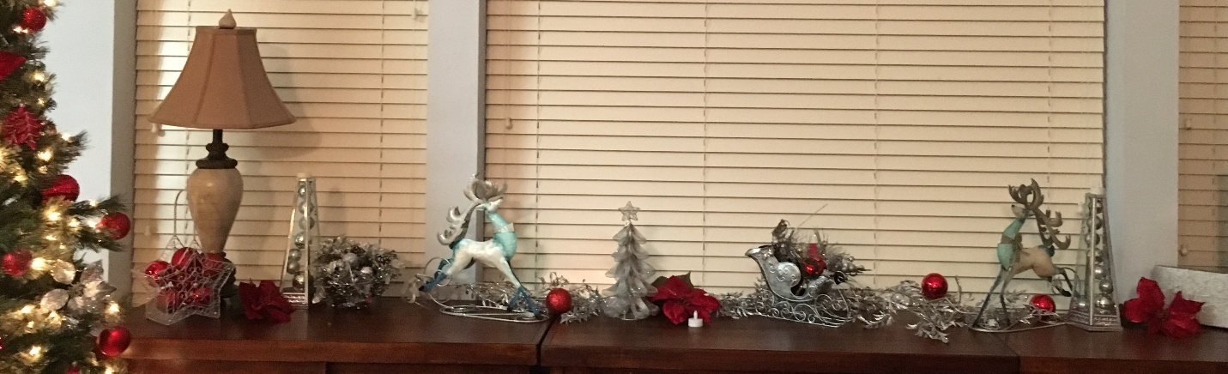

The Family in Pictures and Color!

Bishop Keith and Joann

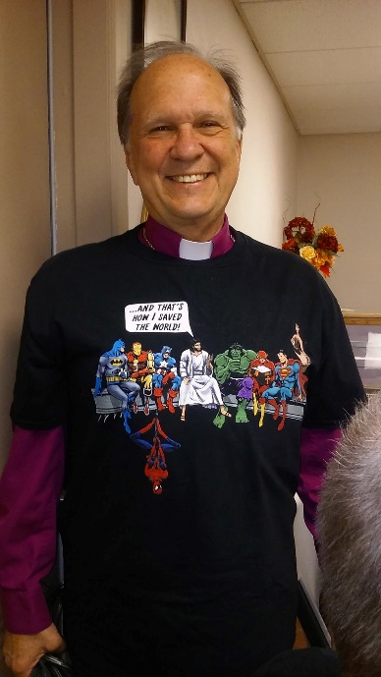
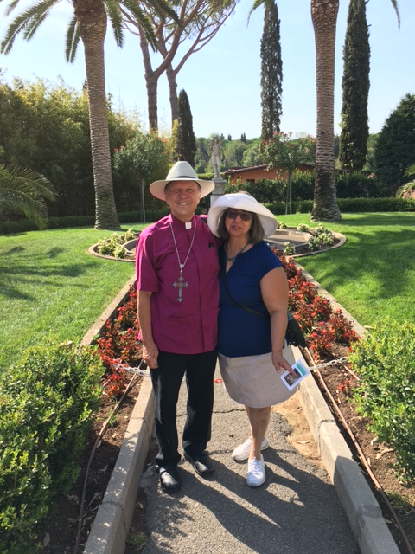
In Rome

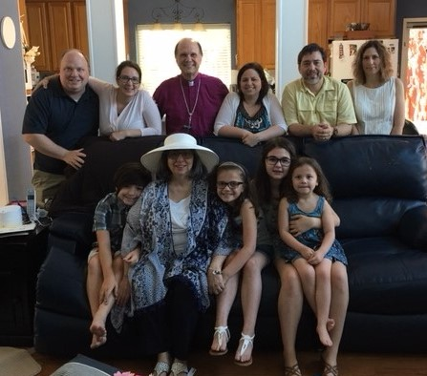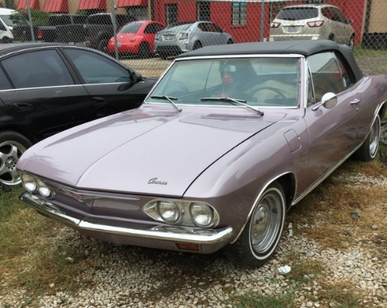

Keith and Donna Ackerman

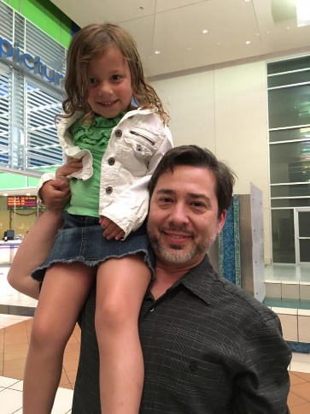

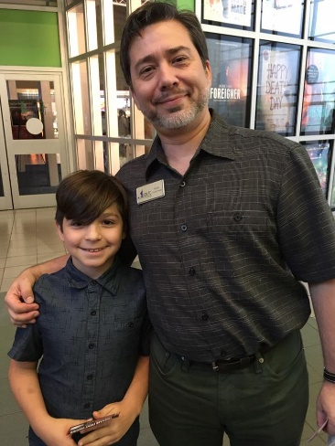

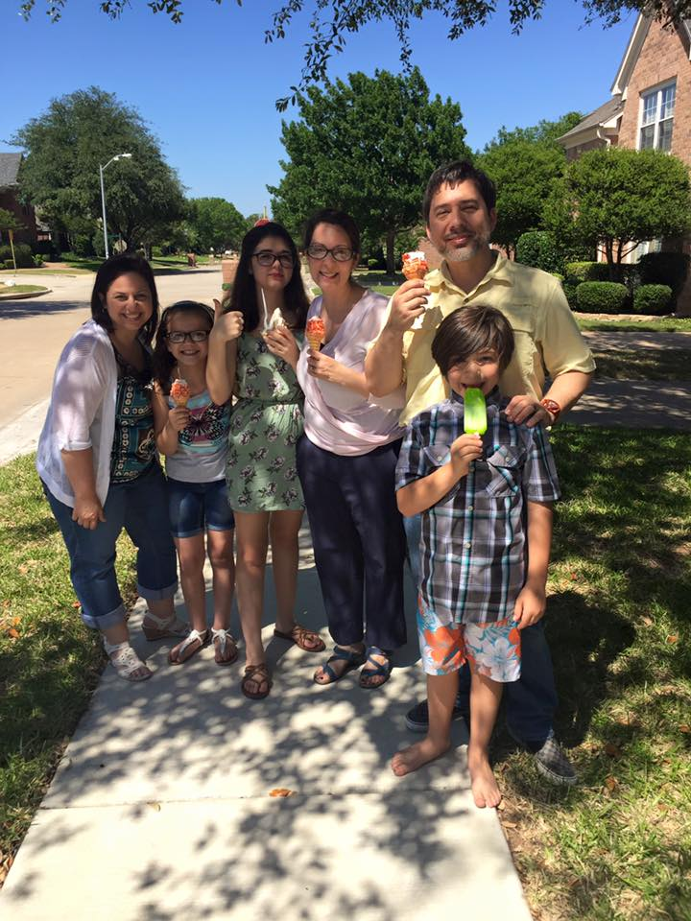

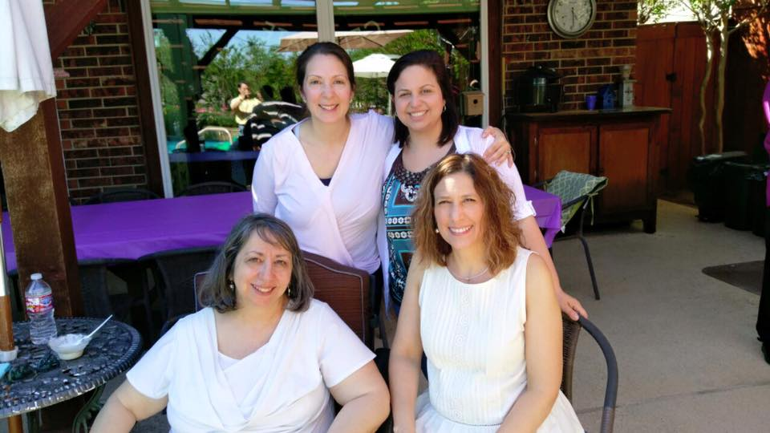

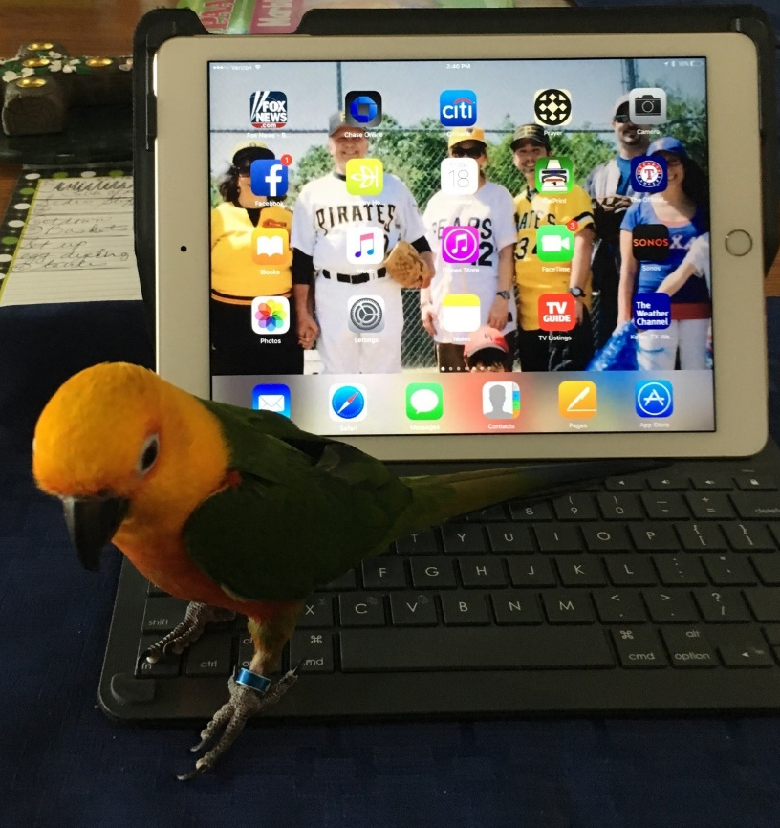

Ethan, Renée, Ellie, and Dominic Norris

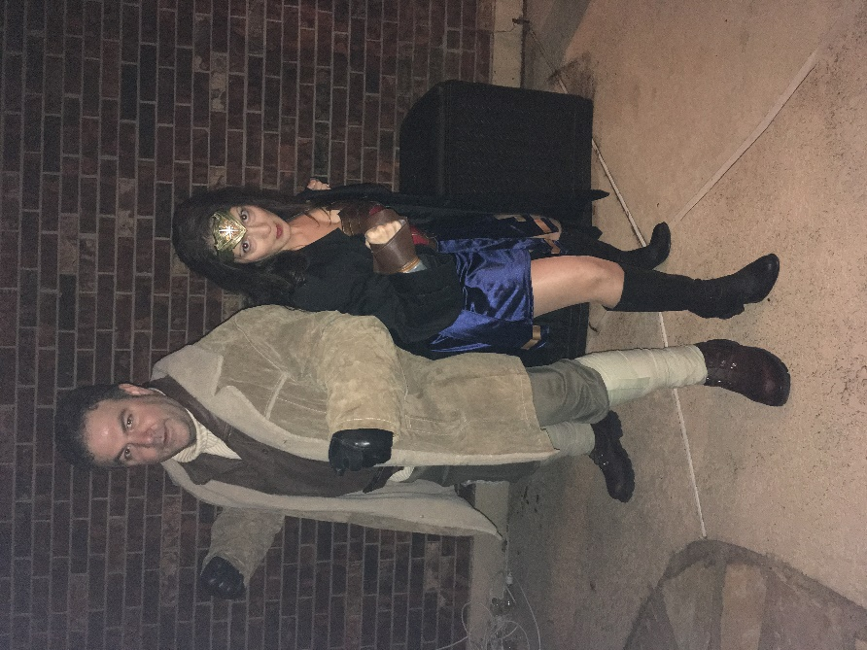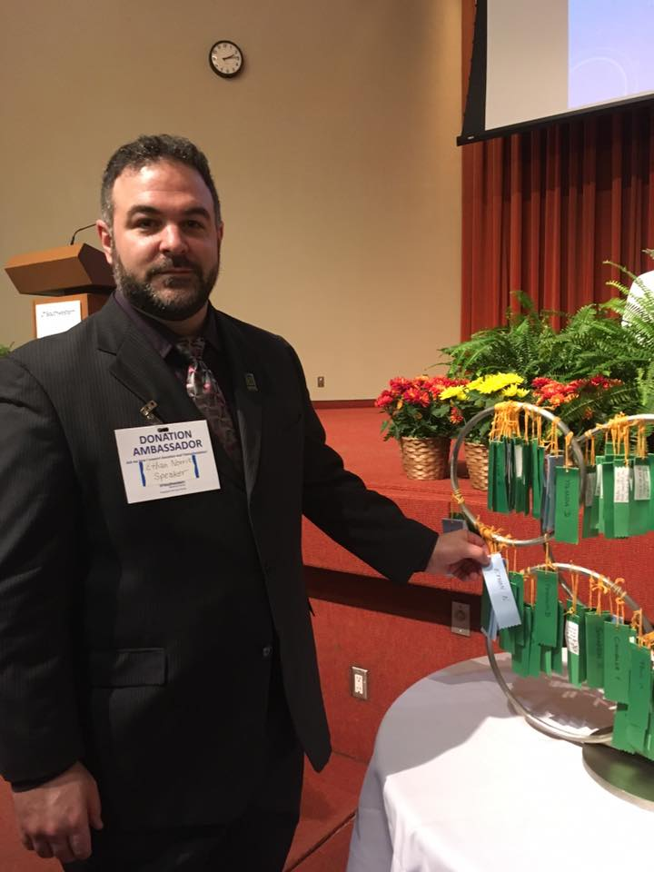

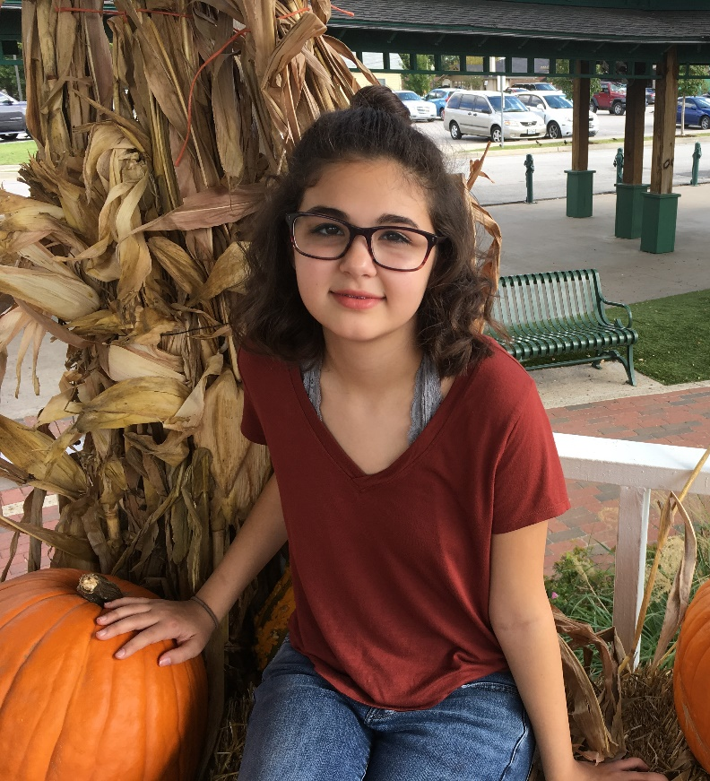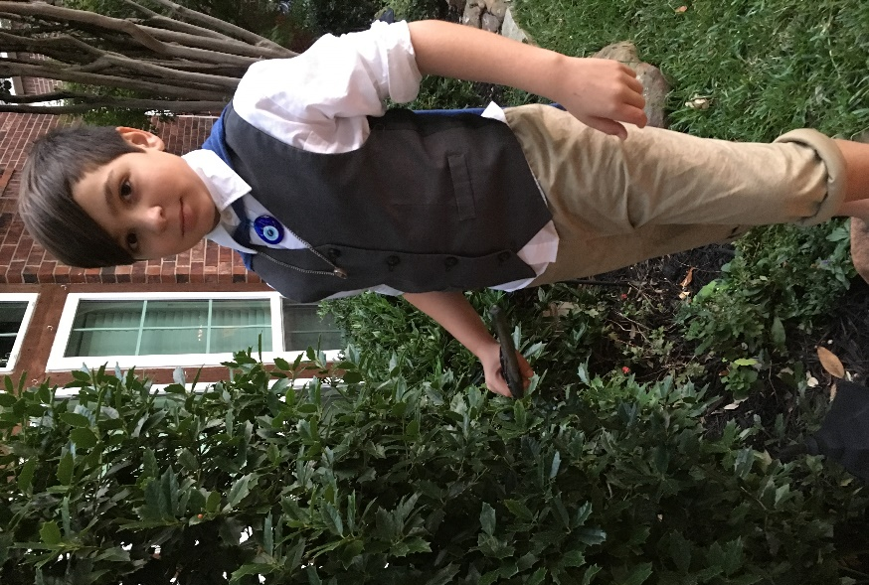

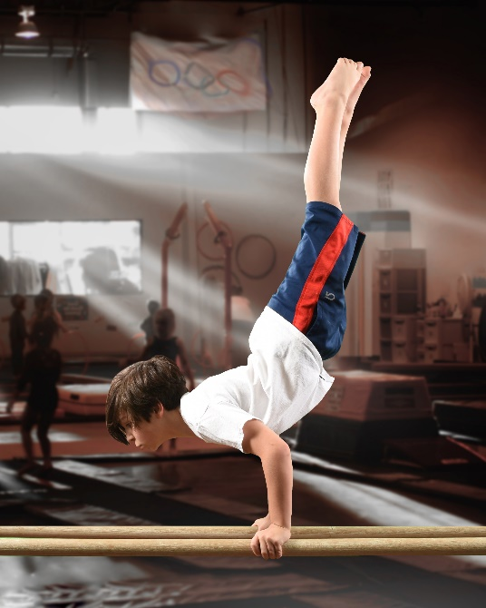

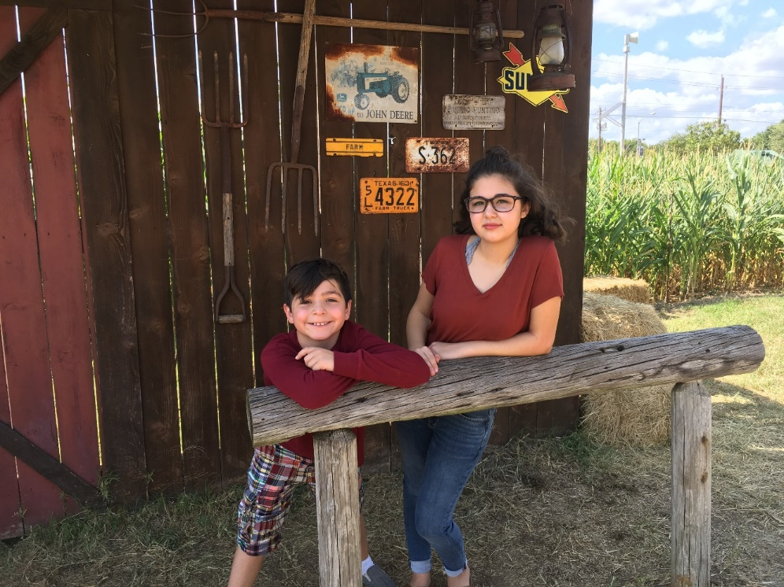
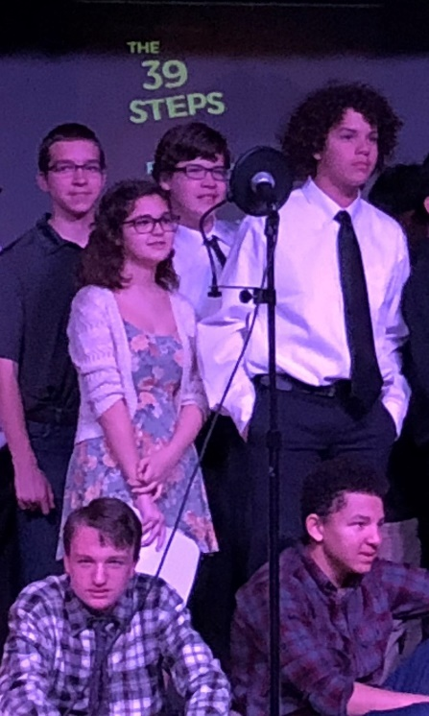

Rob, Lynne, Natalia, and Betty Shattuck

