Our Year in Review - 2018

“And from His fullness have we all received Grace upon Grace.” St. John 1:16

As is the case with Christian families, we are daily reminded that God gives us far more than we can ever imagine. Sitting together and looking at each of our children, their spouses and their children Jo and I are thrilled to see what Grace has been poured into them and into us, by God. The deaths of so many dear friends and parishioners in the past few years reminds us constantly never to take anyone for granted, especially those who change our lives by their presence.

Jo and I have now been married for 51 years, and this past January 4, we celebrated 56 years of “going steady.” We celebrate each day together even more, and daily thank God that at 73 years old, given how fragile life can be - we are both well, relatively speaking! Another knee surgery for me, and ongoing fibromyalgia pain for Jo.......and yet we still sit together holding hands and watching the British and Canadian shows on Roku!

JO pours so much of herself into parish ministry at St. Timothy Church in Fort Worth where they have been serving since January 2012. The Bishop of Fort Worth has had health problems this year, so BP. KEITH has been assisting him in any way that is needed, in addition to serving at St. Timothy’s and serving on numerous Boards and church related groups. The Parish Press continues to be one of their ministries, with many new products now available. They had a wonderful 51st wedding anniversary celebration in August in New England, including some “whale watching.”

KEITH, (47 years old) and DONNA will be celebrating their 25th Wedding Anniversary this year!
Keith continues in his ministry as C.O.O. of the Union Gospel Mission of Tarrant County. They are currently constructing a new building to meet the needs of the homeless and the hungry.
Donna is a private contractor currently working for the City of Fort Worth. She received a certificate this year from the Animal Behavior College, in Cat Training. They now have more cats than dogs at their house, and it is fun to watch all of the training that Donna has received, manifest itself in their “fur family.”

RENEE, (46 years old), and ETHAN, ELLIE (14 years old), and DOMINIC (11 years old) are living the family dream of being in Theatre.
Renee loved her trip with Ellie in the Big Apple! Due to a schedule change this year, Renee directed two Musicals: “In the Heights” which received many nominations at Dallas Summer musicals, with two students walking away with $5,000 each for College! “Gypsy,” with Ellie and Dominic in the production - was a major highlight. Renee says that Ellie is a dream to work with, and Dominic is developing a great rehearsal ethic, too.
Renee was awarded the Maestro Theatre Publication's Spotlight Teacher. “Renee teaches at Haltom High School, where she does more than teach theatre and direct shows. She provides a home for students where they celebrate the “Spirit of Haltom” in many ways. No wonder so many of her students return to teach with her or in her district!”
Ethan is moving along rapidly in realizing a goal to have been in every Shakespearean Play! He received rave reviews in “Comedy of Errors,” was superb in “Othello,” and is in rehearsal now for “Hamlet.”
Ellie started High School this year, and her engagement in things theatrical has escalated! She was the Children’s Manager for “Gypsy,” and did the costuming on the Theatre 1 select Fall show. She is successfully handling her academic load while immersing herself in Fine Arts. She is the Freshman Choir representative. She started a new tradition with her BFF Jillian - a Themed Halloween party! She also loved her trips to NYC and Williamsburg.
Dominic is now in Middle School, and in addition to being the Tap-Dancing Urchin/Young Angie in “Gypsy,” at the High School; he has a lead (Warner) this January in “Legally Blonde” (the musical) at his Middle School. He loves theatre, and he especially loves his theatre teacher. For his last birthday in February, Renee took him to NYC to see Dear Evan Hansen and School of Rock on Broadway and to see the sights.

LYNNE, (42 years old) ROB, NATALIA, and BETTY are as busily engaged as ever!
Lynne continues as Assistant Principal for Pre-K Partnerships at Dallas ISD. In the Church she is active in The Daughters of the Holy Cross, the Flower Guild, and the Membership Development Committee, and has been nominated as Vice President for The Church of the Holy Communion Church Women. Of course, she continues to be the Troop Cookie Manager for Natalia and Betty’s Girl Scout Troops (as witnessed by Natalia’s sales!)
Rob still works at Fidelity, and he continues to be very active in their parish. He serves on the Vestry, sings in the Choir, and is on the Membership Development Committee.
Natalia continues to follow in the footsteps of having active parents. She sold 2,100 boxes of Girl Scout Cookies in 2018 and has set her 2019 goal as being 1,500 (since she needs to share with Betty this year.) In May she completed gymnastics and wants to focus on academics. She spent three weeks at Camp Crucis this past Summer, and enjoyed one week in the Equestrian program. Just like her cousin, Dominic, she is now in Middle School. She is actively involved in Karate and Choir at School, and is a class leader for the choir. At her church she is a Torch Bearer, and she has joined the Youth Group (which she loves.)
Betty is now in the first grade, and she completed her gymnastics training in May. At their church she now sings in the choir. She is really excited about joining Girl Scouts (Daisies), and she has set her goal of selling 600 boxes of cookies! Betty wants you to know that she is very excited about all of her new toys from Santa Claus, and she keeps herself quite busy playing with them, along with an active engagement with YouTube Videos.

And so, from God’s generosity and love we have received Grace upon Grace this year, and as we pray for you, we humbly thank so many of you for your prayers for us!

The Ackerman-Norris-Shattuck Family

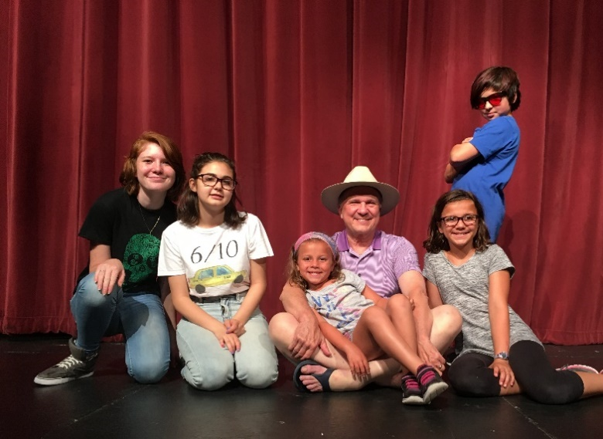

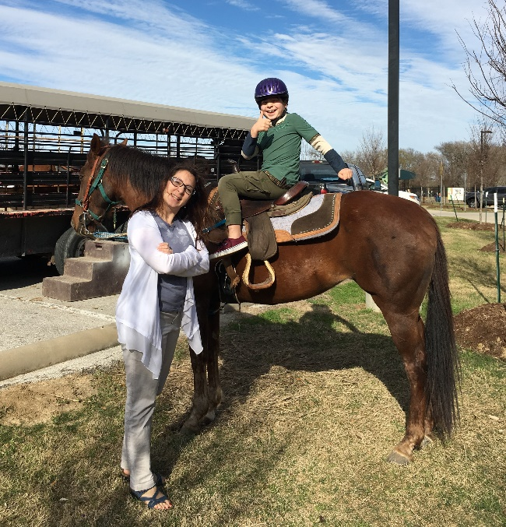
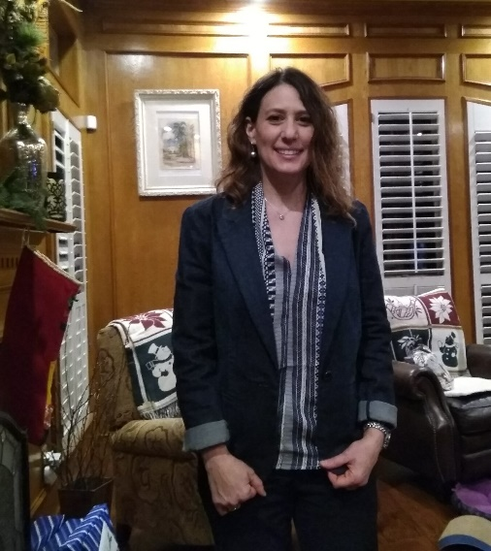
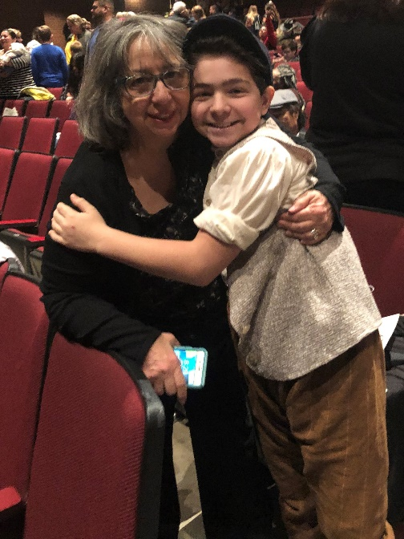
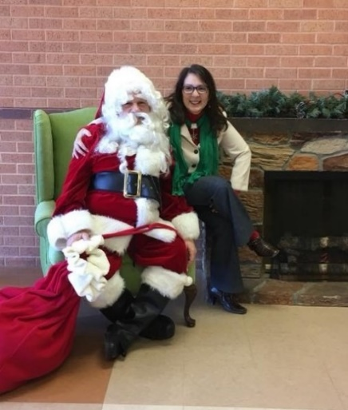

Comedy of Errors.
Ethan played twin brothers Antipholus of Syracuse and Antipholus of Ephesus

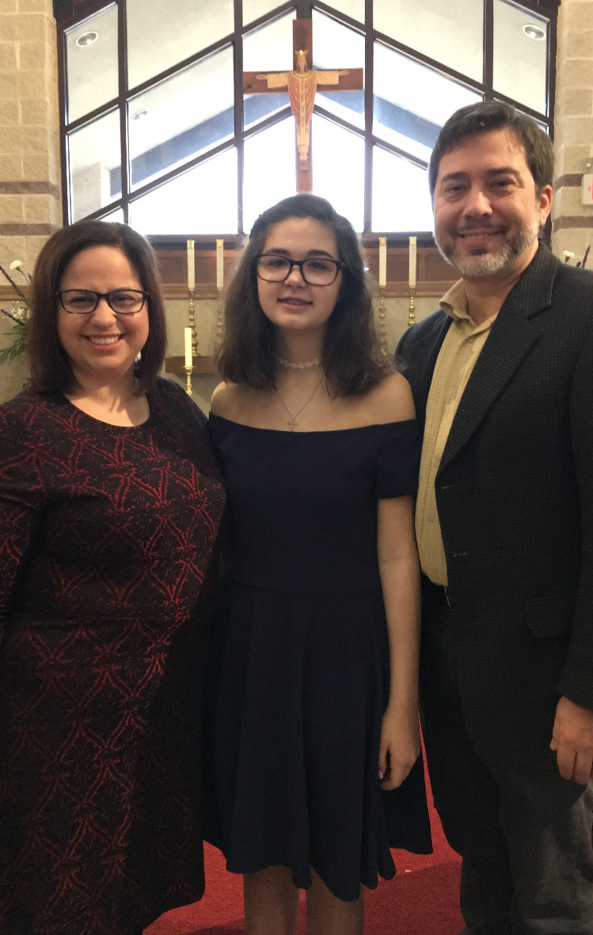
Lynne, Betty, Natalia, and Rob
