Thank you Jesus!

THE YEAR THAT WAS † THE YEAR THAT IS TO COME † AND DNA

Dear friends and family,

We are all blood relatives of Jesus who shed His blood so that we might be Saved, and daily through the Most Holy Sacrament of the Altar, shares His Body and Blood with the family for whom He first shed His blood.

As we write this annual family letter, we do have a slight apology. We did not contact as many people last year as usual............it was a busy year!

Jo and I are blessed to have celebrated our 52cd wedding anniversary this year. Can you imagine that we met in November of 1962! Young Bill Ilgenfritz and I were 16-year-old disc jockeys, hired by a teenage high school leader to spin discs at her high school dance...we danced...we danced some more...fell in love immediately...dated for 5 years before we married. Keith, Renee, Lynne, Ellie, Dominic, Natalia, Betty and Donna, Ethan and Rob - you’re welcome. Thank you God for no Western Pennsylvania snow storms that would have canceled the dance! For people who live in more southern climes - that would have meant more than 6 inches of snow in order to cancel anything.

I continue to serve as Bishop Vicar of the Diocese of Quincy, Vicar/Bishop in residence at St. Timothy Church, and after January 1, Assisting Bishop of the Diocese of Fort Worth. I serve on far too many boards and committees to list...so just pray for my ongoing good health! This year I celebrated my 25th Anniversary as a Bishop (June 29, 1994) and my 45th Anniversary as a Deacon (April 20, 1974) and Priest (December 21, 1974.). I was honored to make Bishop’s Visitations to parishes for Baptisms, First Holy Communions, and Confirmations in addition to several Ordinations as I assisted the retiring Bishop of Fort Worth during his successful battle with cancer. By being ordained 45 years, it also means celebrating my 45th anniversary from Nashotah House (seminary.) If you ever feel an urge to make a difference in the Church - train a priest with a donation to Nashotah House, 2777 Mission Road, Nashotah WI, 53058: www.nashotah.edu.

Jo and I had another spectacular year, and everything you have just read in the paragraph above includes her. She still has her PHT from Nashotah House (Putting Hubby Through) but it extends through 45 years of Ministry. (We do not retire - we simply serve in other locations.) Jo was surprised this year as she prepared to help me surprise a worthy woman of the parish with the “Woman of the Year” award on Mothering Sunday. The surprise was that Jo was named Woman of the Year. Let it be noted that this was the first time in her 74 years that anyone has successfully surprised her - that is, with a “good surprise!” She loved taking two of our granddaughters for Spring Break to Yuma, Arizona to see her big Sister, Rose, and husband, Richard. Another generation has gotten the chance to love and be loved by Aunt Rose. We and Ellie and Natalia were taken, by Uncle Richard and Aunt Rose, to quite a few places in Arizona, California and Mexico for Spring Break, and they came back to Texas with many happy memories (and gifts!)
DNA has been a fun experience for the family. Our children and grandchildren really wanted to register as being more Italian, but they also have Swedish, Welsh, Irish, English and German to factor in! It is a great deal of fun to look at our children and grandchildren and see the various family resemblances. Being connected as family is essential, and when someone marries into the family, they enter into the joy of generations who have loved and shaped the ones whom they have found. In our case it is a discovery in each other of how Jesus has shaped each person and given gifts that Glorify Him.

This is the wonderful wedding anniversary year for our children: Keith and Donna - 25; Renee and Ethan - 20; and Lynne and Rob - 15. It really makes it easier for us to remember!

With Keith and Donna celebrating their 25th wedding anniversary, they delved into a “Roots” experience in Great Britain. I was told, by my mother growing up, that we were primarily Welsh, but that her grandmother was Irish and her grandfather, English. Of course, in that part of the world it is not so simple. Albert Edward Pritchard was, indeed, born in Wales, but Gloucestershire and County Cork were, in fact, places of origin. Keith and Donna loved each place they went to in the UK, but Ireland really resonated with them. They threw in Scotland for good measure. Naturally, while in Wales they looked for the Pritchard name and found a tomb stone bearing that name in Holyhead. In the past Keith (and I) had walked in Albert’s neighborhood in Llanelli, and Jo and I were at Mass in the Parish Church of St. Elli (Llanelli means “St. Elli” - the Saint after whom the city was named.) Of course, when in Ireland a pilgrimage to “Saint Guinness” is essential, and it was accomplished! For Donna’s magic number “50” they went to Best Friends Animal Shelter in Kanab Utah. We are proud of the investment that they - especially Donna - have made in the lives of so many four-legged members of God’s creation. Keith’s ministry as COO of Union Gospel Mission continues to overwhelm us and especially as they are ready to open a new Affordable Housing complex with 104 units! Go to www.ugm-tc.org to see more.

In order to follow the Norris family, you would need a coordinated, “interactive” Play Bill! To be honest, it is easy to get information from Renée about her family and her students, but it is difficult to have her disclose information about herself. If it is about her - it is always in the context of others’ accomplishments! Nonetheless, she is teaching for her Alma Mater, Texas Wesleyan University, (Theater Educator Class), and apart from her non-stop teaching/directing schedule at Haltom High School, she taught acting classes while hosting the Artisan Theatre’s production this Summer of “Frozen.” Her One Act Play advanced twice and won many awards along the way. It was great fun to see an enlarged wedding picture of her Italian Grandparents on the Stage of her One Act. As the Play and the set progressed from location to location, Jo and I called it “Tony and Jean Bevacqua - on Tour!” The Production of “Gypsy” was something to behold and it resulted in being nominated for some Dallas Summer Musical Awards, along with a Student winning the Ambassador Scholarship. Her most recent Production of “Mamma Mia” was beyond amazing. What was particularly exciting for her was working with an incredible student named Ellie Norris, with whom she had shared the vision of the Production. Renee was named “Teacher of the Month” for Fine Arts and Mighty Buffalo Award.

For Ethan it was basically a Shakespeare intensive year starting with “Hamlet” last January. He played Claudius and Ghost of King Hamlet in Shakespeare Dallas’ first ever winter production, in the appropriately named Moody Performance Hall. Then he played Albany in “King Lear” for Shakespeare in the Bar. In the summer, he got to play Duke Fredrick and Duke Senior in Shakespeare Dallas’ production of “As You Like It,” his third set of brothers in 4 shows for them. He had a tiny part in “Twelfth Night,” another Shakespeare in the Bar production during some “As You Like It” off days. In the fall he was King Duncan in Shakespeare Dallas’ “Macbeth,” and closed out his performance year in November as Titus Andronicus for the debut production of Shakespeare Anywhere - Dallas. He and the entire Norris family were excited and blessed when Ethan’s sister, Nina, gave birth this year to a beautiful little girl named Brooklyn.

Although, when I do the Math, I realize that the little girl who used to be my shadow, is now 15, and she is amazing on stage and off stage. You can see Ellie perform: (Nurse Flinn in “One Flew Over the Cuckoo’s Nest” and “Silent Laughter” - playing the lead role HAVING TO LEARN THE PART IN ONE DAY due to the inability of the former lead to perform.) (Okay Charleroi friends - do you remember when Renee became Oliver when the lead dropped out?). But Ellie loves doing the Sound Board, and while starting out as “sound girl” for “Frozen,” the One Act and “Mamma Mia,” she has been promoted to the Head sound person. Ellie also had to step in “last minute” as sound girl with her sound buddies at a nearby high school when their sound person became ill. By the way, it was fun watching her friend, Chris, protecting her on the Stage in the performance of “Silent Laughter.” Ellie was awarded an Excellence in Acting Award at the Theater banquet. She is an officer in the Choir, and is taking all pre-AP and one AP class. The Varsity Choir did a major work for the Christmas Concert in December. Ellie is very humble about what she does, and does not want to be center stage. DNA: Do Not Applaud.

Dominic is all over the place on the Stage. He is a bundle of energy, and he really has a very high expectation of himself. Theatre is fun, but he is serious about it. In a school production of Legally Blond he had a lead role as “Warner.” He played Jacques the Pig in the 6th grade show, and is in Theatre Select, where he has played Hansel and Price in the Fall Show. This past summer he played Wesselton in “Frozen Jr.” He is now ready to play the lead role of Jimmy in his school’s production of “Thoroughly Modern Millie.” He really enjoys the new Trampoline Park, “Airborne” which recently opened near their house. He and Ellie both enjoyed their summer trips with the Cumbie’s to Granbury and Branson. It is fun to hear his voice change, see him outgrow his clothes (and shoes) rapidly and still immediately hug his NaNa and PaPa saying “I love you” every time he sees us. He is only weeks away from being a teenager, but he is still affectionate, and he shows a great deal of love to his two cousins. DNA: Dominic Norris Acts.

If you want to find a member of the Shattuck family - move quickly. Lynne continues as Assistant Principal for Pre-K Partnerships, a school in the Dallas Independent School District that partners with 38 Head Start and various childcare facilities. They added 7 new childcare facilities this year. AND the family moved to a beautiful new house not too far from where they had lived for 15 years. They love getting it set up and decorating and entertaining AND running their new Wine Business. Want to know more? Just contact Lynne (look up Scout and Cellar.) At the church - which is now the Cathedral - she serves on the Flower Guild, as Vice President of the Holy Communion Women, Daughters of the Holy Cross, Director for the Epiphany Pageant and Co-Chair for Membership Development. Both Shattuck vehicles can drive from house to church automatically!!! She really enjoyed a trip with Betty and PaPa to Pennsylvania this past Summer where she reconnected with family and friends, and got to spend time with her Godmother, Betty. She also enjoyed being able to go to a Conference in Chicago in March where she was able to see Kate, Kevin and Claudia Hillen!

Rob continues his work at Fidelity, and at night and on weekends he works to settle things at their new house - still in Carrollton (north of Dallas.). In addition, he really enjoys the ability to spend more time working with their new side “gig” with Scout & Cellar chemical free wines. Rob maintains his very active roles at the Cathedral, singing in the choir and participating in various groups. He recently became Chapter Advisor for the Delta Tau Delta Fraternity at the University of Texas in Dallas. Rob, Lynne, Natalia and Betty had a wonderful time visiting Rob’s Mom and step Dad in their new home in Missouri.

Natalia is like the rest of the family....no grass grows under her feet. She is a Cheer Leader in Middle School, sings in “Harmony” - the show choir at school, is in the Advanced Choir and also the Yearbook staff. In Girl Scouts she is the top seller of Girl Scout cookies. She is very active at the Cathedral of the Holy Communion, where she serves as an Acolyte; she is also active in the Youth group. This year she was Confirmed at the Cathedral by her PaPa. Natalia continues the Ackerman-Shattuck tradition of being a camper at Camp Crucis, this summer spending two weeks there. She loves Theatre Camp - and especially enjoyed being on the stage with Betty and Dominic for the pre-show, just before Mama Mia. She loved spending time with Aunt Rose and Uncle Richard for Spring Break this year and especially enjoyed collecting stones and rocks at several huge stone and geo stores in Arizona. She has a great shell collection!
DNA: Doesn’t Natalia Amaze?

Betty may be the youngest, but she is no longer a baby - although she is the family’s “baby doll.” She is now in the second grade, attending a school that is a Fine Arts Academy, where she has dance, music, art and theatre. She loves being in any class that Aunt Renee teaches, so she loved Theatre Camp this summer (Frozen) and she loved performing in the Pre-Show just before Mama Mia. She is an avid reader, and keeps her iPad and books close at all times. Like her sister, she is a Girl Scout and participates in the Shattuck record setting cookie sales. She is active at the Cathedral of the Holy Communion, and sings in the choir. She immediately connected with her aunts and uncles and cousins in Pennsylvania this summer. She had never been there before, but it only took minutes before she fell in love with St. Mary’s Church, Kennywood Park, the Incline, Heinz Museum - especially the Mister Rogers sets and puppets, and Wholey’s Fish Market. She was thrilled to meet her namesake, Lynne’s Godmother, “Auntie Betty” Wright. She absolutely loves the Loft in her new house. DNA: Does Nothing Annoying.
With this letter we wish to thank all of you for your many acts of love and kindness. As you read about our family please know that they, like you, would never have to DO anything to be loved by God. Just BEING is why you are loved. With the most recent release of the Mister Rogers’ movie with Tom Hanks, many were reminded of or introduced to many expressions of unconditional love. The Rev. Dr. Fred Rogers exuded love. When a person spoke, they became the only person in the room to Mister Rogers. He listened very carefully to what each person said. He taught forgiveness and he taught unconditional love along with the necessity of God’s grace. He did all of that without preaching a sermon (although he was a good preacher when he was in the pulpit at the Presbyterian Church). May you have a Mister Rogers in your life, and may you never forget that going to your Church every Sunday is simply our response to God’s absolute and total love for us. In Mamma Mia one of the great songs is “Thank you for the Music.” May we never forget who gave us the gifts and talents we have, and may we never forget to say “Thank You Jesus.” When we use the gifts He gives, we glorify Him.

Producer and Rhetoric Adjustor: Mrs. Joann Audrey Bevacqua Ackerman, PHT
Director: The Right Reverend Keith Lynn Dominic Ackerman, SSC, DD
Actors (in order of appearance):
Keith Allyn Francis Ackerman, MSSW, LCSW
Renee Joann Sarah Abigail Clare Ackerman Norris, BA
Lynne Mary Theresa Ackerman Shattuck, MA
Donna Lee Battaglia Ackerman, MBA
Ethan Danial Norris, GSA*
Robert Edmund Shattuck, BUS
Helen Elizabeth “Ellie” Rosaria Francesca Maria Norris, CP*
Bryan Dominic Andrew Daniel Edmund Norris, ES*
Natalia Renee Clare Shattuck, CQ*
Betty Nicole Rae Shattuck, FE*

- GSA - Great Son & Actor. CP - Competent Person. ES - Energy on Stage
- CQ - Cookie Queen. FE - Family Entertainer!

All of the above are members of the Eternal Life Union

No Ackerman-Norris pets were injured in the making of this production although several actors were.

Any characters, in this production, who resemble actual human beings, was an intentional action. There were no fictional characters who performed.

This production is not copyrighted and may be used to further the Kingdom

MMXIX

AMDG
(Look it up!)

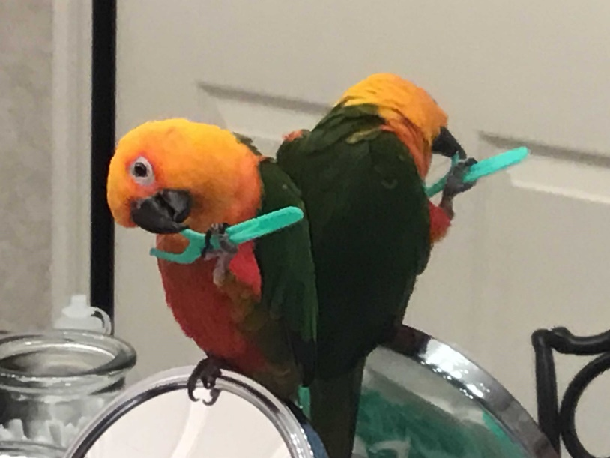
Jill says to floss every day!

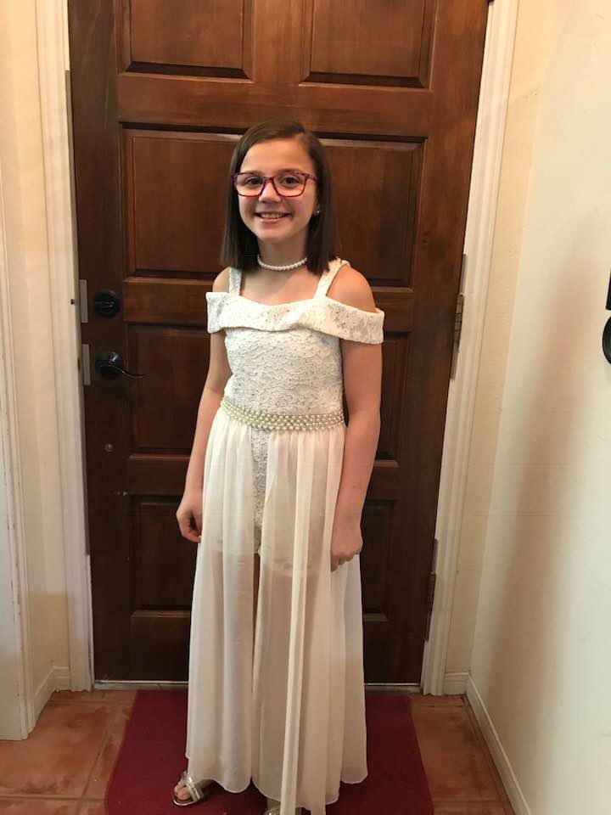
Natalia is dressed for the Bishop’s Ball!

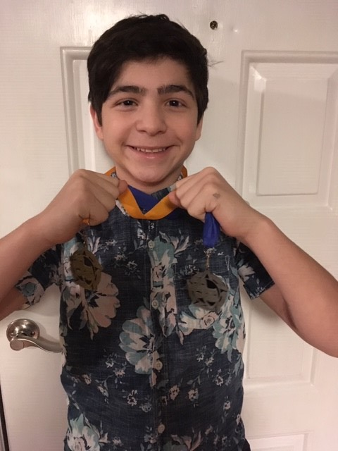
Talked Dom into showing his
Theater Medals

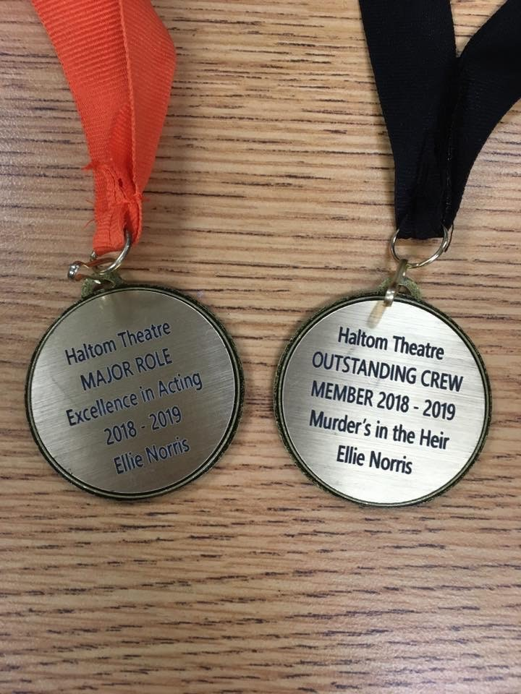
Just a couple of Ellie’s medals!

Working in the Theater together!
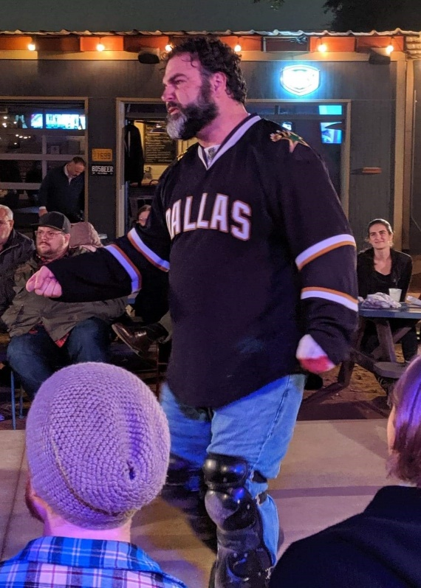
Shakespeare Everywhere's Titus Andronicus
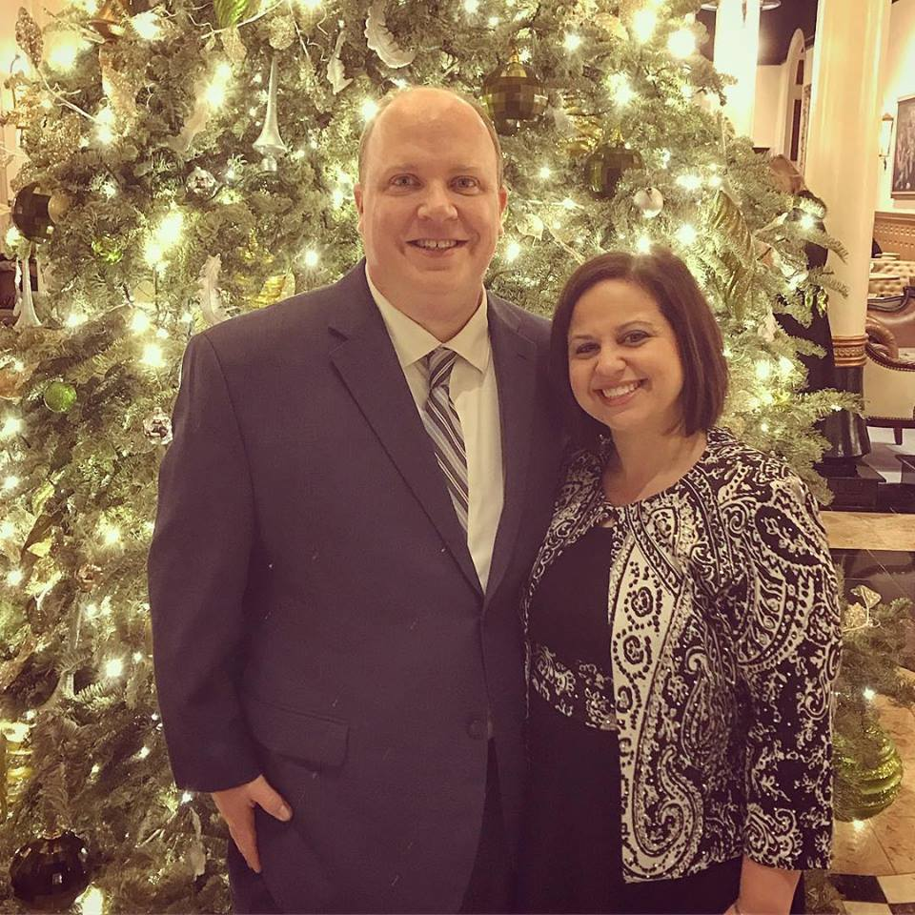
Rob and Lynne

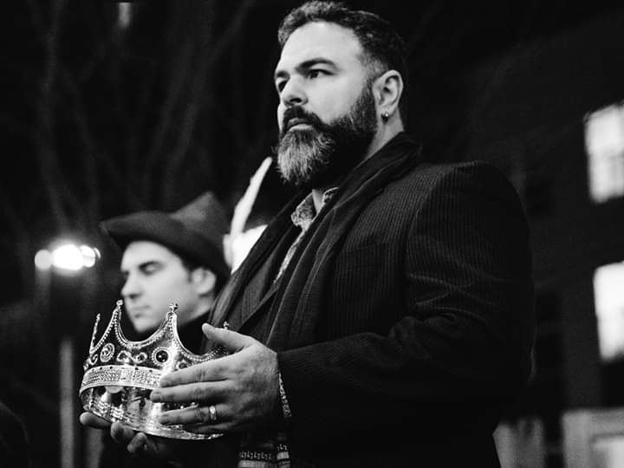
from King Lear

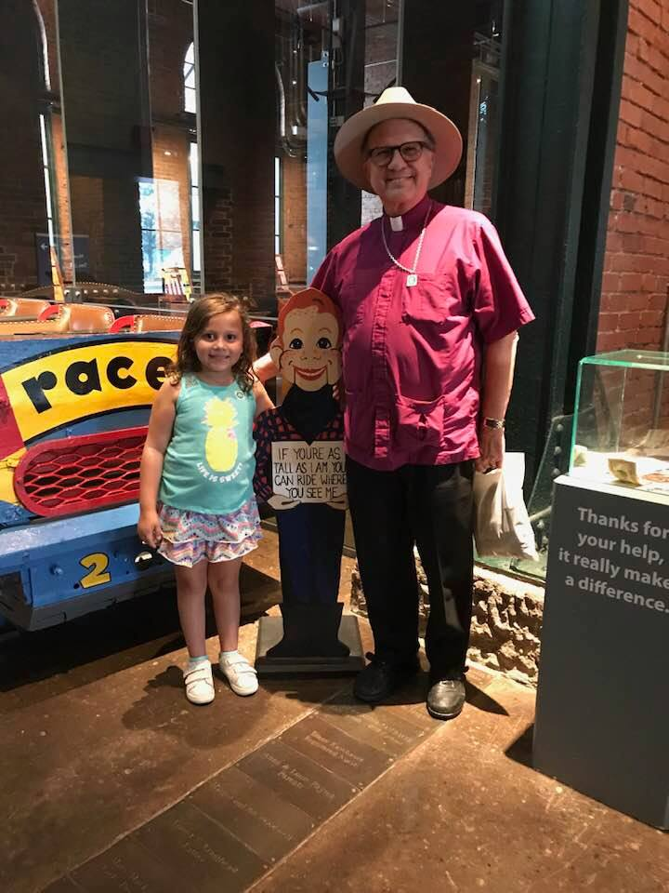
Kennywood and Betty was tall enough!

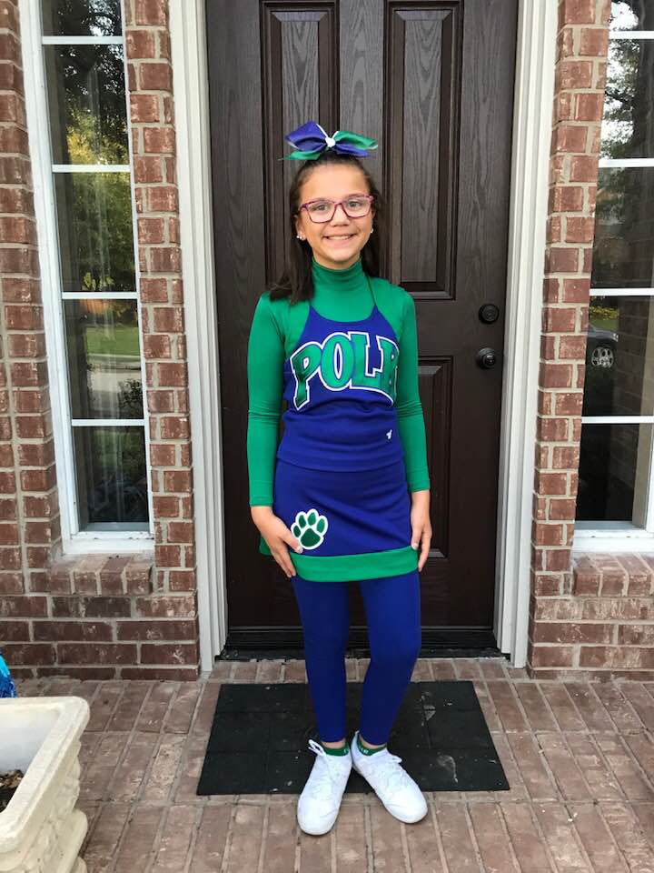
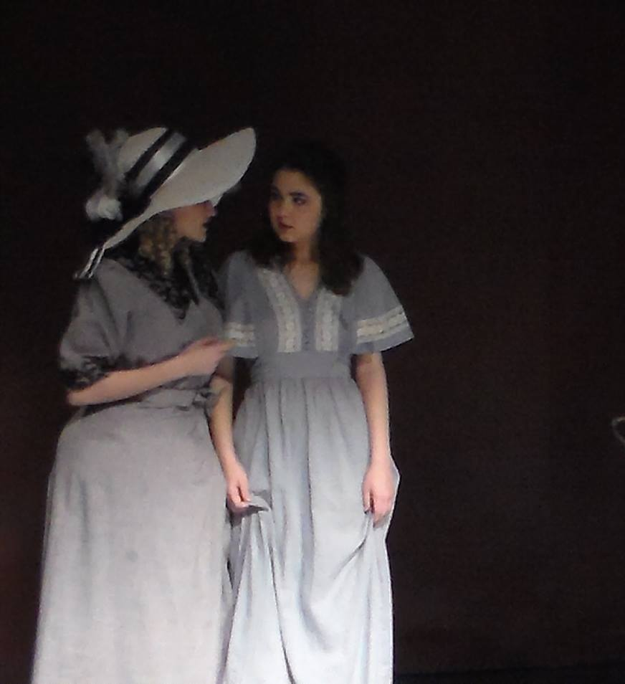
Ellie in Silent Laughter with
one day’s notice.
Go Natalia!

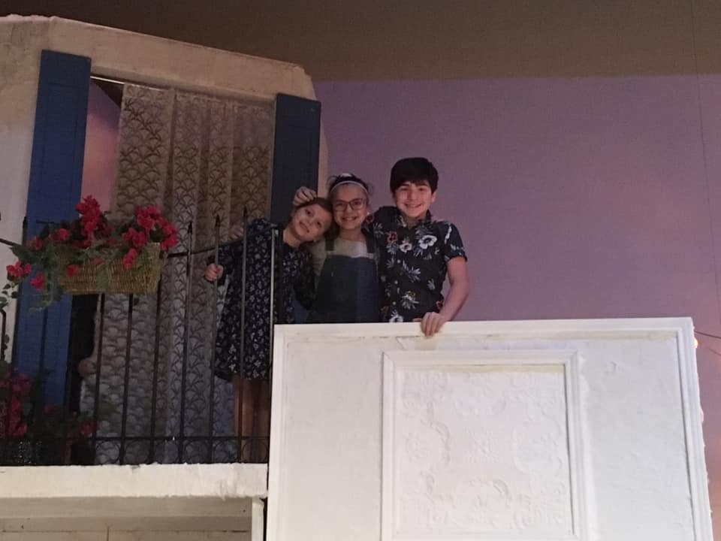
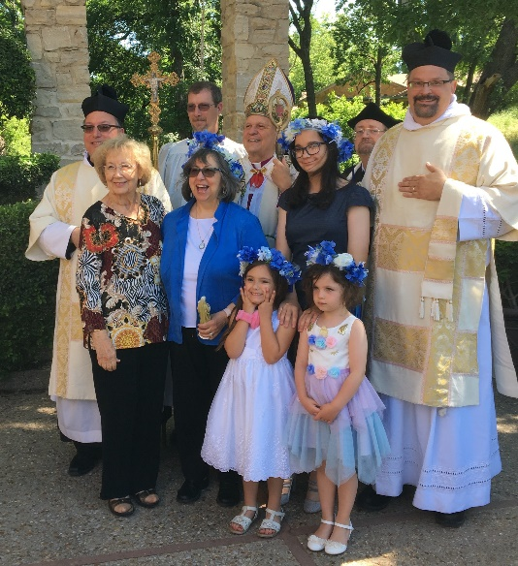
Mamma Mia!
May Day and Woman of the Year

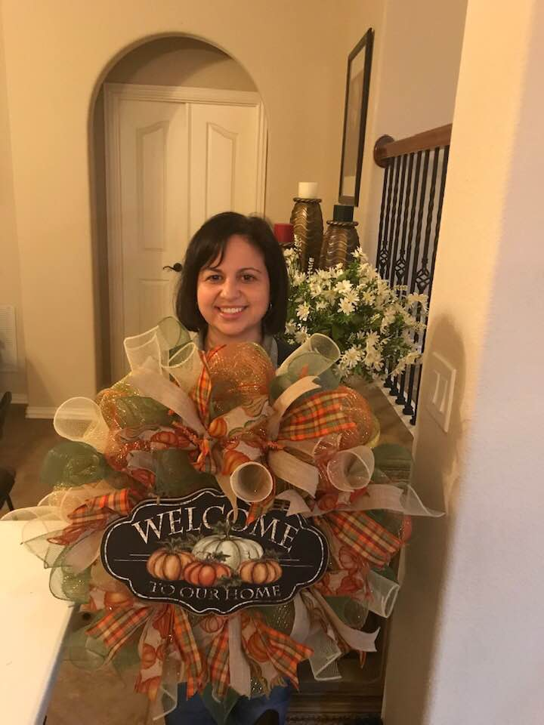
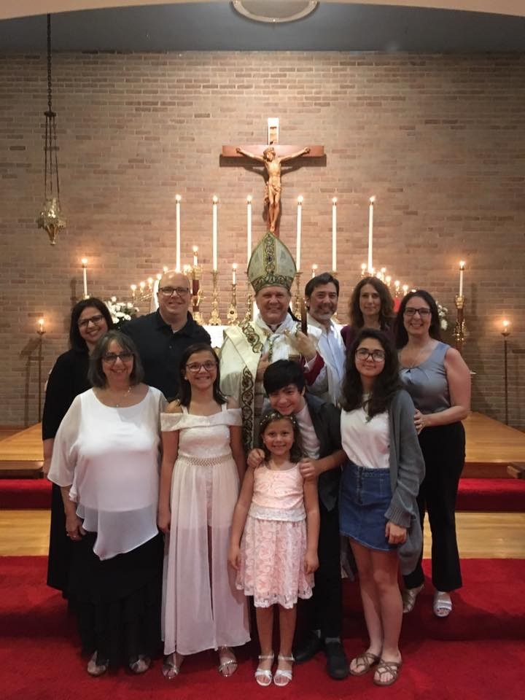
Welcome to our new home!
25th Anniversary Episcopate ~
45th Deacon and Priest
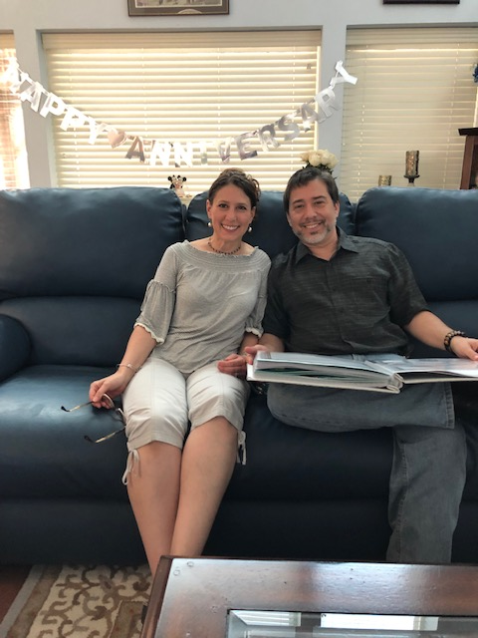
25th Wedding Anniversary

Natalia’s Confirmation

Hugging the Cactus at Aunt Rose’s in AZ
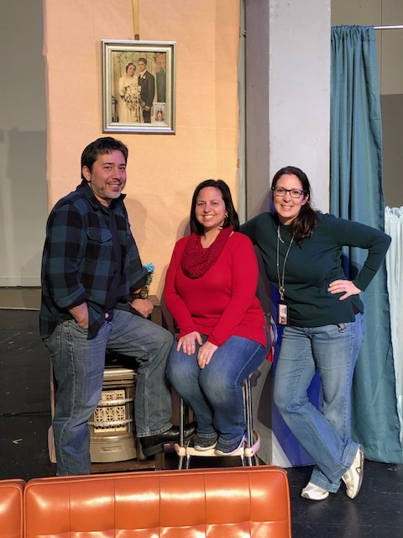
Grandparents on Tour!
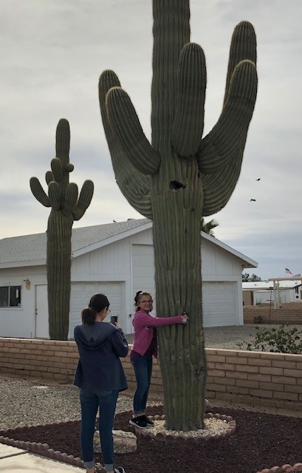
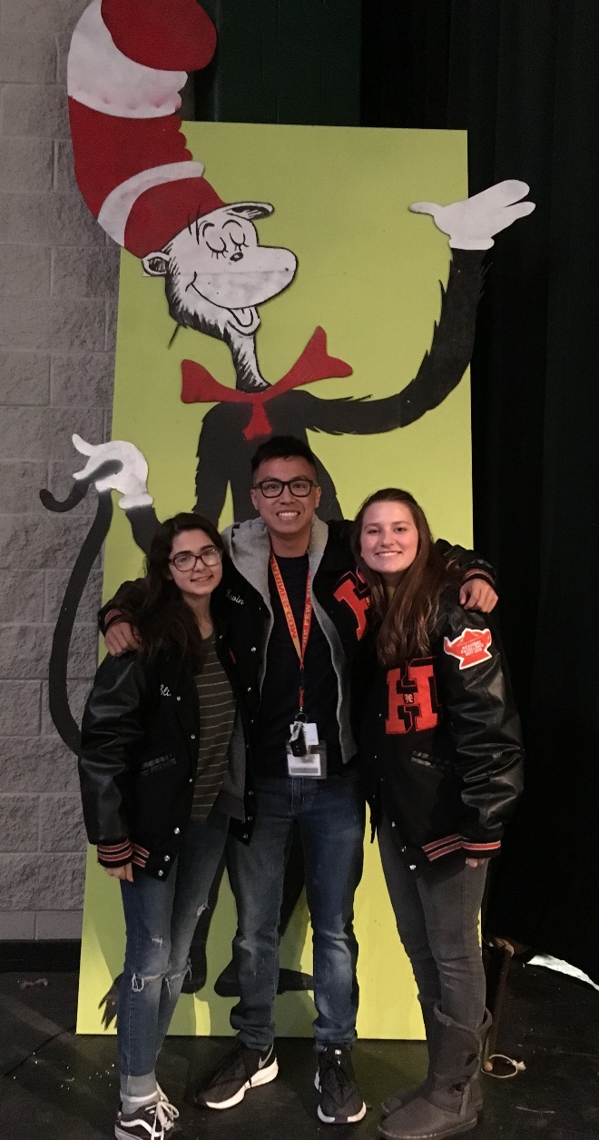
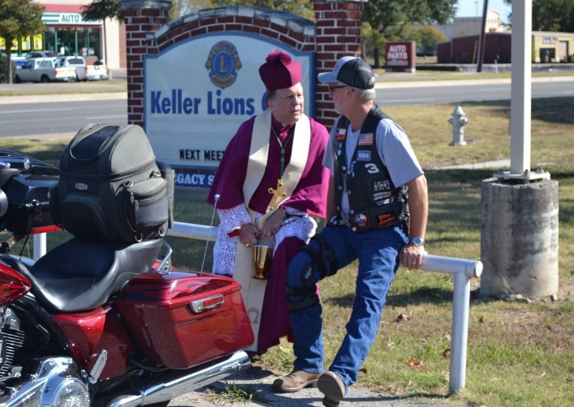
The Sound Board Crew
Annual Memorial Bike Blessing
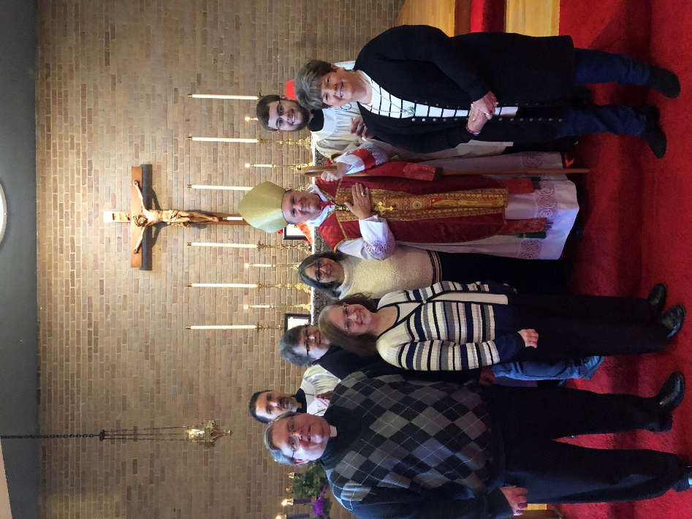
Following the 45th Anniversary
of Priesthood Mass
St. Thomas Day 2019
65 Corvair

