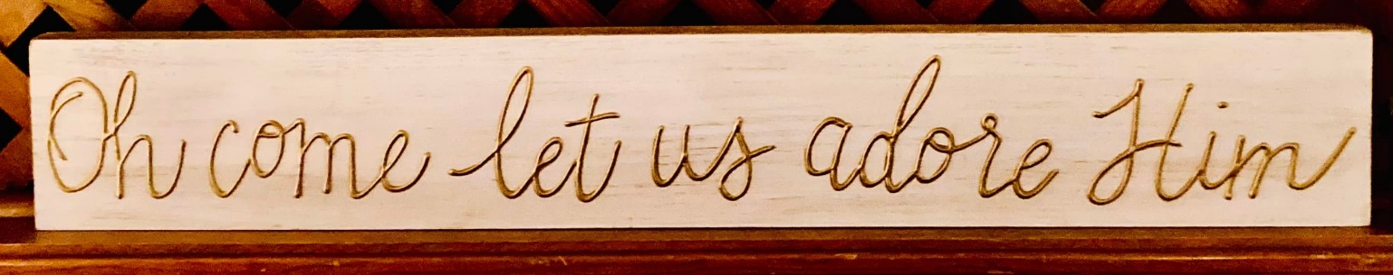

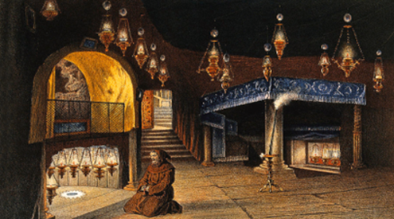

**Bethlehem**

The church of the Nativity in Bethlehem.

Left side the place of our Lord’s birth, the one on the right where the manger was, according to the tradition. These are caves over which the church was built

**Ackerman Family Letter - 2021**

This has been a year of transitions, surprises and grace for our family. The word “transition” has become a more commonly used word of late. Transitions can be intentional, unexpected or a sudden awareness. For our family it is all three. We look to Creation for an obvious example of transition as we see God’s gracious hand providing a Garden of perfection - but by our own misuse of the gift of Free Will, we witnessed a transition from order into chaos, and as we look around us today, we see chaos everywhere. As we look at the Pandemic, we are left with so many questions. Are we transitioning out of or back into isolation? Are we in a safe environment or not? The remarkable ministries that God has placed our families in require complete trust and faith in His plan for us.

**Joann/Jo/NaNa** - In August we heard the words that we had hoped we would never hear again, “I’m sorry, but it is cancer.” When we first heard those words in 1994 we were devastated, and yet God has given us twenty-seven years without cancer, and now post-surgery of a new cancer we, as a family, are walking hand in hand with her as we transition out of cancer into a life that we pray will be cancer free again. Cancer effects everyone in a family, and we are so very proud of Jo’s total faith and trust in Jesus’ healing power and grace. Jo also has transitioned out of a daily life at her beloved St. Timothy Church as secretary, and outreach director, and … (fill in the blanks). At almost the same time several new books for our Publication company (The Parish Press) have emerged and you can follow those updates and publication dates by checking in with The Parish Press Web site. Excerpts of one of the books can be found on Face Book: Bishop Keith L Ackerman. At 76 years old, living in a secure and happy house surrounded by loving family members is more than she could ever have dreamed of having, but wait…there’s more, and her name is…Lillibet! The day after Jo’s first surgery, a four-year-old Maltipoo was delivered to our door, went directly to Jo and will not leave her side or her lap. We are regularly telling NaNa to take a break and to sit down. Lillibet makes it happen. She really loves the entire family, and makes everyone who walks through the door feel special. It’s as if she has always lived with us. And, by the way, she has the same birth month and day as PaPa (Bishop Keith) August 3!

**Bishop Keith/PaPa**. After a part time, “temporary” ten years as first Vicar and then “Bishop in Residence” of Saint Timothy Church, Bishop Keith is now what some are calling “Assisting Bishop 2.0.” The Bishop of the Diocese of Fort Worth (Bp. Ryan Reed) asked Bp. Keith to transition out of St. Timothy Church, and he is now like the ecclesiastical Willie Nelson - “On the Road Again!” Almost every Sunday he makes a Visitation to a different parish or mission in the Diocese. While he most certainly misses the wonderful people of St. Timothy’s there is a sense of joy in exercising the ministry to which he was ordained and consecrated in 1994. Transitioning out of parish life also means fewer emergency, hospital, and pastoral problems, and many of the Diocesan responsibilities can be handled from the new Sun Room that was built onto the house. With Zoom meetings dominating our lives today, many, many meetings can be handled in the Sun Room or from the beautiful Walsingham Chapel in our House, which is called “Dovehaven2” following the custom of Bishop’s Houses having a name. The Bishop’s Residence in Peoria was “Dovehaven.” Having hit the 3/4 century mark this year, he thanks God daily for good health and the privilege of awakening every day to see next to him the love of his life…now married for 54 years. God is so good to us. How could anyone not see all that we do, and not put God first? May our society transition back into not just knowing about Jesus, but rather, in knowing Him as the Lord of their life.

**Keith** ...turned 50 this past April! We celebrated “his day” with every conceivable bit of family joy - since he is a constant source of joy to his family. We had a Monopoly Game personalized for him and the squares and cards and properties all related to his life from Kansas to Wisconsin to Long Island to Pennsylvania to Texas. We had a “silly box” filled with fun items that would make him laugh and we had letters from many of you who are reading this. It was a memorable day. As you probably know, Uncle Keith is the uncle that everyone wishes they had, and when he and Aunt Donna walk through the door for birthday parties and Christmas, everyone in the family can’t wait until they can see the well-considered, well-planned and clever gifts that await them. During this difficult time with both the pandemic and NaNa’s health, Keith comes almost every Sunday morning for either a House Mass or to view and participate in a live-streamed Mass that PaPa is celebrating from some church somewhere! He and Dominic and PaPa had an amazing trip to NYC to see “Little Shop of Horrors” on Broadway, and in the process spent a wonderful time in “Chinatown” and “Little Italy.” What a memorable time. As the father and grandfather, I can tell you that it is amazing to see how similar in appearance and in mannerisms the uncle and the nephew are. Keith’s remarkable Godparents, Anne and Bob Scuitte and their wonderful daughters came to see him and the rest of the family in August. It was fun for all of us! Keith is engaged in many, many exciting endeavors and developments as COO at the Union Gospel Mission of Tarrant County. We thank God that his ministry touches the lives of so many. His staff really love him.

**Donna** amazes us. While many of us talk about the difficulties of some people “It’s like herding cats” she actually does “herd” cats! She trains them, and Keith and she built a “Catio” for their own cats and the ones who are “foster” cats. Their ever-active rescue dog, Gizmo, interacts so well with the cats and he even goes to doggie camp! So, if you ever want to see cats and a dog that are stretched beyond what some people think are limitations - just see Donna in action. Professionally she still works in the computer realm for the City of Fort Worth, and works from both home and “on site.” She and her loving husband have been married for 27 years! Keith and Donna had a marvelous time in December at Disney World.

**Renee** is just as you remember her if you “knew her when.” She was always reflective, and in her childhood, she was planning events, directing church plays at an early age, and loving her family. Fast forward she is an...amazing teacher...amazing mother…amazing wife…and just looking at her former students when they are with her is the obvious indication of what she means to so many. It is fun to consider that this “actress” is not just the head of the Theatre Department, but she is a Theatre wife and Theatre Mom…so she gets to direct and choreograph her own musicals and plays, but also attend her husband’s and children’s performances. Two of her favorite students are her own daughter, Ellie, and her niece, Betty. Betty and Natalia love taking summer classes from Aunt Renee and Renee especially enjoyed directly Betty in Moana this year. Directing “A Chorus Line,” which included Ellie, as an “on line production” was an overwhelming experience, and taking Dominic to his rehearsals and performances means that she has a concert in the car each time! It kind of reminds her of her days as a child sitting in the back seat of the car with her brother and sister, listening to eight track recordings of musicals and singing all the way while driving to Jennerstown (our favorite vacation spot.). As usual…almost always when there is a Musical or a Play and there is an outside scene of a house...the house number is “509” in recognition of thirteen very happy years living in St. Mary’s Rectory on 509 Sixth Street! If you have ever seen one of her productions, then you will note that her mother’s numerous productions from unique birthday parties, to floats in a parade to amazing homemade Halloween costumes have been taken to the next level.

**Ethan** keeps busy being a husband and Dad, and has had his first real chance to be the dad of a daughter with a boyfriend and to have a son who is in high demand for the Theatre. After 22 years of marriage…all of those magical things are taking place, plus helping to plan for his daughter’s soon to be, entry into college in the Fall. Professionally, he still “makes it happen” when it comes to filming and producing and he is even doing the artwork (have you ever seen what he can do) for one of our next books to be published: More Bible Stories from the Old Testament and Apocrypha for Children. His Bible Church background and his artistic talents all come together. Once again, his goals as it relates to the world of Shakespeare are coming true…one play at a time. Shakespeare in the Park in Dallas is an amazing experience and Ethan is a central part of that amazement as a dynamic force on the stage. He is also the consummate pet Dad, taking the beloved fur child, Dahlia,

to a dog park as often as he can. Dahlia is a Black Lab mix who thinks she is a lap dog, and Ethan especially provides a wonderful experience for her.

**ELLIE IS A SENIOR!** PaPa cannot ever forget how she and he “locked eyes” at her birth. She is our “Numero Uno”, and we are very proud of her on many levels - especially maintaining an amazing attitude during High School with Covid. She does not complain about what she has missed. She is an incredible “big cousin” and Natalia and Betty adore her. We also love the special relationship she has with Uncle Keith and Aunt Lynne. She really is an amazing actress and has an incredible soprano voice, but it is how she cares for people in Theatre and Choir that touches us. Ellie has done some student directing and she specializes in being a Sound Technician and Operator. Ellie is also in Dramaturgy which is theater research and, therefore is a resource that her Mom (Renee) will miss next year in Theatre - not because she’s her daughter but because Renee and her teachers count on her. She is insightful. As her Aunt Lynne says, “She’s like Renee. She doesn’t talk very much but when she says something it is memorable.” She was incredible in the live-streamed “The Chorus Line” and she sang a heartwarming “I’ll be home for Christmas” at the Christmas Choir Concert.” She is Vice President of the Choir. She is in the top ten percent of her class, taking virtually all advanced placement classes which will serve her well next year. Her goal is to go to Texas A & M in College Station Texas and to major in Forensic Science. We are absolutely thrilled with her boyfriend, Matt, and in no time at all he is a welcome addition to our family. Matt graduated last year from the same high school where Ellie is a student and Renee is a teacher. He comes from a lovely family, and it is obvious that his family is very fond of Ellie.

**Dominic**, like his cousin, Natalia is a freshman in High School - and talk about making transitions! It became evident last year that his consistent passion and talent in the area of Theatre was ready to explode. NaNa had felt strongly about Dominic participating in the Artisan Theatre in nearby Hurst, Texas - and it is everything that he needs to develop in Musical Theatre and he has everything they need….to the extent that they contact him about what they would hope that he would be in. Here are just a few performances since last year: The most amazing thing about “The Lion, the Witch and the Wardrobe” is that Dominic was asked to play the role of Edmund and midway through, the actor playing Peter became ill and the Director asked Dominic to play Peter. He had less than 24 hours to learn not only the script but also the sword fight. As a result, we were able to see him perform both as Peter and Edmund. His voice has really developed and he has had a few voice lessons. It was obvious to us in his role as Friedrich in the Sound of Music that he is continuing to develop as a stage performer. He is currently in rehearsals for “Grease” at his High School where he has the role of “Doody” and he is also playing in the musical version of Scrooge at the Artisan during the Advent-Christmas Season. As we have written, the trip to Manhattan with Uncle Keith was memorable. In spite of how sought-after Dominic is to perform, he has not lost his sense of humility. This year he has been in “Junie B. Jones,” “Les Misérables,” “Into the Woods,” “Sound of Music,” “The Lion, the Witch and the Wardrobe,” Scrooge,” “North Ridge Musical Revue”, and “The Pirate Show.” The love he shows for his NaNa is very, very special and the love he has for the eleven of us in our family of twelve is overwhelming. As is the case with all of our family. We love being together as often as we can.

**Lynne**...trick question: name every type of experience related to church and education and being a Mom and being a daughter and being a wife…and there’s Lynne. You may recall “Lynnie Pooh” the clown (yep - that is her) but we think she is actually a juggler, since no one is better at juggling all off the elements of her life than she. We are very, very grateful for her love for Jesus and His Church and realizing with Flower Guild, Women’s Group President, Daughters of the Holy Cross, Camp Crucis, Girls Scouts, her own “Rob & Lynne” business - “Scout and Cellar” that she makes Jesus smile. She even calls her Mom and Dad daily just to check in, but often to tell a “Betty Story” which leaves all of us laughing. Her professional life is amazing as numerous campuses of children in Dallas are able to benefit from her loving, positive and Christian based guidance. As most of you may recall, Lynne has one of those beautiful smiles that makes others want to smile. But her job as an Assistant Principal means that she must often be very firm and people soon discover that there is a great deal more than a smile; as the Bible teaches us “speaking the truth in love.” She never misses anything that her sister, brother-in-law and niece and nephew do, which means that she drives from Carrolton (north of Dallas) to North Richland Hills (Renee) or Keller (NaNa and PaPa) almost weekly. Family is incredibly important and she juggles family activities with the very large Shattuck family along with the Ackerman-Norris activities. She epitomizes “JOY” - (J esus first, O thers second and Y ou last.).

**Rob** is a busy guy! Professionally with Fidelity he is helping numerous people, and as the husband of a very active wife and the father of two active daughters he does not have a life filled with “sleeping in” or lounging. He is very active at the Cathedral Church of the Holy Communion, in every phase of the church and he is also the glue that holds together the Alumni of Camp Crucis, the Diocesan Church Camp where he and Lynne met over thirty years ago! He and Lynne have been married for seventeen years and he cares for his own extended family deeply, to the extent that he and his dad and brother spend quality time together. It is also fun to see how close he is with his brothers-in-law Keith and Ethan, and we love seeing his face when Uncle Keith surprises all of us with the well-planned gifts. One of Rob’s highlights this year was the marriage of his long-time bachelor brother, David. It was a great event, and it also helps to have in your immediate family a Deacon and a Priest when it comes time for a wedding!

**Natalia** is a Freshman in High School - just like her cousin Dominic! Like her parents, she is a juggler. She continues to set records in cookie sales in Girl Scouts and is well on her way to receive the highest rank in Girl Scouts; in fact her project will be at Union Gospel Mission with Uncle Keith again. Like her parents before her, she is a freshman cheerleader. Some of you know that Rob was a school mascot and some remember that Lynne was once the Bailey Ram! Natalia is literally “on top” in cheerleading as you can see in her pictures, and she was even dropped but is recovering nicely from a broken collarbone. It should not surprise anyone that Natalia is VERY active at the Cathedral Church of the Holy Communion where she is in the youth group and even is a Server. She is also active in the Youth Program of the Diocese of Fort Worth, which means (you guessed it) she is at Camp Crucis every chance she gets. In fact, this summer she went with PaPa every week to Camp Crucis as PaPa checked in with the campers and the staff to encourage them on behalf of the Diocese. She is in the choir at her High School and in January will become a part of DECA. Between being at Camp and keeping up with her busy parents, she also went with her Mom to Illinois for a vacation as Mom showed her the Cathedral in Peoria where PaPa was consecrated bishop in 1994, the Benedictine Abbey where she spent time with Abbot Luis and (“Uncle”-Tio) Fr. Harold. Most of the trip was spent with longtime friend, Courtney and her family. Natalia also loves being with Lillibet! We must also add that she is an amazing big sister, and even though all sisters occasionally have “spirited conversations” Natalia is always demonstrating protective care and concern.

**Betty**...is...well she’s uniquely Betty! Recently during a humorous interaction with her Mom (which most of their interactions are) she told her Mom that “NaNa and PaPa are my parents and Lillibet is my sister.” Betty spends as much time as she can with NaNa and PaPa (and Lillibet) and this summer she even turned down the “girls’ vacation” to Illinois so that she could be with her Aunt Renee and be in “Moana” at the Artisan Theatre - where Aunt Renee sometimes is “in residence” as a director in the summertime. Recently Betty was with PaPa at an event and people came over and said, “It’s Betty from ‘Bible, Bishop and Betty’” which is a weekly live-streamed program that has PaPa reading a chapter each week from the Old Testament and the Apocrypha. People tune in to watch the unrehearsed humor and responses from Betty. (Note: the book will be published in 2022.) Betty is at an elementary school that is a Fine Arts Academy and she is a member of an Improv Ensemble. By the way, she was doing Improv with Aunt Renee before even entering the Academy! She is also in Girl Scouts and does a good job with cookie sales (thanks Mom and Natalia.). Betty is a little bit like the family “Mascot” and all of us wait to hear what the next humorous statement will be. Since she was in “Moana” this summer she “lived” at NaNa and PaPa’s house a great deal of the summer, and once Lillibet was adopted, Betty even became one of Lillibet’s sources of attention and affection. Many of Betty’s friends are church friends - which pleases NaNa and PaPa, and she is regularly invited to parties and sleepovers. This was her first summer as a camper at Camp Crucis, and just like most of the family…Camp Crucis is a bit like a home away from home.

**Bishop Keith and Joann**

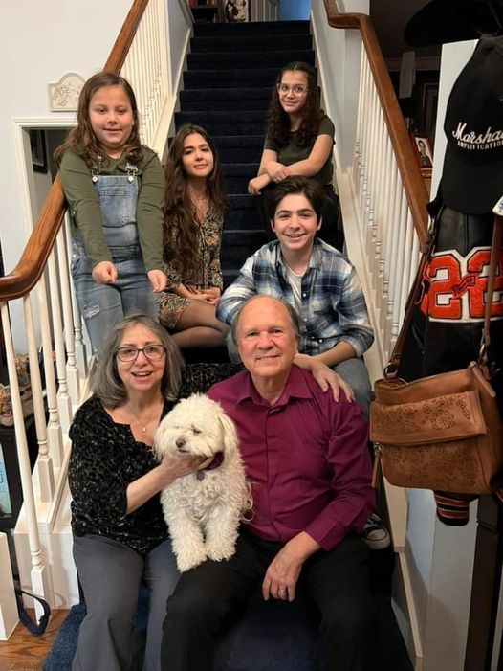

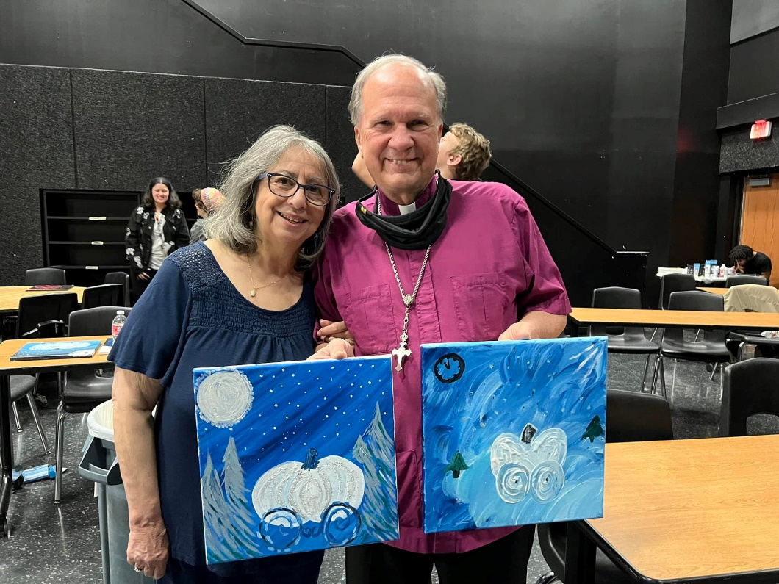

**Keith and Donna**



**Ethan, Renee, Ellie and Dominic**

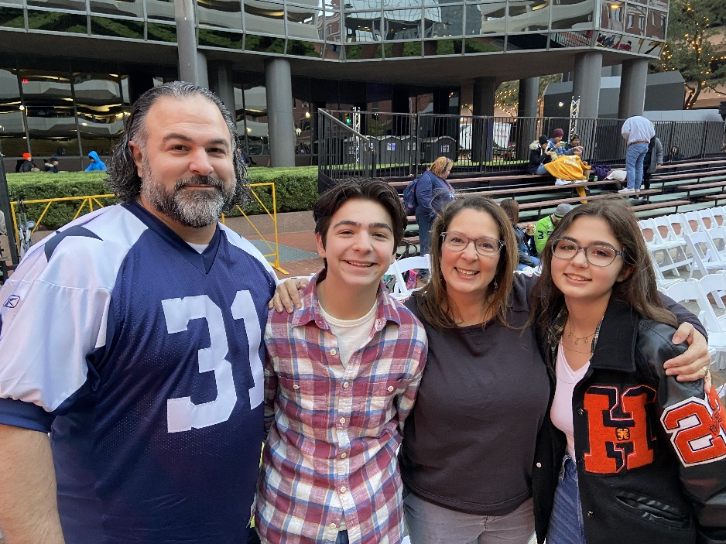

**Rob, Lynne, Natalia, and Betty**



