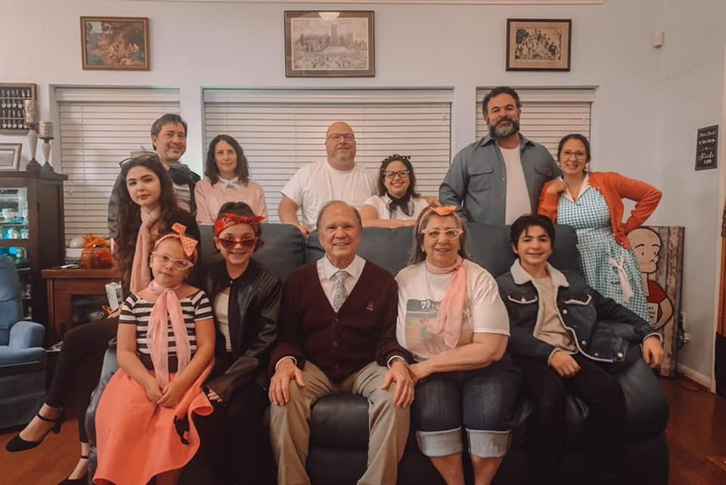

2020 FAMILY 50/60 BIRTHDAY PARTY FOR JO-DONNA-AND -ROB

To all of our family and friends throughout the world we greet you in the Name of the Prince of Peace, Who, in spite of a pandemic, political strife, chaos and turmoil is and was and will forever be the Author of our Salvation and the only Name given as the answer to most questions that seek to make sense out of all that the world is immersed in. For those of you who have suffered any form of loss this year - especially during Coronatide - we can assure you that you have been in our thoughts and your name and the names of those whom you love are prayed for at our Altar.

Now for an escape! Life as we have known it has changed this year for each member of our family, but what follows is a Covid 19 free Letter, which happens to be our 50th family letter from what we can determine.

**Bp. Keith** will be concluding his 9th year as part time Vicar of St. Timothy Church in Fort Worth and on January 1 will become “Bishop in Residence” focusing primarily on the wider ministry that is necessary as a bishop. That means that he will continue as Bishop Vicar in his beloved Diocese of Quincy and Assisting Bishop of the Diocese of Fort Worth, primarily doing what is requested by the Diocesan Bishop of each diocese. This past June he became, also, the Bishop of the Diocese of the Southwest (El Paso to Albuquerque) and when the new bishop is consecrated in March, his responsibilities there will conclude. He continues to work on numerous committees for the Anglican Church in North America. At this point in his life, enjoying excellent health as a gift from God, he loves being married to his high school sweetheart (53 years!), being Dad to Keith (49) and Donna, Renee (48) and Ethan and Lynne (44) and Rob all of whom live very close to each other which is reflected in how much we all do together! He absolutely adores being PaPa to Ellie (16), Dominic (13), Natalia (13) and Betty (8.)

Our First Christmas Letter in 1971 announcing the birth of Keith and our move to Nashotah House could never have imagined the joys we have. They make life feel “normal.” A teaser: stay tuned for the 1965 Midnight Orchid Corvair Corsa Convertible (just like the one some of you remember who knew us ca. 1967-1972.). It’s almost ready!!!

**Jo/Joann**/NaNa/ Momma Jo just celebrated her 75th birthday and it was unbelievable. As most of you may know, in 1962 Joann Bevacqua of West Mifflin North High School hired Keith L. Ackerman of McKeesport High School to be the Disc Jockey of her High School dance. It was love at first phone call and the sight part merely confirmed it. That night his partner “Ackerman-Ilgenfritz Disc Jockeys - Reasonable Rates” Bill, played many records by himself so that his partner and the president of the High School group could dance. So...........58 years later, on her 75th Birthday the duo returned. Bishop Bill Ilgenfritz zoomed in and the resident Keller Texas disc jockey stepped aside so that the lovely young couple could dance, but this time with their children and grandchildren present. It was a true 1960’s sock hop with most of the original 45’s still “playable.” Although Jo has always been the glue and the visionary that can turn any common event into an exciting one, our gratitude is to be found in the fact that in spite of cancer, heart attack, diabetes and fibromyalgia, she can still “dance.” Thank you Jesus. She continues to do everything she can to help at St. Timothy Church, but she and her untrustworthy and often unreliable computer and printer form a partnership that can “virtually” light up peoples’ lives. Her gift planning and gift giving skills and her deep and abiding Faith have touched not only our lives but the lives of our extended family and friends.

**Keith** will turn 50 in April! He and **Donna** celebrated their 26th wedding anniversary this year and they have created an environment for their rescue dog and cats that must be the envy of their neighborhood. They try to keep their fur family away from the neighborhood pets because those pets might complain that they don’t have what the Ackerman family has. Keith continues to be the C.O.O. of the Union Gospel Mission of Tarrant County (Fort Worth area.) You can well imagine, given all that is happening what life must be like for him as he ministers to people with multiple needs - the needs we take for granted: food, shelter, clothing, and a sense of human dignity. What makes UGM so special is that it is a Christian Ministry, and it is not dependent upon the government. That means that this ministry exists to a large extent on the generosity of people who see this as an essential ministry. As Keith’s Dad has often said, “If you can’t personally feed and house the homeless, then please give resources to those who can.” Keith is every sibling and every niece and nephew’s dream. He is the son that everyone dreams of having. He simply loves his family. Apart from an incredible ministry and a deep and abiding love of his wife, and a love for his fur family, Keith is a remarkable Christian man whose faith is demonstrated daily with actions. In his office are the words attributed to a famous saint - his Patron St. Francis (he is Keith Allyn Francis) “Now go into the world and preach the Gospel, and when necessary use words.”

Just when you think she had done it all - **Donna** has progressed from being a “Cat Lady” to be a “Professional Cat Lady.” No, that does not mean that she simply likes to adopt stray cats. No - she is a certified cat trainer, and if they weren’t enough, she is on track to be a certified dog trainer, too. Why not? If you could see all the things that their precious cats and Gizmo the dog can do, you would understand. She is REALLY very good at this! She continues to work as a project manager for the City of Fort Worth, but like so many of you who are reading this - she has been working from home since May. In case you wondered if she likes working from home.......well you should see their home. This year she and Keith built a Catio. Yes, you got that right: it is a patio for their cats! It has everything that a cat could want. But back to the 9-5 gig: she is also serving as a Trainer for the City of Fort Worth, city employees, teaching and “Listening with Intent.” By the way, Gizmo wants you to know that he is very grateful for the fact that Donna takes him to Dog Scouts. We are not sure which merit badges he has earned, but he can successfully answer the following questions: what is the outside of a tree called? What does sandpaper feel like? What do do call the top covering of your house? Now you who are reading this has answered this successfully, you may have just passed the entrance exam to Dog Scouts.

**Ethan** consistently makes it clear that simply put, we are Mom and Dad. It has been that way since we met. His consistent love for “Mom” is shown by the attention he gives her, and the love he shows for “Dad” is demonstrated by the ways in which he includes Dad. This year this inclusion was shown in having Dad be a part of a fascinating and thought provoking broadcasted dialogue with Dad/Bp. Keith, a Jewish Professor of Shakespeare, and a well know Rabbi. They were brought together to discuss “The Merchant of Venice” with the emphasis being on the character, “Shylock.” Although “Shakespeare in The Park” suffers as does all live theatre (PLEASE pray for everyone in Theatre - vocational and avocational) Ethan continues his goal of performing in every one of the Bard’s stage offerings! Ethan continues in his “day job” that all too often is his “night job” too, but that does not mean that his family sees less of him. The Norris part of the family continues to bond during Covid - making the best of what has happened. The fifth member of the family, Dahlia, is the direct beneficiary of Ethan often having to do his creative works on computer at home, and Dahlia has him trained to take her to the Dog Park. Ethan enjoys sharing his nocturnal chats with Ellie and watching Dominic accomplish at a young age, the many theatre endeavors that delight a Dad’s heart. He love his wife, and is grateful that he is daily surrounded by real love in a virtual world.

**Renee** continues to move faster than the speed of light. It’s as if she is the constant “actor/actress” on her own stage that engages the admiration, love and respect of the audience. EXCEPT - she is not acting, and she cannot handle being visible on that stage. She is simply playing herself. To see the responses from her former students over the years, it becomes apparent that whatever she has given of herself to them has found a place in their memories and in their hearts. She has the ability to make people feel better about themselves after they have taken a class from her or been directed by her or simply been loved with the love of Jesus, by her. She loves without judgment or the expectation of receiving anything in return. This year she directed two virtual productions and she produced one, too! Apart from teaching at Haltom High School, she also taught for a local theatre called “Artisan” so that she could help them through these challenging times. Even though she has taught just about everything there is in theatre she also taught Advanced musical theatre, and the one that has really excited us is that she is teaching musical theatre to special needs young people.

**Ellie** is sweet 16 and is a Junior in High School (when High School is in session!) Obviously in the category of “the fruit doesn’t fall far from the tree...” she continues to be active in theatre and choir! When it comes to choir, she is the Secretary of the High School Choir and auditioned for and was selected for the top choir and theatre classes! She is both a performer AND much MORE! She was in “A Lie of the Mind” - original sound design and played the German Girl in “Madonna” just to name a few offerings! Ellie is currently preparing to student Direct “A Chorus Line” which will be “cleverly” filmed and then later streamed. Very creative! She was on the Sound team for “virtual” Fall Show. This year for Spring Break - 16th Birthday (days before the “recent unpleasantness” she wanted to go to New Orleans, but being the amazing big cousin that she is, she insisted on having Natalia and Betty go, too. It was a Dixieland girls tour! On a vehicular note: the family acquired a truck - for all of us to share, and Ellie stands out as the main cheer leader for having an Ackerman Family Truck. We bought it from a precious member of St. Timothy’s! The truck has become a part of the family. Academically, Ellie is in the top 3% of her class and is a member of the National Honor Society.

Ellie has led the Covid isolation days at home with lists of movies by select filmmakers for evening family bonding. She is currently researching her college path and continues to visit campuses. In May the family visited Texas A&M.............all aimed towards her vocational goal of being.............a neuroscientist!!!!!

If you think Ellie is “into Theatre” wait until you talk with **Dominic**! He is immersed in theatre! At 13 he has had a starring role in “Thoroughly Modern Millie,” and he received an All Star Cast “Birdie Award.” He also starred at The Artisan in “Ella Enchanted.” He has studied privately under Abi Oxley-Derrick - “Triple Threat Performance” lessons - a gift from NaNa and PaPa and has had vocal lessons with Opera Singer, Christina Majors. But it gets better! At the District Monologue contest, he received superior rating and judges’ choice, with his evaluation - a perfect score. He has an extraordinary Middle School Theatre teacher, and he surprised her, for Teacher Appreciation Week, with a backyard celebration with a few friends - yep appropriately socially distanced. Dominic has been an “on line learner” all semester, but he was able to record a theatre class radio show and is currently rehearsing a musical revue for January. For his 13th birthday weekend, Gran Jane and Gran Gary treated him to a party at the Great Wolf Lodge, followed by a red carpet return party with more family. Dominic also was selected for House Council, his school’s student council. But Dominic shines off the stage, too. His demonstrated love for NaNa and PaPa by his kind words, hugs, and ongoing concern for his NaNa’s health make a real star in the family. He adores “The Twelve” (12 in our family) and his kindness and his love for others spill over in whatever he does. He has a spontaneous smile........and he loves being with his little cousin, Betty.

**Rob** had a great year being “Big brother.” His only sibling got married and the entire Shattuck family rejoiced. In fact, it was a very good thing that he has a capable wife and delightful daughters since they made everything related to the wedding very special. Rob continues to work FOR Fidelity but (like many of you) not AT Fidelity...well at least not on site. He and Lynne have really done an extraordinary job with their “side business” Scout and Cellar Wine. In fact, you may wish to see more by going to their Scout and Cellar Website. Rob is also active at the Church of the Holy Communion Cathedral and is the Vice President of the St. James Brotherhood, the Co-Chair of Technology, and soon will be joining the safety committee. This “at home time” allows him to spend quality time with his girls! Like so many of us not being brought up with any sisters, having three ladies in his house is a whole new opportunity for grace.

**Lynne** was one of the best clowns we have ever seen - Lynnie Pooh. Her total love for children disarmed even those who have been infected with a modern cultural phobia regarding clowns. BUT the juggling part of being a Clown is Lynne’s daily life. We have never seen anybody keep as many balls up in the air as she does. As you look at each group, professionally, ecclesiastically, and (forgive the word invention) entrepreneurially) you will see Lynne in the center. She is what we would call a natural evangelist. No sermon and no lecture. Living her life for Jesus and sharing His love for her with anyone who meets her. That passion is demonstrated in her children. She is now in her 5th year as an Assistant Principal for Pre-K Partnerships in Dallas. Her involvement in the Cathedral Parish where she is a communicant knows no bounds! She is the President of the Church Women, Co-Chair of Membership Development, on the Flower Guild, and the Cathedral Parish Chapter of the Daughters of the Holy Cross. She is also the mentor for the new Chapter of the Daughters of the Holy Cross at St. Timothy Church. She was the Speaker at the Annual Retreat. Not enough? She is also the Troop Cookie Manager for the Girl Scout Troop that Natalia and Betty are in!

**Natalia** is, indeed, a teenager, having turned 13 this year! She is in the 8th grade, and at school she is active as a Cheerleader, a member of the choir including the Show Choir (called “Harmony”), and the Yearbook staff. Like the rest of her family, she is very active in the church and serves as an Acolyte where she is trained and supervised by her other grandfather, Deacon Chip Shattuck, and she also loves her Youth Group. As you may recall, she is an extraordinary cookie salesperson and is in her 9th year of being a Girl Scout. Although her Dad (and Uncle Keith) are Eagle Scouts, Natalia is encouraged by them as she moves towards the highest rank in Girl Scouts - the Gold Award! Natalia really is an amazing big sister and a remarkable cousin. On her Dad’s side of the family she has numerous cousins and loves the opportunities to be together with them especially when there are 4 generations of Shattuck’s present! On her Mom’s side of the family she has two cousins, Ellie and Dominic, and simply looking at family pictures over the years it is obvious that these four (Ellie, Dominic, Natalia, Betty) are “BCF’s” best cousins forever. Although not all big sisters enjoy every moment with their little sisters, apart from the typical annoyances of having a 4+ year age gap, we hear words of wisdom and see acts of love coming from big sister to little sister. Isn’t family the best!?

**Betty** - definitely last but most definitely not least. She brings out the best in everyone in the family. She is one of those personality types that you cannot help but love: hugs, kisses, “I love yous” for every member of her family. Sometimes she simply packs her bag and announces that she is ready to go to NaNa and PaPa’s house “for a few days.” Then she sets up the bedroom and her kitchen table and her TV tray in the Living Room. When word reaches the Norris house that she is “in residence” activities start. In the modern jargon she is a “media influencer” and can be seen every Saturday afternoon at the St. Timothy Anglican Church Facebook page in “Bible Story, Bishop and Betty” known to some as “B, B, & B.” She has quite a following, and without any rehearsal she spontaneously responds to a range of subjects from PaPa reading (and having written) Old Testament Bible Stories to subjects like “Is Hallow’een Christian?” and “Who was St. Lucy?” Of course, she dressed as St. Lucy that day! Betty is 8 years old and is in the 3rd grade. She is blessed to be at an elementary school which is a designated Fine Arts Academy, and she loves Theatre and Dance (is Aunt Renee proud?”) Betty won the Dance Award in the Second Grade and was a major family hit doing the Twist at NaNa’s 75th! She recently won the “BUG Award” in her class: “Being Unusually Good.” She, too, is in Girl Scouts and while not the driving force in cookie sales, charms shoppers into buying more!

And so, dear friends in Christ, all of us remember you with love, and we ask you to join with us, as we join with you in remembering those who are celebrating their first Christmas in Heaven. As all of us mourn the loss of so many, let us never forget that they helped shaped our lives: parents, siblings and sadly, children. At every Mass (I celebrate Mass daily at 9:30 AM - livestream Facebook - St. Timothy Anglican Church) I pray the words, “Remember also, O Lord, thy servants and handmaidens, who have gone before us with the sign of Faith and are at rest in the sleep of peace. To these, O Lord, and to all who rest in Christ, we beseech Thee to grant a place of refreshment, of light, and of peace.” Having prayed these words for years before and now for 46 years as a priest, I see the list grow, but I also see your faces and the faces of those whom you love, at the Altar in this world, and now at the Altar in the Heavenly Jerusalem.

**To God be the Glory - Jesus Christ is Born.**



BISHOP AND JO



KEITH

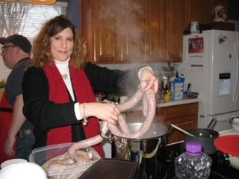

DONNA

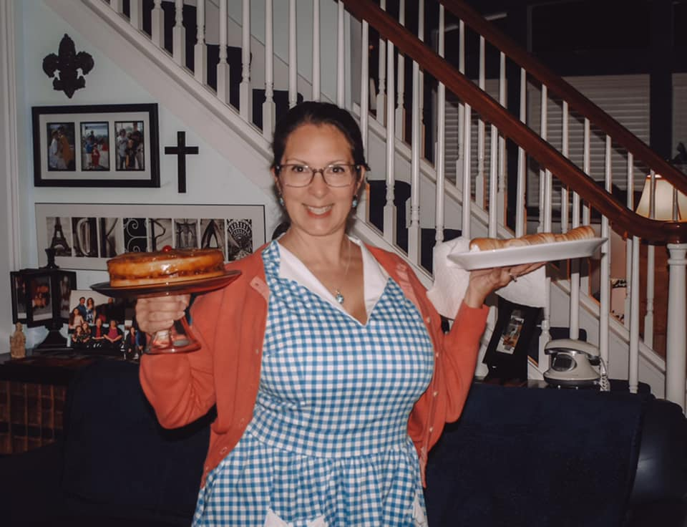

RENEE



ETHAN

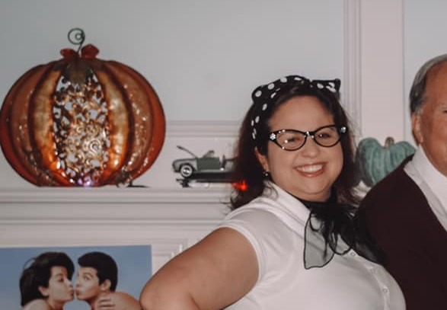

LYNNE

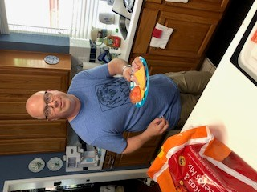

ROB



ELLIE 16 YEARS OLD



DOMINIC 13 YRS OLD



NATALIA 13 YRS OLD

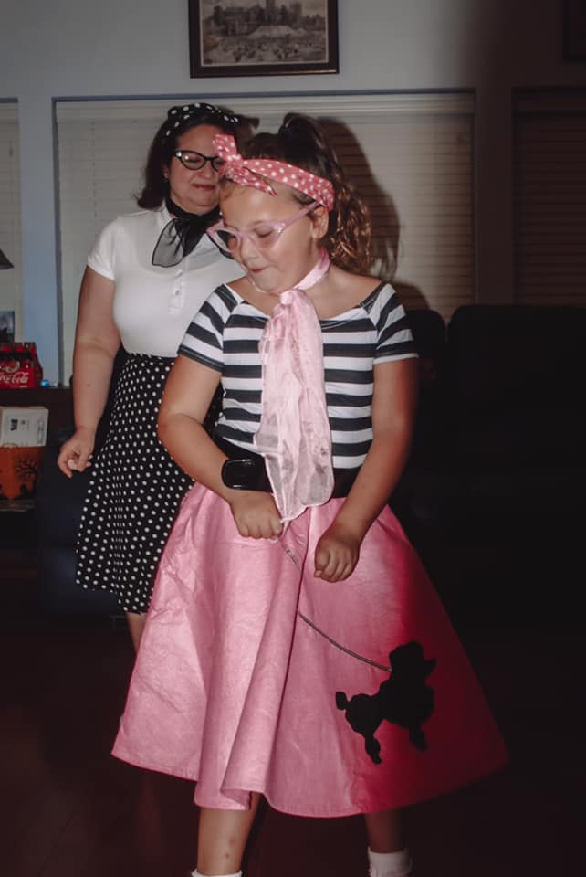

BETTY 8 YEARS OLD