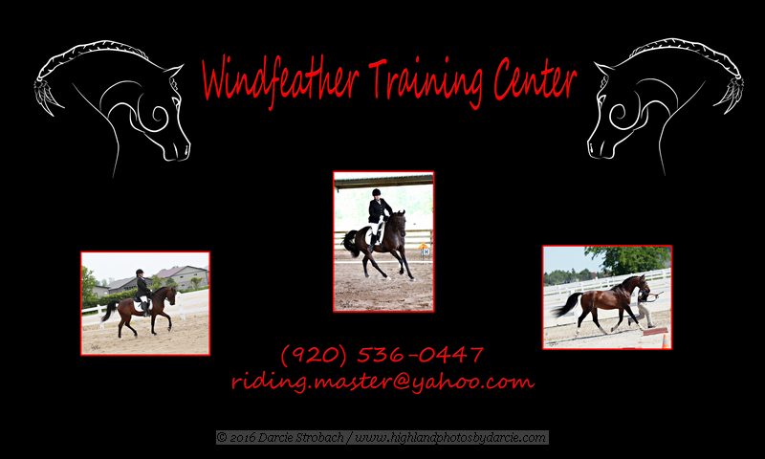

ONE MONTH BEGINNER HORSEBACK RIDING LESSON

PACKAGE OF 4 LESSONS

DATE:

1)__________________

2)__________________

3)__________________

4)__________________

THIS PACKAGE IS BEING PRESENTED TO YOU BY: