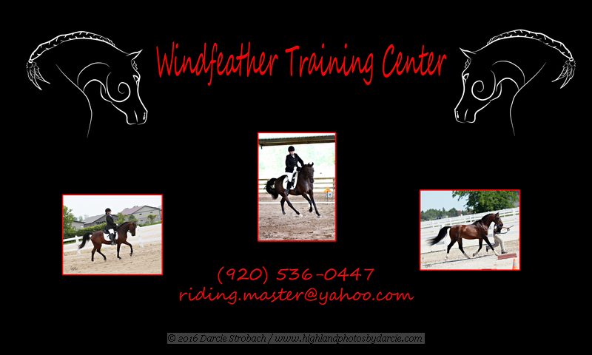

Thank you for taking the first step in the process of developing an even better connection between you and your horse. Whether you are just looking to improve your communication, or if you are struggling on a plateau in your current training routine, this method of online video lesson format can be a very helpful tool to move forward in your journey of achieving your goals. I have been successfully teaching lessons for over 30 years, and in my current role, I have been also, working with several online learning tools, that have given the equestrians access to video lessons, and training even while we have been dealing with the “NEW” reality challenges that 2020 has brought us.

To better help me understand your goal in this lesson program please tell me a little about yourself and your horse.

_________________________________________________________________________________________________________________________________________________________________________________________________________________________________________________________________________________________________________________________________________________________________________________________________________________________________________________________________________________________________________________________________________________________________________________________________________________________________________________________________________________________________________________________________________________________________

Please tell me a little about what the immediate and long term goals you have set for both you and your horse.

______________________________________________________________________________________________________________________________________________________________________________________________________________________________________________________________________________________________________________________________________________________________________________________________________________________________________________________________________________________________________________________________________________________________________________________________________________________________________________________________________________________________Please list in order of importance some of the things you would like to address in this lesson.

1. ________________________________________
2. ________________________________________
3. ________________________________________
4. ________________________________________

Please add anything else you would like to share at this time.

Payment information: PayPal.me/WindfeatherTraining

Online lesson/training session is $35

Package of 4 lessons $100