**WINDFEATHER TRAINING CENTER**

**TIME TO RIDE**

**7 CLASS SESSIONS + HOLIDAY EVENT**

**General horse care, Parts of the horse, Parts of the Saddle, English & Western riding, Horse Nutrition, Safety, Exercises on Horseback, Drill Team, Hippolgy quizzes to test your knowledge!**

**$450 for semester – three payments of $150**

**Windfeather Training Center, 5254 HE Townline Road Green Bay, WI 54311**

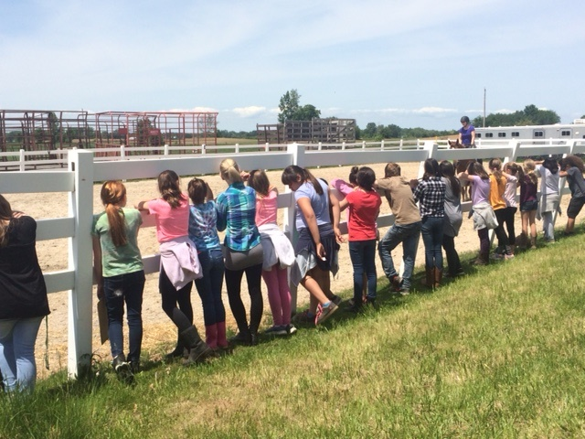 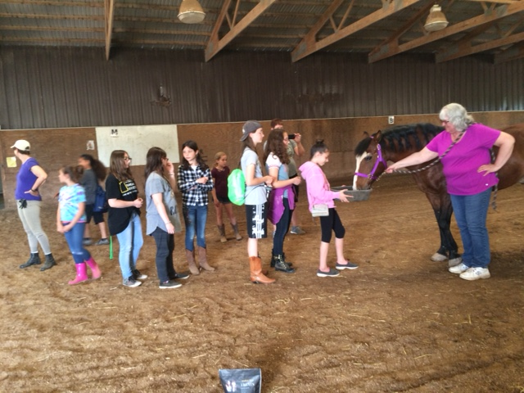

please call Gail at 920-536-0447

(Start date September 17th, October 1st, 15, 29th, November 12, 26th,December 10th and Drill Team performance December 14th)