***HAZARDOUS MATERIAL***

**Business Collection & Drop-Off Services**

Every day we help business keep hazardous materials out of the landfill by encouraging safe and smart disposal of hazardous materials. It’s easy to participate requiring only a few short steps prior to your first visit.

**Registration**

Business must complete a short registration/certification form. This form will certify the participant is a Very Small Quantity Generator (VSQG) and register the business with the North Central Iowa Regional Solid Waste Agency-HHM.

NCIRSWA Staff will review the completed form and contact the business to set up delivery of the hazardous materials.

**Shipping Papers**

Businesses must complete the shipping paper, including the name of the chemicals, if known, the quantity of the material and the number of containers. Additionally, this form must include an emergency contact person with a phone number, signatures of the business representative and the driver.

**Drop-Off Appointments**

VSQG participants must make an appointment for hazardous waste material to be dropped off at the collection center. Appointments can be made during regular business hours Tuesday through Fridays 8am-2pm.

**Billing**

Payments may be made at the time of delivery, or an invoice can be mailed once the inventory is completed. Payments in the form of cash, credit card, or business check will be accepted.

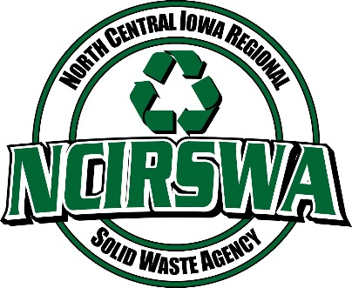 **Phone: 515-576-5866**

**Fax: 515-576-5870**

**Certification Form (By law, this form must be kept on file)**

I certify that I am a generator of hazardous waste within the State of Iowa and that because of the small volume of hazardous waste generated and/or stored, I qualify for very small quantity generator status.

I understand that to qualify for very small generator status, I must meet both of the following conditions (as defined by 40 CFR Section 261.5):

1. Generate less than 1kg/month (2.2 pounds) of acute hazardous waste, and never store more than this amount on site at any time; and
2. Generate less than 100kg/month (220 pounds) of all other hazardous waste, and never store more than 1,000kg (2,200 pounds) on the site at any time.

I further understand that if, in the future, I exceed the quantity limitations described above, I will become subject to additional regulation as a hazardous waste generator and will no longer be eligible to participate in this type of collection program.

I certify that I have the right to make these statements on behalf of my farm or business.

Print Name: ________________________________________________________

Signature: _____________________________________________ Date: ___________________

* I understand that typing my name above constitutes an electronic signature and acknowledge I am the person named.

Business Information

Business Name: ________________________________________________________________

Type of Business: _______________________________________________________________

Address: ______________________________________________________________________

City: ___________________ State: ___________ Zip Code: _______________________

Contact Name: ___________________________ Title: ___________________________

Work Phone: _________________________ Fax: ______________________________

Email: ________________________________________________________________________

**Send Completed Form ___________________________________________________________**

Email: [jmoffitt@ncirswa.org](mailto:jmoffitt@ncirswa.org) Mail: NCIRSWA

Phone: 515-576-5866 c/o HHM

Fax: 515-576-5870 2150 S 22nd St.

Fort Dodge, IA 50501

FOR STAFF USE ONLY

* VSQG documentation was listed on RCRA Information Search Results (copy is placed with documentation).
* No information is listed on RCRA Information Search Results for this location.