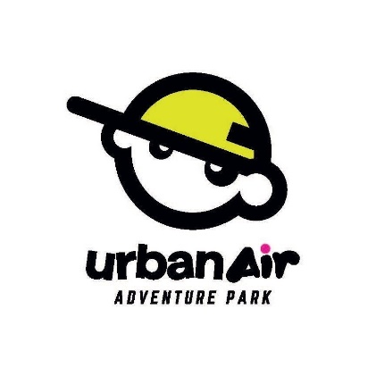
New Hire Checklist
This is for your records - Please make sure to complete all tasks

Completed before Day 1:
- Finished Paycor Onboarding paperwork
- Complete Urban Air University “Team Member” modules; Obtain:
  - “Team Member Certificate”
  - “Court Monitor Certificate”
  - “Harnessing Certificate”
Complete before start of Day 2:
- Employee Waiver signed
- Emergency Contact filled out
Complete before end of Day 2:
- Download Paycor App
- Download Optim8 Employee Portal App
- Set availability in Optim8
- Obtain uniform (Shirt, socks, whistle, name tag)
- Know how/where to clock-in
- Know where to put your cellphone during your shift
- Know where to store personal belongings during your shift
Complete before end of Day 3:
- All quizzes related to your position
- Signed Training Acknowledgment

