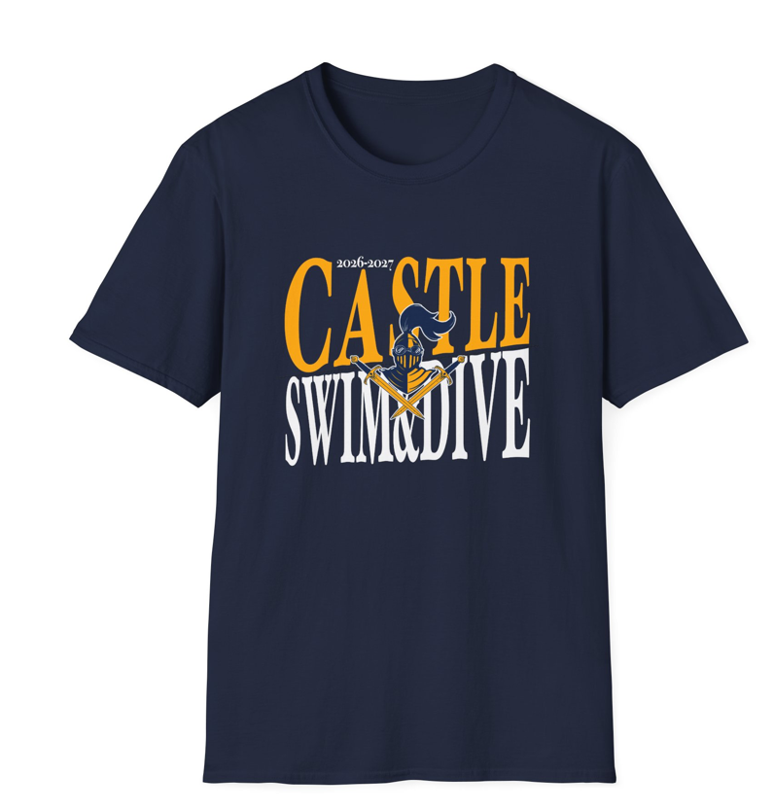
Castle Swim & Dive Fundraiser Shirts & Sweatshirts
- Navy shirt with gold & white design as reflected above
- Names can be added to back of Shirt
- Orders are due September 18th
- Use one line per shirt order
- New this year, is an option for a crew neck or hooded sweatshirt
- Write one check for total cash you receive or Venmo - Castle-Swim-Dive
- Checks payable to Castle Swim & Dive Booster Club
- Drop off your order form and money in an envelope (with athlete name on it) into the Castle Swim & Dive Box (located on left wall outside the pool entrance doors)
- The athlete selling the most t-shirts will receive $25
- Additional forms can be printed from our website: www.castleswimdive.org
- Questions can be sent via Remind, emailed to castlswimdive@gmail.com, or directly contact, Sarah Hurst

