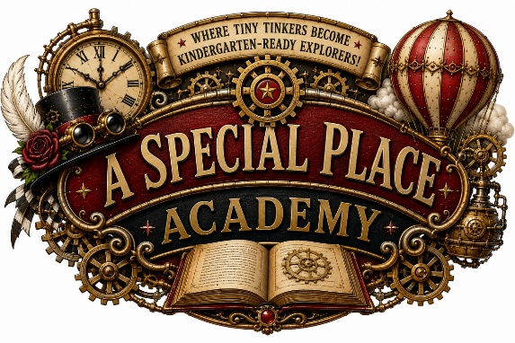 | PARENT QUESTIONS  & ANSWERS  A Special Place Academy Featuring Tinker Tock  Enrollment • Daily Program • Safety • Family Communication
Welcome to A Special Place Academy, where young learners explore, create, investigate, and grow through age-appropriate learning adventures inspired by the whimsical world of Tinker Tock.
ENROLLMENT & TUITION

What ages does the program serve?
A Special Place Academy serves children ages 2-6. Classroom placement is based on each child’s age, developmental needs, program readiness, and available space.
What are the program hours and tuition rates?
Families may select one of the following monthly enrollment schedules. Tuition must remain current for a child to continue attending the program.
• 8:00 a.m.-4:00 p.m.: $700 per month
• 7:00 a.m.-6:30 p.m.: $900 per month

Is there an enrollment fee?
Yes. A $150 entry enrollment fee is due when a child first enrolls. After the initial enrollment, a $75 annual enrollment fee is due each August. Enrollment fees are separate from monthly tuition.
What documents are required for enrollment?
The enrollment packet may include child and family information, emergency contacts, authorized pickup information, medical and immunization records, allergy and nutrition information, toileting information, parent permissions, media-release selections, and tuition and attendance agreements. Enrollment is not complete until all required forms, records, fees, and payments have been received and approved.
How does the enrollment process work?
Parents begin by contacting the academy to discuss availability and schedule a tour or enrollment meeting. Once space is confirmed, the family completes the enrollment packet, submits all required documents and payments, and receives an approved start date.
Can parents tour the program before enrolling?
Yes. Prospective families are encouraged to schedule a tour to see the learning environment, ask questions, and determine whether the program is a good fit for their child.
LEARNING & DAILY PROGRAM

What type of curriculum do you provide?
Our program combines early childhood education with hands-on STEAM learning in science, technology, engineering, art, and mathematics. Children also participate in literacy, creative play, movement, music, social-emotional development, and age-appropriate school-readiness activities.
What makes the Tinker Tock program different?
Tinker Tock transforms learning into an imaginative adventure. Children become young “tinkers” who ask questions, solve problems, build, create, and discover through engaging classroom themes and projects.
Is the program licensed?
Yes. A Special Place Academy is licensed and regulated through the Illinois Department of Children and Family Services. We follow applicable requirements for supervision, staffing, health, safety, child records, and program operations.
Is there a dress code?
Yes. Children must wear any combination of black and white clothing, including socks and shoes. The dress code is strictly enforced. Families should also provide weather-appropriate outerwear when needed.
Are meals and snacks provided?
Yes. Meals and snacks are provided according to the program’s daily schedule and menu. Families must inform the academy of all food allergies, dietary restrictions, and medical concerns before their child begins attending.
May my child bring additional snacks?
Additional snacks are permitted only when they are provided for every student in the child’s classroom. Shared snacks must be store-bought, unopened, and in their original prepackaged containers. Parents should contact the academy before bringing shared snacks, particularly when classroom allergies or dietary restrictions may apply.
What does my Pre-K child need for naptime?
A small blanket will be available for each Pre-K child during naptime. Families do not need to send an additional blanket unless specifically requested by the academy.
Does my child have to be toilet trained?
Toileting readiness is discussed individually with each family. Parents should provide accurate information about their child’s current toileting routine so staff can offer consistent and developmentally appropriate support.
What should my child bring?
Families may be asked to provide the following items. All belongings must be clearly labeled with the child’s first and last name.
• A complete change of clothing that follows the black-and-white dress code
• Diapers, wipes, or training supplies when applicable
• Weather-appropriate outerwear
• Required medication or health supplies
• Any additional items requested for the child’s classroom

SAFETY, ARRIVAL & DISMISSAL

When are the entrance and exit doors locked?
For the safety of the children and staff, exterior entrance doors remain locked between 8:30 a.m. and 3:30 p.m. Families who need access during these hours should send a Brightwheel message before arriving. This courtesy allows staff to assist with entry while minimizing disruptions to classroom instruction, activities, meals, and rest periods.
What happens if my child is absent or sick?
Parents should notify the academy as soon as possible when their child will be absent. Children who are ill must remain home according to the academy’s health and exclusion policies. If a child becomes ill while attending, a parent or authorized guardian will be contacted and must arrange prompt pickup.
Who may pick up my child?
Children will be released only to individuals listed and authorized by the parent or legal guardian. Photo identification may be required. Parents must notify the academy of any changes to the authorized pickup list.

FAMILY COMMUNICATION

How are parents kept informed?
Brightwheel is the academy’s primary parent communication platform. Parents are responsible for regularly reviewing messages, announcements, reminders, and account information. General announcements may also be posted on the academy’s Facebook page. Weather-related school closings will be communicated through Brightwheel, Facebook, and FOX 2 school-closing announcements. Families are responsible for monitoring these platforms during severe weather.
How can I begin the enrollment process?
Contact Tanya Ferguson, Director/Teacher, by email at aspecialplace@asp2steam.com. Enrollment is subject to classroom availability, completion and approval of all required records, payment of applicable enrollment fees and tuition, and confirmation of the child’s start date.
READY TO BEGIN?
Tanya Ferguson, Director/Teacher
aspecialplace@asp2steam.com

