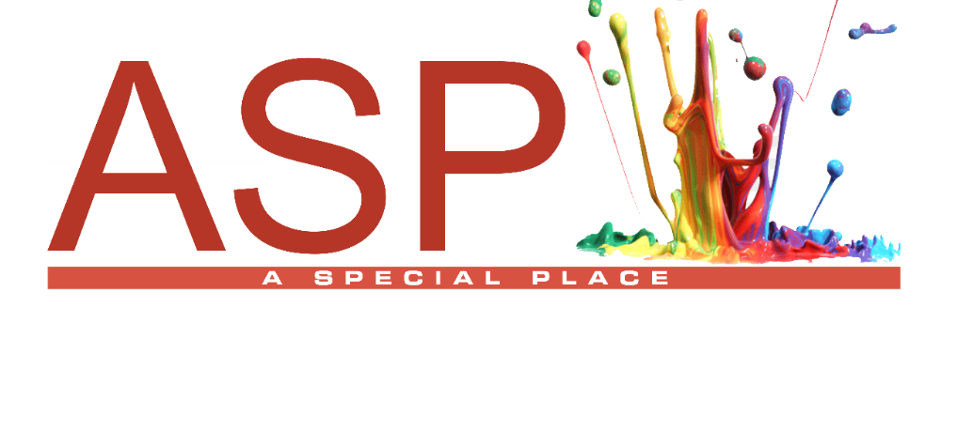
Parent Handbook

A Special Place Academy LLC

424 Lebanon Avenue
(Upper-Level)
Belleville, IL 62220
(618) 416-5442
asp2steam.com



Statement of Purpose & Policies
A Special Place Academy LLC
424 Lebanon Avenue
Belleville, IL 62226
(618) 416-5442

Welcome to A Special Place Pre-K Academy LLC. I, Mrs. Tanya Ferguson, am the owner/director of A Special Place Academy LLC. I am legally responsible for the program and have immediate responsibility for the daily conduct of the program outlined in the Licensing Standards for Centers Part 407.
In my absence, a qualified staff member will be designated as alternate director to fulfill the duties of director. This will include making decisions in accordance with maintaining the licensing standards. Section 407.130
We are excited to be a part of your child’s new journey. “A Special Place Pre-K Academy” is recommended as a foundation of learning for attending ASP2 STEAM Academy.
1. Program Philosophy
With the help of Tinker Tock, A Special Place Academy provides a structured, developmentally appropriate environment that supports the whole child through consistent routines, active supervision, and positive guidance. Classrooms are designed to promote social-emotional growth, independence, and academic readiness while maintaining compliance with all applicable state licensing standards.
Our approach blends imaginative, themed learning with clear expectations to ensure children are engaged, supported, and safe always.
Motto:
Tinker • Try • Think • Triumph

Please take a moment to review the material outlined in this handbook. Thank You!
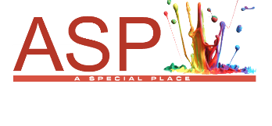
Our Mission
At A Special Place Academy LLC, our mission is to ignite curiosity and foster lifelong learning by introducing early educational principles through the innovative and vibrant guidance of “Tinker Tock”—a creative, imaginative mentor who inspires wonder and exploration in every child. Tinker Tock engages tinkers through hands-on discovery, inventive problem-solving, and playful inquiry, nurturing their innate sense of adventure and encouraging intellectual growth. We are committed to building a strong academic foundation, setting extraordinary expectations, and cultivating self-esteem through genuine, supportive relationships between students and staff in a secure and structured environment. By integrating early exposure to Science, Technology, Engineering, Arts, and Mathematics, alongside active collaboration with parents, teachers, and community members, we empower each tinker to realize limitless academic potential and to confidently embark on a journey of discovery in their own special place.

Creative Director
Tanya Ferguson

The Art of Black and White
  - A Kid-Friendly Poem About Balance and Calm

Black & white dance side by side,
Bring balance, calm & peace inside.
White is bright, like a sunny day,
Black is cozy, in its gentle way.

Patterns of stripes & spots so neat,
Help some kids focus & take a seat.

No wild colors, no busy sight—
Just calm & clear in black & white.

Together they make a perfect pair,
Creating harmony everywhere!
By Tinker Tock

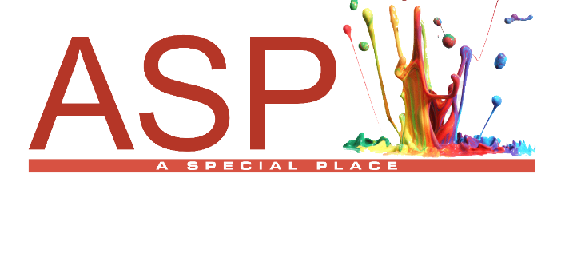
Daily agendas are subject to adjustments to meet the needs of our tinkers.
Daily Agenda
- 7:00 Arrival – (Rear Entrance) Sign-In Kiosk
[Designated Areas for Breakfast 7am-7:30am]
- 7:50 Clean-Up
- 8:00 Curriculum Academic Learning
- 9:00 STEAM Power Snack & Restroom Break
- 11:00 Lunch-Clean Up-Recess Activity
- 1:00 Naptime
- 2:00 STEAM Snack & Recess Activity
- 3:00 1st Departures
- 4:00 Scheduled After-School Activities
- 4: 30 STEAM Power Snack
- 6:30 2nd Departures
Late Fee Charge:
Parents must notify the Academy by 6:00pm if they are going to be late.
A $5.00 per ½ hour will be assessed to your account after 7:00pm. Transportation is not provided by A Special Place Academy LLC

Description of Daily Program

Program Overview
A Special Place Academy LLC provides quality education for families in Belleville and nearby areas. Operating hours are Monday to Friday, 7:00am–6:30pm, except on days listed in the “Program Operating Dates and Closures” schedule. This schedule details all closures and holiday breaks. Operating dates and closure information are available in your Welcome Packet, from your tinker’s teacher, on the information board, and online at asp2steam.com.

Curriculum and Academic Expectations
A Special Place Academy is committed to providing a challenging curriculum for its tinkers. The curriculum is progressive, designed to gradually advance tinkers to higher levels of phonographic awareness and penmanship. To ensure a comprehensive learning experience, tinkers are expected to follow the daily lesson plan, complete all assigned work, and actively participate in academy activities. Classroom Organization

Classroom Structure
Children are grouped according to their age and developmental readiness. Each classroom is structured with clearly defined expectations, daily routines, and curriculum goals that are aligned with recognized developmental standards.
Tiny Tinkers ages 2-3. {1.5 Ratio}
Purpose:
To provide a safe, nurturing introduction to group care, focusing on routine, communication, and early social development.
Developmental Goals:
- Build trust and secure attachments
- Encourage early language development
- Introduce structured routines
- Promote safe exploration
Staff Responsibilities:
- Maintain constant sight and sound supervision
- Follow consistent daily schedules
- Use simple language and modeling
- Support (not force) toilet learning readiness
- Sanitize materials and surfaces regularly
- Document daily care and incidents
Imagination Tinkers ages 3-5. {1.10 Ratio} Behavior Support with STEAM
Purpose:
To support children needing additional structure in developing emotional regulation and appropriate behaviors through consistent routines and creative expression. Incorporate learning through art methods such as directed drawings and coloring activities, which encourage self-expression, fine motor development, and help reinforce behavioral expectations in a creative, engaging way.
Developmental Goals:
- Emotional regulation
- Positive peer interaction
- Expressive communication
- Behavioral self-management
Staff Responsibilities:
- Implement positive guidance strategies only
- Use redirection and modeling (no punitive discipline)
- Provide structured transitions and expectations
- Maintain behavior and incident documentation
- Ensure environment supports calm and safety
Innovation Tinkers ages 5-6. {1.6 Ratio}
Purpose:
To provide a structured academic environment that builds foundational skills in reading, writing, math, and responsibility.

Developmental Goals:
- Academic readiness
- Task completion
- Responsibility
- Social communication
Staff Responsibilities:
- Maintain weekly lesson plans available for review
- Ensure consistent daily schedule implementation
- Provide individual support as needed
- Track academic and behavioral progress
- Maintain organized and structured classroom environment
Elite Tinkers ages 5-6. {1.6 Ratio}
Purpose:
To extend learning for advanced students through enriched curriculum and critical thinking opportunities.
Developmental Goals:
- Higher-level thinking
- Problem-solving
- Leadership and collaboration
- Advanced academic skills
Staff Responsibilities:
- Differentiate instruction appropriately
- Provide enrichment without exceeding developmental limits
- Encourage independence and leadership
- Document progress and mastery
- Maintain balanced daily schedule

Arrival and Departure
We make every reasonable effort to accommodate all children; however, transportation is not provided for our tinkers. Arrival time is set at 7:00 AM.
Parents are required to complete a DCFS-mandated sign-in procedure when checking tinkers in and out each day. These records are maintained on file by the academy. Parents may visit the academy at any time during regular operating hours without an appointment. For security, the doors are locked from 8:00 AM to 3:00 PM.
If a parent anticipates being late for pick-up, the Academy must be notified by 6:00 PM. Tinkers may only be released to a parent or a responsible person designated by the parent on the Child Pick Up List.
At 6:30 PM, the Academy will begin making three attempts to contact a parent, guardian, or emergency contact, with each attempt spaced five minutes apart. After 7:00 PM, late fees will be assessed. If no contact has been established by 7:30 PM, the Academy will request assistance from local authorities, which may include contacting the Child Abuse Hotline.

Late Fee Charge
A late fee of $10.00 per half hour will be charged to your account for any pick-ups after 7:00 PM.

Admission Acceptance
Before a tinker is accepted into A Special Place Academy LLC, a pre-enrollment interview and a tour of the facility are required. Once the tinker is accepted, both the parent or guardian and the Director must sign and date the “Admission Acceptance” form. This document serves as an acknowledgment of the requirements set forth by the academy and can be found in your Enrollment Packet.
Parents are responsible for reviewing all program information provided and for completing every document included in the enrollment packet. Required documents include a certified copy of the child’s birth certificate, an up-to-date medical immunization record, emergency contact numbers, and a list of persons authorized to pick up the child. It is essential that parents read and comply with all requirements outlined in the Enrollment Packet. This process includes signing acknowledgments, submitting all necessary paperwork, and paying any enrollment or registration fees prior to the tinker’s first day.
Once enrollment is finalized, a Brightwheel account is established for each family to facilitate invoicing and communication with the Academy. This platform is used for academy notifications, classroom updates, and communication regarding individual parent questions or concerns. Parents must ensure that they maintain access to this platform throughout their child’s enrollment in the Academy.
Tuition
Tuition is your responsibility. For co-parenting families, payments can come from multiple sources, but only one person will be the main contact for tuition communication. In addition to a $150 New Enrollment Fee or $75 Annual Fee for returning students, monthly tuition is due as follows:
- Full-Time Tuition: $900 per month, with available discounts. Pay annually or three months in advance for a 10% discount.
- Part-Time Tuition: Must be approved; rates are adjusted and reflected in Brightwheel.
All accounts must be current for students to participate in school activities. Subsidiary assistance through Brightpoint is accepted; parents must apply online and show approval, then select an option on the Financial Service Agreement page of the Enrollment Packet.
Tuition is due on the 15th each month. Late payments incur a $5 daily fee starting on the 16th, up to $50. Legal action may be taken for unpaid tuition, with legal costs charged to the party responsible.
Thank you for your support!

Classroom Expectations (All Rooms)
Staff must ensure expectations are:
- Clearly taught
- Consistently reinforced
- Developmentally appropriate
Core Expectations:
- Safe bodies and gentle hands
- Respectful communication
- Participation in daily routines
- Proper use of materials
- Clean-up after activities

4. Active Supervision Policy
All staff are required to:
- Maintain constant sight and sound supervision
- Position themselves strategically in the classroom
- Count children frequently during transitions
- Never leave children unattended

Discipline and Redirection

Children require clearly defined rules and boundaries; however, effective discipline goes beyond strict enforcement. It is rooted in mutual respect and sets high expectations for responsible conduct. The most effective way to guide tinker behavior is through ongoing cooperation and communication between parents and the academy. “A Special Place Redirection Policy” must be followed by all staff members. The academy prohibits the use of corporal punishment as a disciplinary tool. If a tinker engages in any of the behaviors listed below, a parent conference may be scheduled depending on the severity of the incident, as determined by the Director. The following actions are subject to review and intervention:
- Creating an unsafe environment for other tinkers
- Vandalizing academy or personal property
- Using profanity
- Speaking or acting in a lascivious manner
- Hitting, biting, or fighting with malicious intent to inflict injury

A Special Place Redirection Policy

Permitted Strategies:
- Redirection
- Modeling appropriate behavior
- Offering choices
- Teaching problem-solving
- Providing calm-down/reset areas

Prohibited Practices:
- Corporal punishment
- Verbal humiliation or threats
- Withholding food, rest, or bathroom access
- Suspension or expulsion (unless compliant with state regulations)
The policy will allow your child to be given 5 chances each day.
- The first time, redirected for unacceptable behavior and given a verbal warning.
- The second time, placed at the appropriate age "Time Out,"
- The third time, parents will be notified of the behavior via Brightwheel message.
- The fourth time, the director will be notified of your child’s behavior.
- The fifth time, at the director’s discretion, a parent conference is scheduled to discuss the behavior and the solutions for correcting the behavior in question.

Daily Schedule Requirements
Each classroom must:
- Post a daily schedule visible to parents and licensing
- Include:
  - Free play
  - Teacher-led activities
  - Meals/snacks
  - Rest time (as applicable)
  - Outdoor/gross motor time
- Maintain a balance of active and quiet activities

Curriculum and Lesson Planning
Staff must:
- Prepare weekly lesson plans
- Align activities with developmental goals
- Ensure materials are age-appropriate
- Adapt plans based on children’s needs
Lesson plans must be:
- Accessible for review
- Reflective of current classroom activities
Health, Safety, and Sanitation
Staff are responsible for:
- Regular handwashing (staff and children)
- Sanitizing toys and surfaces daily
- Monitoring for illness and reporting concerns
- Maintaining safe, hazard-free environments
Documentation and Communication
Staff must:
- Document incidents and injuries
- Track developmental progress
- Communicate with parents regularly
Consistency Across Classrooms
To ensure smooth transitions and behavior expectations across the center, staff should use consistent language:
- “Tinker Tock Tool Check” = Clean up
- “Piston Formation” = Line up
- “Reset Your Gears” = Calm down
- “Gears Turning” = Begin thinking

Compliance Expectation
All staff are required to:
- Always follow all licensing regulations
- Be prepared for unannounced inspections
- Maintain classrooms in compliance daily (not just during visits)
- Seek clarification from administration when unsure

Failure to follow these policies may result in corrective action, as compliance is essential to maintaining licensing and ensuring the safety and well-being of all children.

Inclement Weather
In the event of inclement weather or emergency situations that require school closures, delayed openings, or early dismissals, the academy will generally follow the Belleville District 118 Notification system. This system offers guidance regarding closures and schedule changes. However, please note that the Director retains the authority to make the final decision regarding whether the academy will close, open late, or dismiss early.
Once a decision has been made, families and staff will be notified through multiple communication channels to ensure everyone receives timely information. Official notifications of changes due to weather or emergencies will be provided via:
- Fox 2 News
- The academy website at www.asp2steam.com
- A Special Place Facebook page
- Brightwheel Notification
Behavior Support

Behavior Support and Program Transition Plan
- A Special Place Pre-K Academy LLC utilizes the “Behavior Support and Program Transition Plan” template provided by ISBE – Early Childhood Block Grant (ECBG). This plan is designed to support children’s behavior and facilitate transitions within the program.
https://www.isbe.net/Documents/Behavior-Support-Transition-Plan-Instruction-Manual.pdf
Insurance Coverage
A Special Place Pre-K Academy LLC does not offer medical insurance for enrolled children; families must arrange their own coverage. The academy maintains all public liability insurance required by DCFS licensing, meeting state and local childcare regulations.
Personal Belongings
Guidelines regarding personal belongings brought to the center are determined by the teacher and adjusted for each grade level to ensure appropriateness and convenience. Every tinker is required to keep a spare uniform change at the center to address any needs during the school day. For added convenience, parents may utilize the ASP Store located on site to obtain uniform items as necessary. Additionally, the academy prohibits non-school personal items such as tablets, cell phones, and similar devices to maintain a focused and distraction-free learning environment.
Personal Information

Confidentiality and Retention of Personal Information
All information related to the admission, progress, health, or discharge of each tinker is treated as confidential and is restricted to academy staff designated by the director. Disclosure or sharing of this information is permitted only when the child’s parent or guardian provides written consent. The academy follows strict policies outlined in the “Retention Policy” to safeguard personal information about both the child and their family, always ensuring privacy and confidentiality.

Retention Policy Overview
The purpose of the Retention Policy is to ensure that all records and documents of the Academy are properly protected, maintained, and disposed of when no longer needed or of no value. This policy is designed to guarantee the security and accessibility of important records, while allowing for the timely and appropriate destruction of outdated or unnecessary information.

Types of Records and Their Management
The Academy must retain certain records because they contain information that serves as the Academy’s corporate memory and has enduring business value, or must be preserved to comply with legal, accounting, or other regulatory obligations. Inappropriate destruction of any records, files, documents, samples, or other forms of information is strictly prohibited.

Definition and Disposal of Information
A record is defined as any information created, received, or transmitted in the course of the Academy’s business, regardless of the format. Disposable information refers to data that may be discarded or deleted once it has fulfilled its temporary purpose, provided it does not meet the definition of a record according to this policy.

Confidential Information from External Sources
Any confidential information received from outside sources must not be disclosed to or used by the Academy. If unsolicited confidential information is submitted, it should be refused, returned to the sender when possible, or deleted if received electronically.

Compliance and Storage
The Academy is committed to complying with all applicable laws, rules, and regulations, as well as recognized compliance practices. Records are stored in a secure, safe, and accessible manner. Essential documents and financial files required for business operations during emergencies are duplicated or backed up to ensure continuity.

Destruction of Records
The Director of School Affairs is responsible for the ongoing process of destroying confidential, financial, and personnel-related records, which must be carried out by shredding. Non-confidential records may be disposed of through recycling.

Contact for Policy Questions
If you have questions regarding the Retention Policy, please contact Tanya Ferguson, Director of School Affairs, at (618) 416-5442 or email aspecialplace@asp2steam.com, who is responsible for administering, enforcing, and updating this policy.

Emergency Medical Care

Parents or guardians will be promptly informed and asked to pick up their tinker if the child is exhibiting symptoms of illness. To maintain the health and safety of all staff and tinkers, any child who is sent home due to medical concern must present a physician's statement before returning to the Academy.

Conditions Requiring Exclusion from the Academy
- Illness that prevents the child from participating comfortably in program activities
- Illness that requires more care than staff can provide without compromising the health and safety of other children
- Fever accompanied by behavioral changes or symptoms of illness
- Unusual lethargy, irritability, persistent crying, difficulty breathing, or other signs of possible severe illness
- Diarrhea or vomiting with risk of dehydration
- Mouth sores when the child cannot control saliva
- Rash with fever or behavioral changes
- Purulent conjunctivitis (pinkeye), until 24 hours after treatment has begun
- Strep throat (streptococcal pharyngitis), until 24 hours after starting treatment and until the child has been fever-free for 24 hours
- Head lice, until the morning following the first treatment
- Scabies, until the morning after the first treatment
- Chicken pox (varicella), until at least six days after the rash appears
- Whooping cough (pertussis), until five days of antibiotic treatment have been completed

Medical Emergencies and Parental Notification
Parents are required to complete the Medical Instruction Form included in the Enrollment Packet. This form details the procedures to follow in case of a medical emergency. Parents will be notified immediately if there is an emergency involving their tinker. If parents cannot be reached, the signed form authorizes the Academy to provide immediate medical care as needed.

Accident Notifications
All accident notifications will be communicated to parents using the Brightwheel platform.

Meals
Meals will be provided by the Academy in accordance with the requirements outlined in the Il Licensing Standards Section 407.330 Nutrition and Meal Service.
Menus will be planned monthly and made available for review on the Academy’s Communication Platforms. If substitutions are made for any food item, menus will be corrected to reflect meals as served. The monthly menu will also be posted in the kitchen, the classroom, and Parent Information Board.

Meal Schedule
Continental breakfast is served each morning from 7:00 AM to 7:30 AM. This meal provides a nutritious start to the day for all tinkers.
Morning snacks are provided at 9:00 AM, ensuring that tinkers have an opportunity to refuel mid-morning. Additionally, an after-school snack is served at 2:00 PM to support tinkers in the afternoon.
Lunch is served between 11:00 AM and 11:30 AM following a rotating café schedule. This allows tinkers to enjoy a balanced and varied meal in the middle of the day.
Food will be offered to children at intervals of two hours and no more than three hours apart, except when a child is asleep. This regular meal schedule ensures tinkers’ nutritional needs are met throughout the day.

Special Diets and Food Accommodations
The Academy supports special diets for medical, allergy, or religious reasons. Parents must supply all meals and snacks, follow provider or clergy instructions, and submit a written outline of their child's dietary requirements for the Academy’s records. Food intake logs are kept only if requested in writing by a doctor. As there’s no refrigerated storage, parents should send food in insulated containers. All items need clear labels with the child’s name, date, and food description. Food sharing is not allowed to prevent cross-contamination and safeguard children with dietary needs.

STEAM Summer Program
STEAM Summer Program Services are offered to Summer Tinkers, providing engaging opportunities for tinkers during the summer months. Enrollment in the Academy’s regular programs does not automatically include participation in the Summer Programs. Parents must specifically select the Summer Program option during the enrollment process to secure a spot for their child.
Tinkers who do not attend the Summer Program must submit updated information before the start of the upcoming school year. This required information may include an updated medical or physical record, any changes to contact details, and revisions to the child pick-up list. Failure to provide the necessary updated information may result in the loss of the tinker’s space in the program.

