V.O.W (Voice Out Woman) PROGRAMME
“YOUNG SAMARITAN” FOR ADOLESCENTS AND YOUNG PEOPLE

Summary of activities carried out during the course of the 2ndtrimester 2024
The activities were carried out in the three establishment’s where we started since the beginning of the 2023-2024schoolyear.

- The figures :

Name of school | Class | Participants |  |  | Quantity of material distributed
School of Awakening |  | Girls | Boys | Total | Notebooks | BI
School of Awakening | 1st year | 18 | 21 | 39 | 39 | 2
School of Awakening | 4th yearA | 12 | 9 | 21 | 21
School of Awakening | 4th yearB | 11 | 13 | 24 | 24
School of Awakening | 5th year A&B | 14 | 21 | 35
Ecole privée « Les p’tits supers » | 3rd, 4th & 5th year | 13 | 12 | 25 | 25 | 1
Ecole privée « Les p’tits supers » | 1st & 2ndyear | 14 | 10 | 24 | 24
Ecole « Les sages de l’Eternel » | 3rd, 4th & 5th year | 15 | 18 | 33 | 33 | 1
TOTAL |  | 97 | 104 | 201 | 166 | 4

- The chapters covered :
Name of school | Class | Chapters
School of Awakening | 5th class | (Revision of chapters1 to 3).  4 ‘Taking care of my body’;  6‘The influence of friends’  7‘Good decisions’  8‘My body is growing’
School of Awakening | 4th class | 1‘I am on my way’  2 ‘I am someone special’  3‘My entourage and me’
School of Awakening | 3rd year | As above
The Super Petits | 3rd, 4th & 5th year | 4 , 5, 6, 7, 8
The Super Petits | 1st and 2ndyear | 1, 2 and 3
‘The Wise Men of Eternity’ | 3rd, 4th &5th year | Chapters 1-5 :  Des chap. 1 à 5  ‘How to be a good friend’

- The Super Petits School
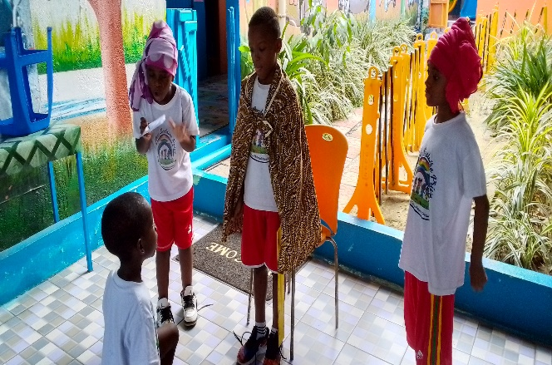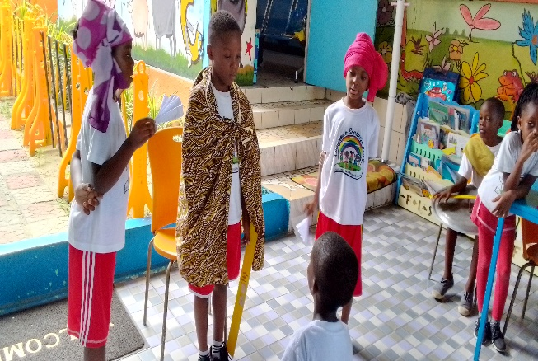
« David et Goliath sketch»David asks King Saul for permission to fight Goliath.

« With the Good Samaritan course, I learned to help my mother in the house, even when my favourite cartoon was on television. Before, I never worked in the house, but with the story of Naku I understood that it isn’t good to let one person do the jobs all alone, so I help my mother when I can. » Orchidée
« I don’t want to be shy in class because I am someone special » Diawara

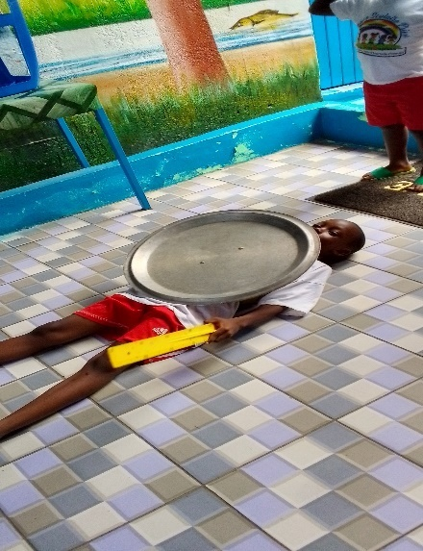

Goliath defeated by David
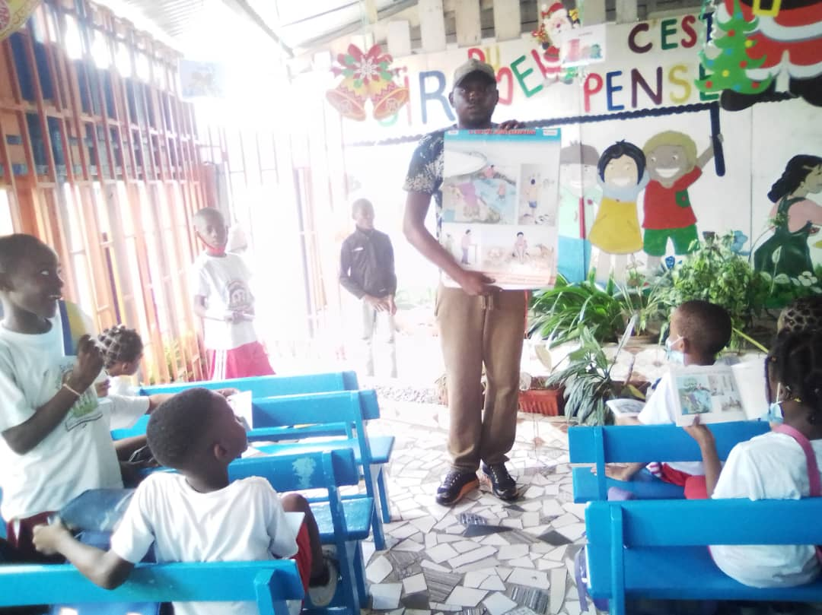
Pupils try to interpret volunteer Dylan’s images

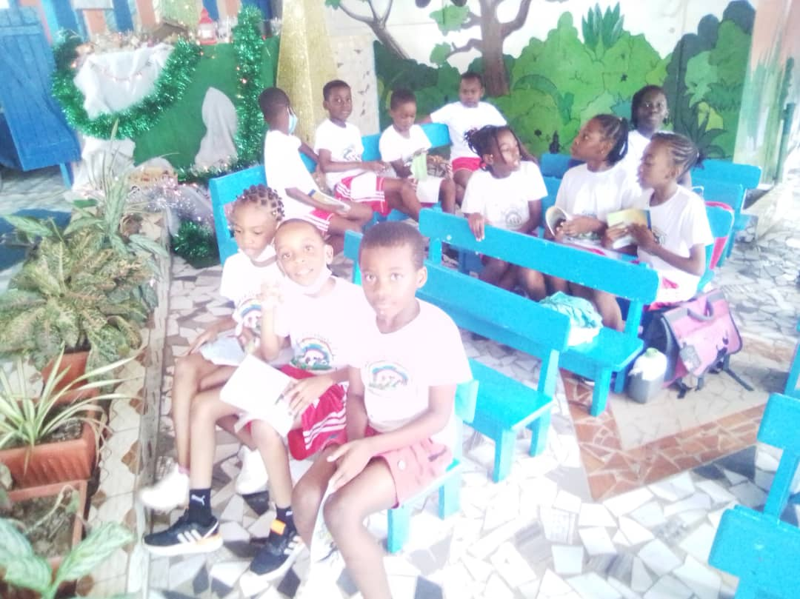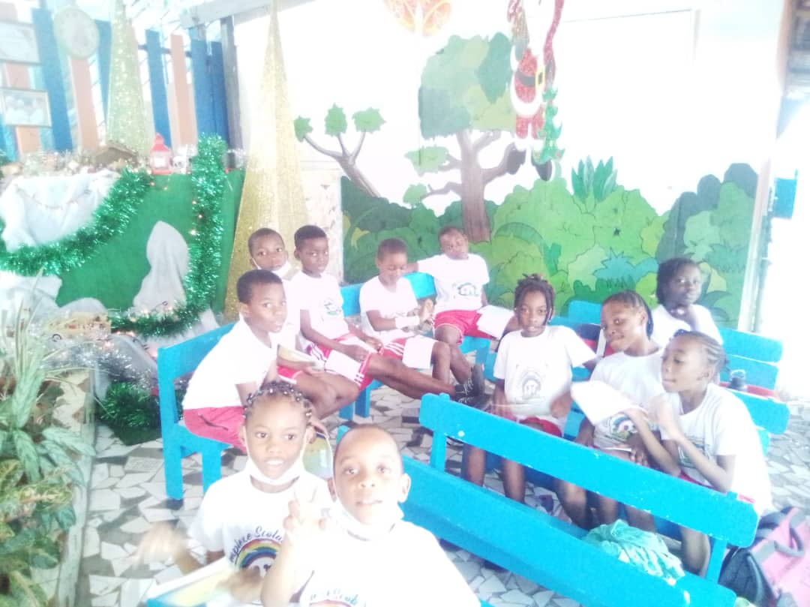
«Before the lesson ‘how to be a good friend’, I didn’t used to pay attention to the problems of others in the neighbourhood or at school. But now I am learning to be a good friend by talking a bit more with others; in fact by being a bit more interested in others. Thank you. » Dorcas
- School of Awakening l
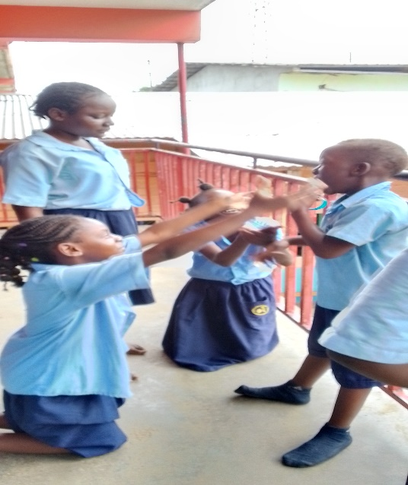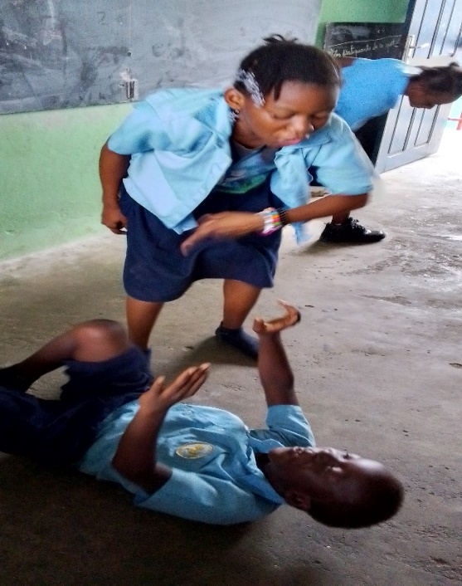
Group training on the story of Massiko. Massiko’s aunt beating him up (domestic violence).

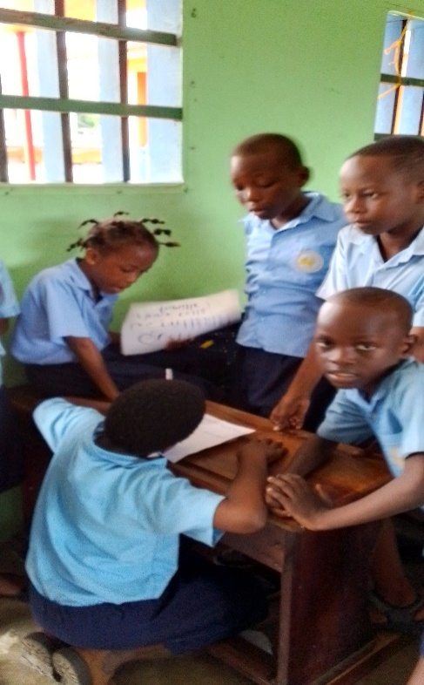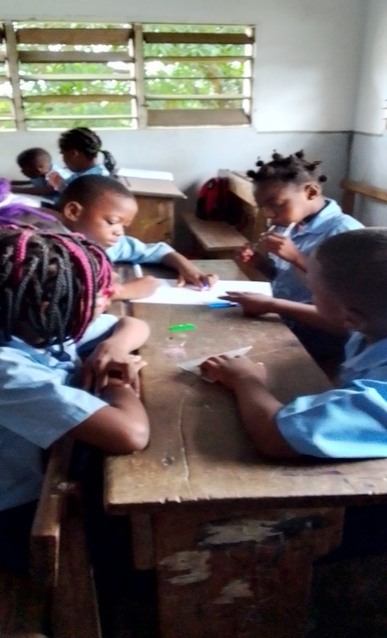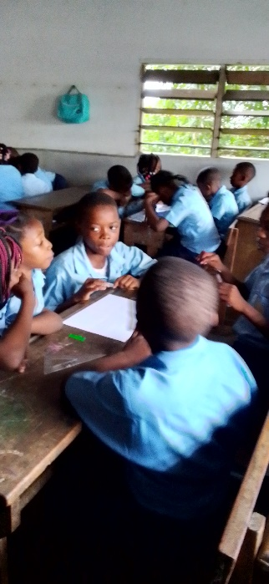
Pupils working in small groups.
« I like the Good Samaritan course a lot, because I learn new things about the way we should live in society; how important it is to get on well with others. The lesson on ‘I am someone special’ helped me understand that each one of us is important, so I avoid being violent with my friends» NSA EDZANG Emy
« The Good Samaritan course is interesting because we learn things about life and God. My favourite lesson is ‘I am someone special’ because I understood that no-one can replace me, not even in my family. Each person represents something special. Thank you very much ! I hope that this course will continue in the next school year because we learn things about social life. Thank you. »MEGNE Fallon Nathalie Flore
« With the Good Samaritan course we learn to love our neighbour and appreciate ourselves. I remember the chapter ‘I am someone special’ because no-one is more special than me, we are all the same in God’s eyes. Knowing this makes me happy because I used to think I was nothing at all.»MBOUITY Célia
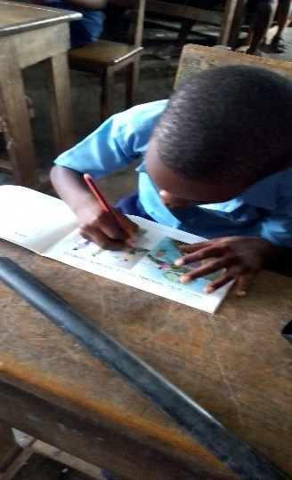
«I really like the Good Samaritan course because it helps to understand how to live. The lesson ‘I am someone special’ is one I cannot forget because I understood that even though I am small in size, I have value in the eyes of God and I am special. My mates used to bother me (about my size) but now I am not bothered anymore, because I am special! I would very much like for us to benefit more from the Good Samaritan course. »POULI MOUSSAVOU Holi
« The Good Samaritan course helps us to see life clearly; that is to say, to understand what is good for us and what is not. I learned a lot from the lesson ‘I am on the path’, that there are good and bad paths, and that I must be careful when choosing.»MBOUMBOU FOUMBI Darius
Pupils working with their notebooks.
Pupils listening attentively to the volunteer Jeanne
