**V.O.W (Voice Out Woman) PROGRAMME**

**“*YOUNG SAMARITAN*” FOR ADOLESCENTS AND YOUNG PEOPLE**

**Summary of activities implemented during the first quarter of 2024.**

The activities were carried out mainly in Libreville.

* 3 educational establishments, namely: ‘The school of revival’, ‘The wisdom of the Lord’, and ‘The Little Supers’. These three schools are private establishments we have been working with for several years. The school of ‘Revival’ was the very first, the pilot of the “Good Samaritan” Program for children, and we have been working with it for 5 years ; the two others have been our partners for three years. At the beginning of each school year, it is their leaders who want to ensure that the project team returns to run regular sessions throughout the year.
* Some figures :

|  |  |  |  |  |  |  |  |
| --- | --- | --- | --- | --- | --- | --- | --- |
| Name of school | Class | Participants | | | Amount of materialdistributed | | |
| **Revival School** |  | **GIRLS** | **BOYS** | **Total** | **Note books** | **BI** |  |
| 3rd year | 18 | 21 | **39** | 39 | 2 |  |
| 4th year (A) | 12 | 9 | **21** | 21 |  |  |
| 4th year (B) | 11 | 13 | **24** | 24 |  |  |
| 5th year(A & B) | 14 | 21 | **35** |  |  |  |
| **Little Supers School** | 3rd, 4th, 5th years | 13 | 12 | **25** | 25 | 1 |  |
| Ist& 2ndyears | 14 | 10 | **24** | 24 |  |  |
| **School of the wisdom of the Lord** | 3rd, 4th & 5th year | 15 | 18 | **33** | 33 | 1 |  |
| **TOTAL** |  | **97** | **104** | **201** | **166** | **4** |  |

* Volunteer Jeanne and children at the Revival School
* 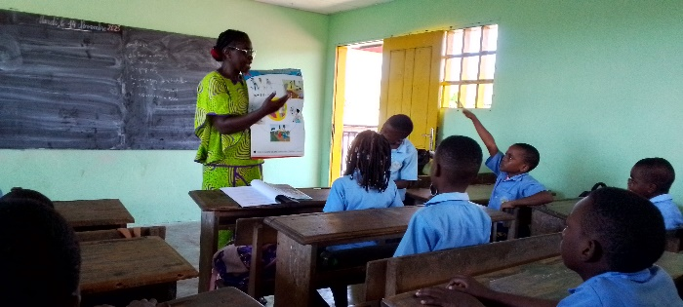

|  |
| --- |
| Volunteer Jeanne asking who can interpret the image on the lesson ‘My entourage and me’ |

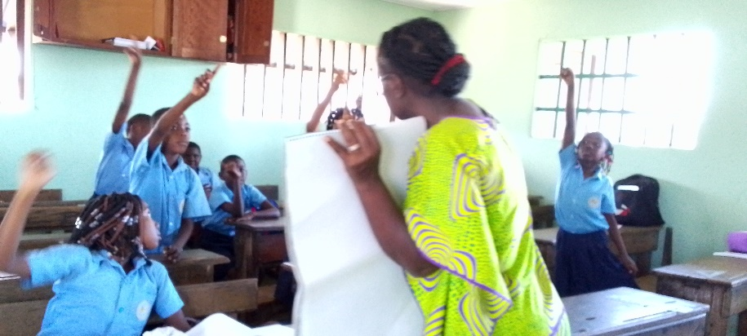

|  |
| --- |
| Several pupils motivated and excited to try to interpret the image. |

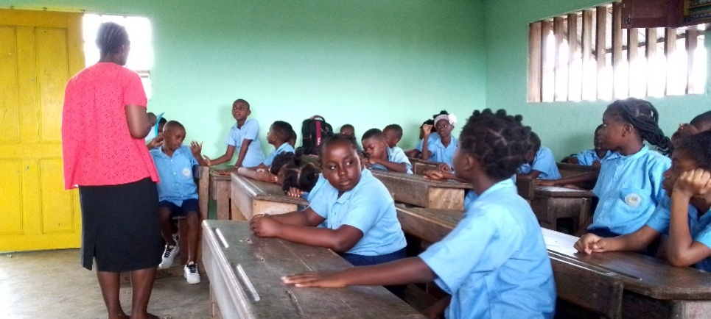

|  |
| --- |
| Jeanne asking the pupils to recall the previous lesson. |

Three chapters studied:

* My body is growing
* Peer pressure
* Sexuality and love

For the alumni of the program, the concepts are well understand; All that remains is to put them into practice in their lives, and we encourage them to do so by ensuring that the subject relates back to themselves and their environment.

As for the beginners, they are very happy with the program, above all with the content of the chapters.

Testimony :

Lucas witnessed a scene where a shopkeeper wanted to abuse a woman. Not knowing what to do, he didn’t react. But when we dealt with cases of sexual abuse, he understood that we must always alert people to help a victim of sexual abuse.

Jeanne : ‘For my part, I think that these children are well equipped and that it is up to them put into practice what they have learned.’

* The coordinator and her classes ‘The Little Supers’ and ‘Revival’.

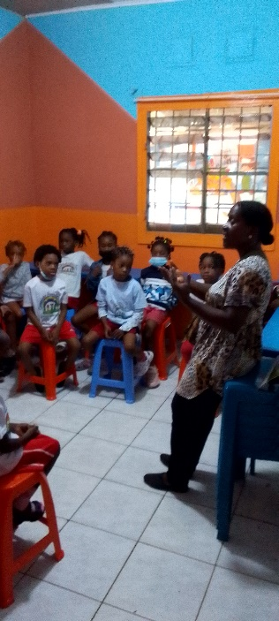

|  |
| --- |
| Armelle the coordinator gives some explanations at her class of ‘The Super Petits’. |

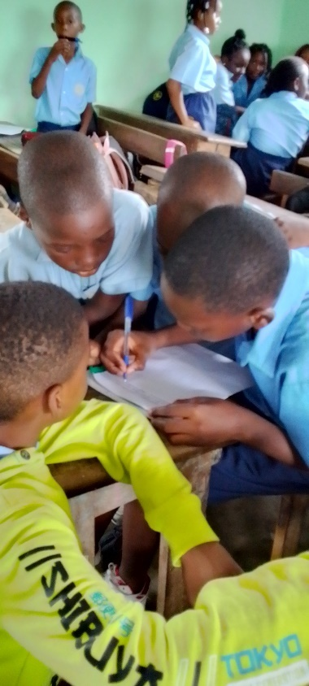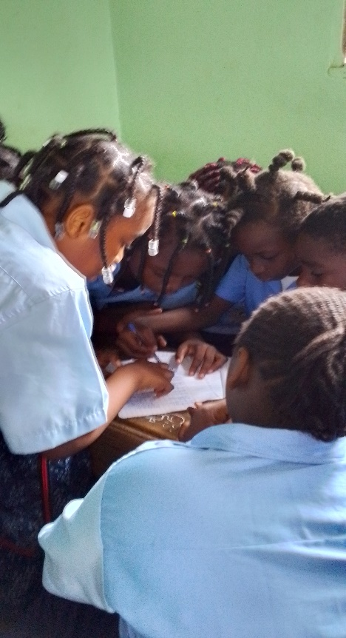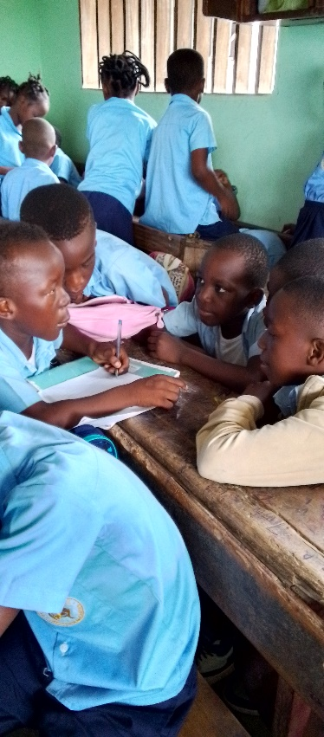

|  |
| --- |
| Very motivated pupils working in groups at the ‘School of Revival’. |

« The PJS is always very appreciated by the children because of the quality of the subjects which concern them. Two children in particular left an impression on us in both schools.

At the time of ‘Awakening’, young Andy from the 4th grade class was ashamed of his small stature because his classmates made fun of him. But when I told them of the story of David and Goliath, he understood that his size need not prevent him from achieving great things like little David who defeated the giant Goliath. Since this session, he has been proud of himself and actively participated in lessons.

The second story is that of Diwara from the second year class at the ‘The Super Petits’. Diwara never responded when questioned, and was even hesitant when playing a few small games. But when we approached Chapter 2 ‘I am someone special’, in particular with the exercise which consisted of saying what others can do well, the class mates who liked to make fun of Diwara realised that, beyond his shyness, he also had positive aspects. For example, he was one of the best students in reading and writing. The act of telling him this woke him up. Since then, Diwara answers questions and participates well in sessions. (Armelle)

* The volunteer Dylan and his class at the ‘The Super Petits’ school.

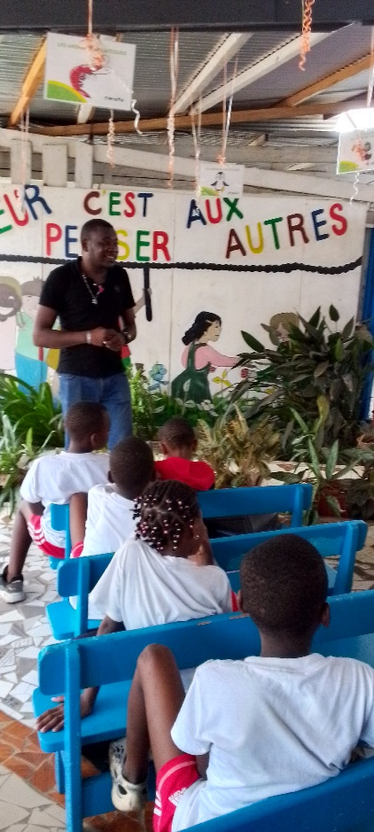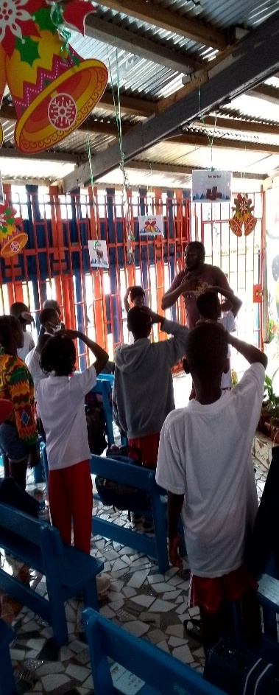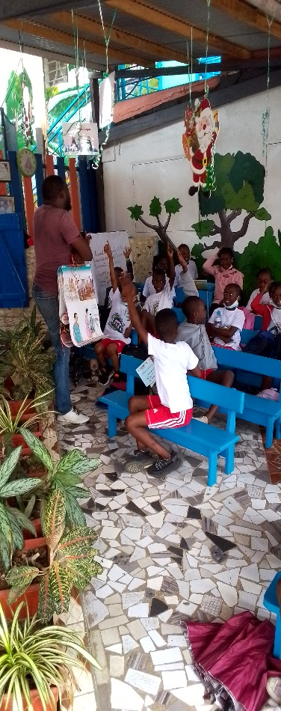

|  |
| --- |
| Dylan and his chidren participate in a summary of a discussion, an ice-breaker and a question and answer game. |