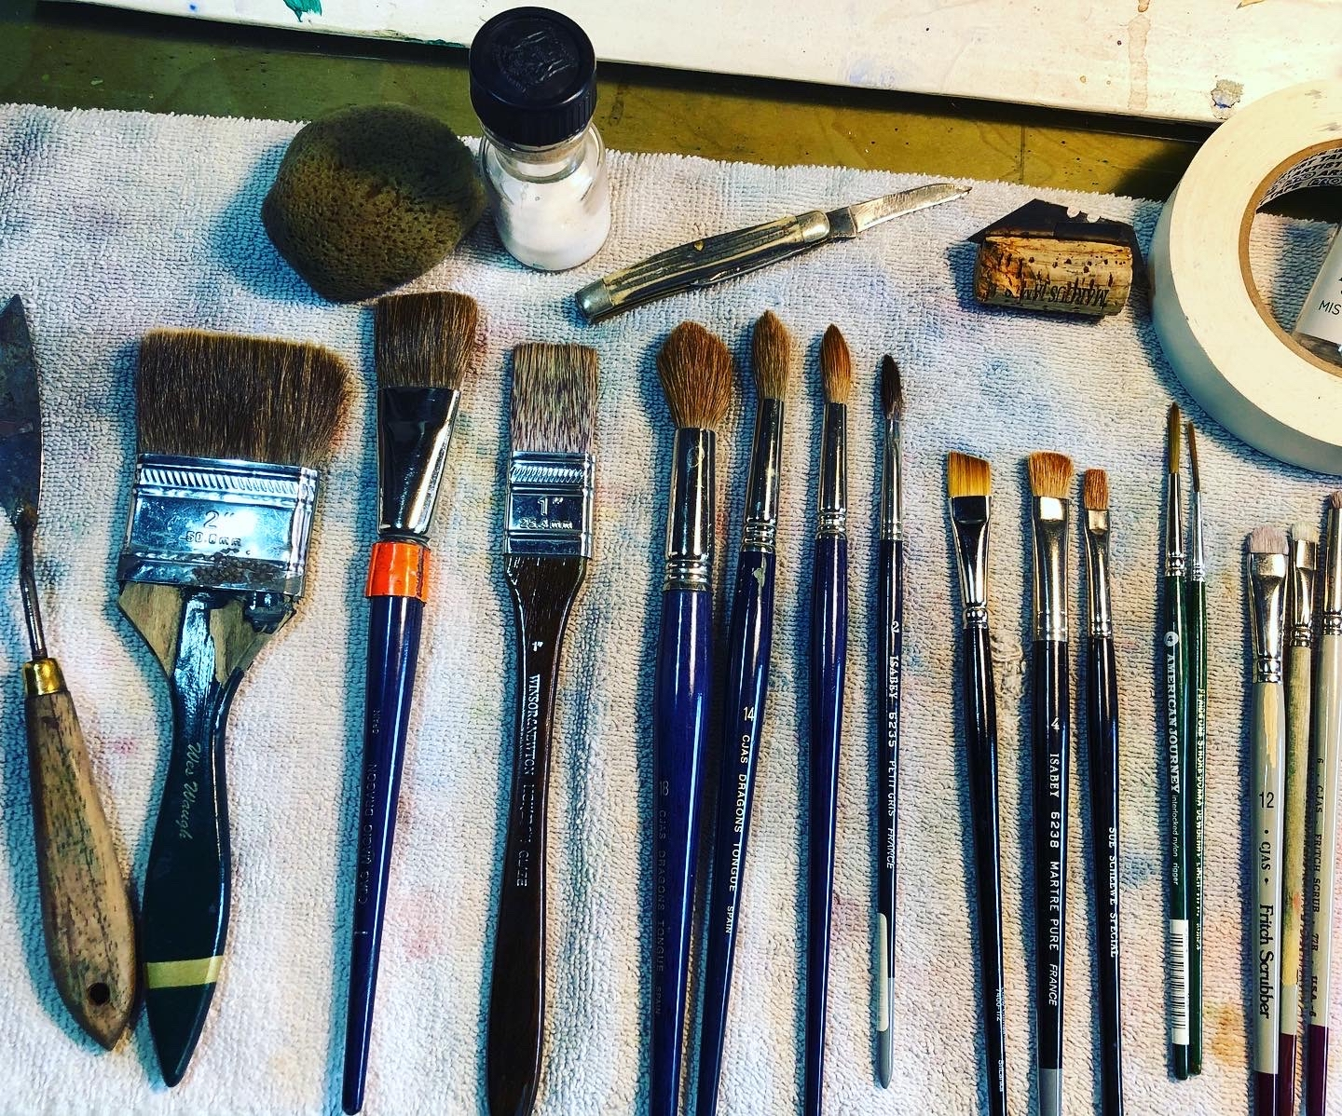
High Country Watercolor Society Video Workshop
October 2026

Title:
“Painting an Atmospheric Watercolor Landscape: A Comprehensive Video Workshop”

Wes Waugh / beartrailstudio@gmail.com /
(828) 773-1947

SUGGESTED SUPPLIES

Most of you already painting or experimenting with watercolor will be well stocked with the basic materials and supplies needed in terms of brushes, palette, range of pigments, support & preferred tools and supplies. I paint with very moist pigments for being able to pick up strong color. I primarily use American Journey Watercolors because I was also an ambassador for Cheap Joe’s. Even though Cheap Joe’s is no longer in business, American Journey paint is still being offered via a company acquisition to Journey Art Stuff https://journeyartstuff.com/products/american-journey-artists-watercolor

If you are already comfortable with watercolor materials and supplies different from below, do not worry about substitutions for what you regularly use. The only thing I feel rather strongly about is the use of ¾” gatorboard hard foam as a backing. A completely flat and tight result is best achieved by using this backing with closely placed staples. However, if you feel committed to another method, you will not be ostracized!

Any quality brand of similar pigments that you prefer is suitable.
If you are an advanced beginner with limited supplies, please feel free to contact me by email (beartrailstudio@gmail.com) and we can discuss your needs and options.

Paper: Professional quality 140 #cp (will be used for demos)
I typically use Fabriano Artistico Bright White or Natural cotton rag paper. Other professional quality brands are certainly acceptable. However, I find that Arches paper does not possess the “ease of lifting out color” that Fabriano has.
I will usually demo on a 20” x 26” sheet (an elephant sheet cut in half).
A good size of paper to consider for this workshop would be in the 20”x16” or 15” x 22 range, though you can certainly paint larger to your comfort zone.

In my view, the wet-into-wet approach is best suited to using the largest size you feel comfortable with to get the full effect of color blending and pigment precipitations. Big strokes are best and big paper is better!

Brushes
1” flat brush suitable for w/c (natural or quality synthetic)
#10 or #12 round brush (natural or quality synthetic)
Optional: a #4 w/c rigger brush and of course, any favorite brushes that you already own and use regularly for painting.

I often use larger rounds #14-#18 for bigger papers, and a wide 2-3” flat brush to quickly dampen paper for stretching and for very large bold “loaded washes”. These brushes are by no means required but useful if you want to “go big”.

A support such as gatorboard or your preference for painting on stretched / damp paper. I will use and demo gatorboard with stretched paper stapled at 1.5” intervals. Do not go with 3/8” foamboard as a substitute for ¾” hard surface gatorboard! It does not have the strength for stretching paper without buckling.

Preferred palette with adequate mixing area or an extra mixing tray for large washes. I use a porcelain palette with deep wells and two large rectangular mixing areas.

A range of preferred pigments with warms, cools and earth colors. I am listing my most utilized below. You certainly don’t have to have all of these in your palette.

Warms
American Journey w/c Alizarin Crimson (quin)
American Journey w/c Ramblin Rose (a rose madder)
American Journey w/c Red Hot Moma (a cadmium red)

(one of the yellow’s below)
American Journey w/c Aureolin
American Journey Bumblebee Yellow

Earth Colors
American Journey w/c Burnt Sienna
American Journey w/c Yellow Ochre
American Journey sepia
American Journey indigo
American Journey Indian Yellow

Cools
American Journey w/c Joe's Green (phthalo)
American Journey w/c Prussian Blue
American Journey w/c Cobalt Blue
American Journey w/c Andrew’s turquoise
American Journey w/c Manganese blue
American Journey w/c Skips Green
American Journey w/c Royal Amethyst
American Journey w/c Ultramarine Blue

Additional Supplies that prove helpful:

- Roll of paper towels
- Box of tissue
- a decent size square sponge
- a roll of toilet paper and cool whip size plastic container (for a blotter)
- stapler that opens up
- hairdryer (optional)
- old cotton towel
- drawing pencils (for value sketching)
- plastic eraser (for w/c paper)
- water container
- scoring tools – i.e. safety edged razor blade, old credit card, palette knife, small pocket knife, etc.

Please feel free to email me directly with any questions you may have or if you need more detailed info. Beartrailstudio@gmail.com

I look forward to this month of painting together and note that we will be “in progress” during the spectacular fall color season!

Wes

