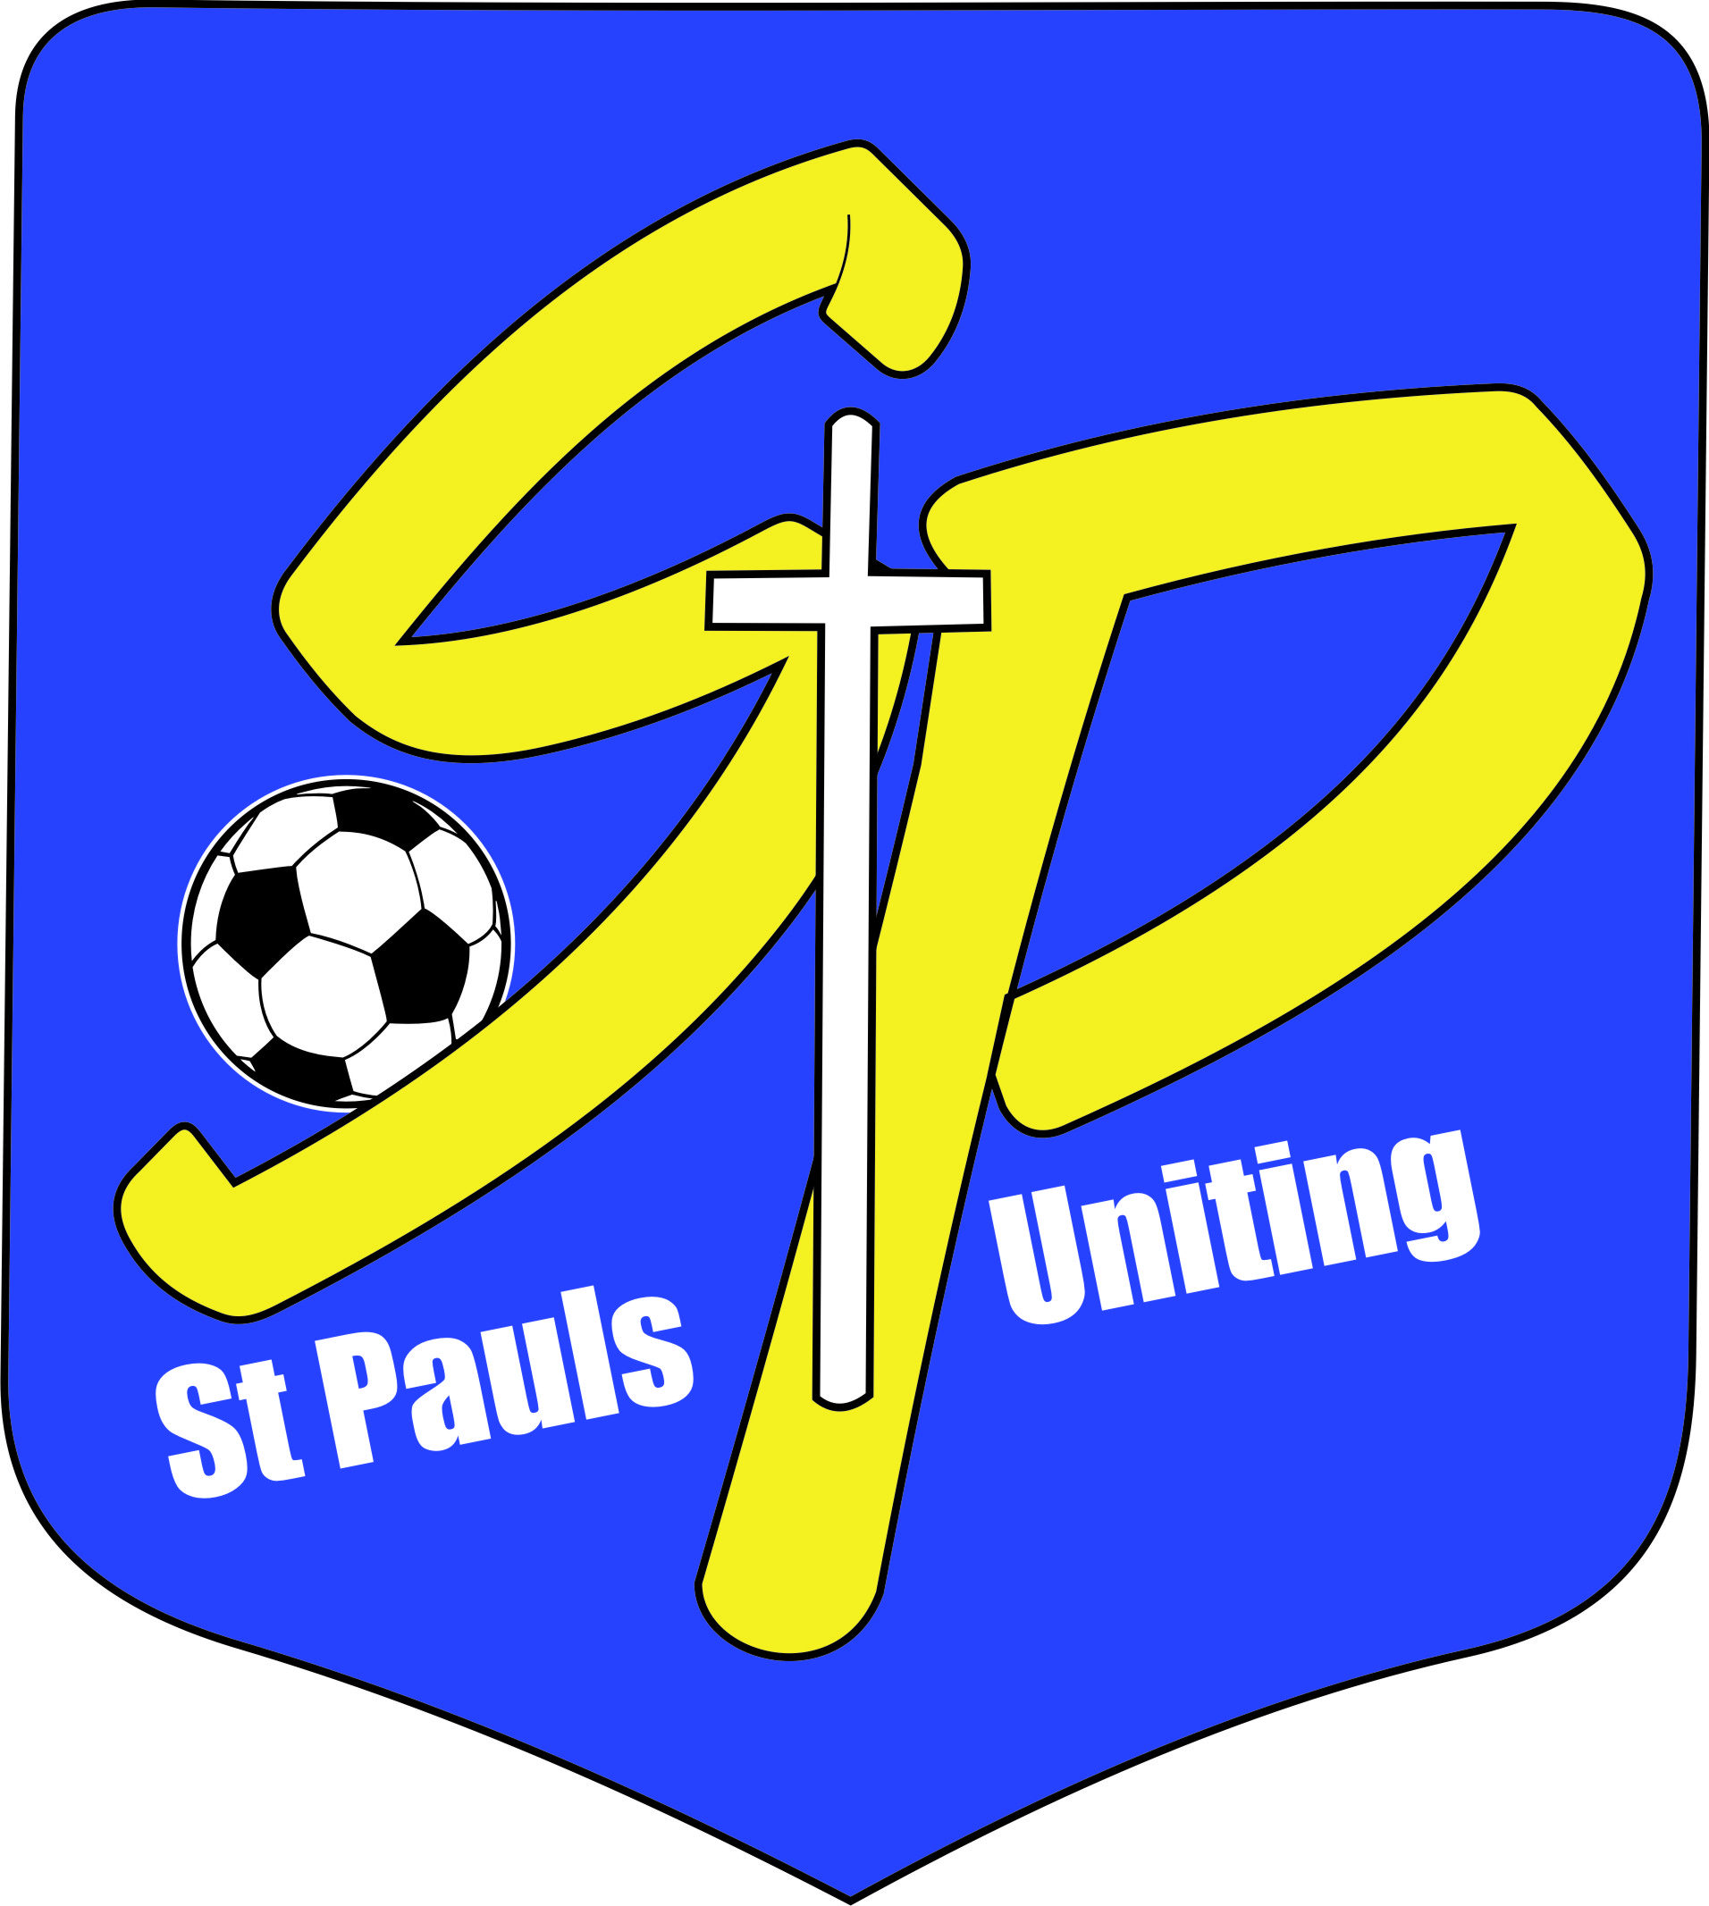
ST PAULS UNITING SPORTING CLUB INC
Respect. Integrity. Community.

COMMITTEE NOMINATION FORM
for the Annual General Meeting
to be held 7pm Wednesday 25th November 2020 at
St Pauls Clubhouse
Yandina Park, Wecker Road Mansfield.

We hereby nominate

for the position of

Nominated by:

Name Signature

Nomination seconded by:

Name Signature

I, , accept the nomination for the above position.
Should I be successful in obtaining a role on the committee of St Pauls Uniting Sporting Club Inc, I promise to uphold the club’s core values of Respect, Integrity and Community in my dealings with everyone as a representative of St Pauls. I also promise to uphold the rules and By-Laws of the QCSA.

Signature Dated

Please return this nomination to secretary@stpaulssoccer.org.au by Wednesday 11th November 2020.

Executive Positions and current office bearers:
President Stephanie Murphy
Vice-President (2) Brendan Cook (soccer) & Adam Barwick (cricket)
Secretary Susan Paton/Rhiannon Paton
Treasurer Andrew Millward
Registrar Darryl Miles

Other club roles:
Results Officer Debbie Miles
Equipment Officer Brendan Cook
Canteen Convenor Josh Klatt
Coaches’ Mentor Ian Bolt
Field Co-ordinator Karen Stehbens
Groundsmen David Stehbens
Webmaster Andrew Millward
Fundraising/Sponsorship vacant
Discipline Iain Williamson

