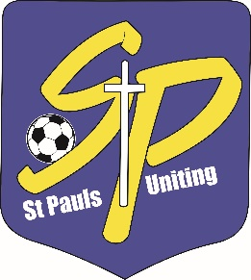**ST PAULS UNITING SPORTING CLUB INC**

a founding member of the QUEENSLAND CHRISTIAN SOCCER ASSOCIATION

**RESPECT. INTEGRITY. COMMUNITY.**

**For God through Sport since 1969**

**Little Saints 8-week Soccer Program**

**for children aged 4 to 6**

**Monday afternoons 4:30 to 5:30**

**Yandina Park, Wecker Road, Mansfield**

**10th May- 28th June**

**$50 plus a one-off $20 uniform cost**

Each child will be supplied with a shirt with the club logo on it, shorts, club socks and a size 3 soccer ball.

Register by contacting our Little Saints team at [littlesaints@stpaulssoccer.org.au](mailto:littlesaints@stpaulssoccer.org.au)

Registrations can also be completed on the day

