Coventry Chronicles

April- July 2021

Calendar of Events

All meetings begin at 7:00 p.m. at the Coventry Clubhouse unless otherwise noted. Master Board Meetings begin at 6:00 p.m. for Executive Session and 7:00 p.m. for Open Session. Homeowners are welcomed and encouraged to attend.

April Activities
3 EGG HUNT
5 CHOA Meeting
13 Ferguson Glade Meeting
19 Swim Team
26 ARC Meeting
27 Smithy Glen Meeting

May Activities
1 SPRING YARD SALE
3 CHOA Meeting
5 FT Meeting
11 Ferguson Glade Meeting
17 Swim Team
24 ARC Meeting
25 Smithy Glen ANNUAL Meeting
29 POOLS OPEN

June Activities
7 CHOA Meeting
8 Ferguson Glade Meeting
21 Swim Team
22 Smithy Glen Meeting
28 ARC Meeting

.

Coventry Board Members

Tony Collins – President
David Wilson – Vice President
John Rogne – Treasurer
Brian Kross- Secretary
Kelly Burleson - Director

Coventry Office Staff
Annette Sauer
Rachael Falls

Hours
Tuesday – Friday 10:00 am – 5:00 pm

How to Reach Us
Phone…………...……..(757) 867-9200 FAX…………...………….(757) 766-0249
E-Mail………coventryhoa@verizon.net
Web...www.coventryhoaofyorktown.org
www.facebook.com/CoventryNeighborhoodHOA
www.facebook.com/groups/CoventryWatch

If you have an idea for an article or would like to submit an article or picture, please send to our editor: Leah Greene at leahgreene1013@gmail.com or the CHOA office at coventryhoa@verizon.net for submission. CHOA Board approval may be required

Be a Good Neighbor:
10 Reasons to Leash Your Dog

Virginia law requires that dogs be kept on a leash at all times when on public property. While on private property, dogs must be under the control of their owners. The intent of this law is to protect the health and safety of the public and to protect your pet. The use of a leash will benefit you, your neighborhood, and your pet. There are many good reasons to keep your dog on a leash.

1. It’s a great good neighbor policy, preventing your dog from trespassing on neighbor’s property during your walk. It also keeps your dog from jumping on people you encounter, ensuring that your dog has the chance of being properly introduced.

2. Improved companionship. A well trained and leash-obedient dog is a pleasure to walk with.

3. Walking your pet on a leash will prevent the spread of disease. It is less likely that your dog will be exposed to Parvo or Distemper. A leashed dog can be restrained from sniffing the droppings of other animals.

4. A leash is commonly referred to as “Your Pet’s Lifeline,” protecting your pet from traffic and unrestrained animals. Accidents or animal bites are greatly reduced when responsible pet owners obey the leash law.

5. An obedient and well behaved dog is a positive reflection of its owner.

6. Re-locating your dog into another household is 100% easier if your dog is obedient and leash trained.

7. It’s a great way to reward your dog. Your dog will immediately respond with a wagging tail the moment he or she sees you holding the leash.

8. It’s a great identification tool, symbolizing that the dog has an owner, and enabling someone who sees the leash and identification tag attached to the dog’s collar to find you if you and your pet should become separated.

9. It’s a great relief to wildlife, keeping your dog from chasing squirrels, deer and other wildlife.

10. It’s the law! The law is in place to protect other members of the public and your pet from injury. Be a good neighbor. Be a good friend. Use a leash.

Dear Homeowners,

“WOW, Summer is almost here!” As we have entered into the New Year, we’ve encountered 2 issues that have become a challenge within our community. As your elected president, I am asking for your cooperation, help, and understanding related to each issue.

- As we all face the concerns, challenges and fears related to the Coronavirus, I ask that we all see the value and the many blessings that come with such a great community and great neighbors. With respect to each other, I ask that if you have any of the symptoms related to the possibility that you may have the virus, that you please stay home. As we walk within our neighborhood and continue to use some of the amenities as a means of exercise, I ask that you please show respect, concern and care for your neighbors based on keeping a respectful 6-feet or more of distance between each other, and remain at home if you do not feel well.

- The fact that we have all been created with different personalities, interests, likes and dislikes, that is what makes life so much fun and interesting. Together, when we value those differences with respect, we create within our community a place with great worth and friendship. It has been brought to the attention of your Master Board that some neighbors, when walking their dogs, will allow their “best friend” to use a neighbor’s yard as a place to go to the bathroom. There is a code within the County of York that gives a homeowner the legal right to file a complaint with the county that could become a Class-4 felony. As your elected president, I am asking that we all strive to respect the differences in each other and the properties related.

In my 36 years involved in community service, I must say, I feel so blessed to be part of the Coventry team of volunteers. It’s the variety of ideas, a mixture of different talents, passions aimed in different directions, a willingness to give, a desire for improvement, and a heart to serve, that produces such a successful team. Each person can help in making a difference.

With so much to be thankful for in our community, your Board is in need for volunteers for your Beautifications committee and with the Architectural Review Committee. If you would like to volunteer to help, or just want more information, please call the Coventry office at 757- 867-9200

Thank you all for the opportunity to serve you. Your feedback is helpful and necessary in helping your Board find solutions to your concerns.
Remember, times may be tough, but the Coventry Family is tougher! We need YOU!

Tony D. Collins Sr.
President, Coventry Homeowners Association

***COVENTRY ZUMBA UPDATE***
FREE COVENTRY Outdoor Zumba® CLASSES
I hope you have been enjoying outdoor Zumba these last few months, I know I have! If you haven’t joined us yet, you’ll have to check us out.
Please note: I have decided not to move Zumba indoor yet due to COVID-19. And since the weather is getting colder, I’m forced to look for more options. Therefore, I will continue to hold Zumba classes outdoors whenever the weather permits, either on a Monday, Tuesday or Thursday evening of any given week. Unfortunately, classes will vary week by week since the weather will be the boss. So, keep a look-out for the Zumba® flag located on the corner of Coventry and Honeysuckle, the Coventry marquees as you enter into Coventry, and you can contact me to be put on my Zumba distribution list. I will post another update whenever I decide to move Zumba indoors. Remember… Keep Zumba’ing!!!.

~ Jennifer Collins
Zumba® Instructor

FREE COVENTRY OUTSIDE ZUMBA CLASSES

Where: Coventry Harvest Lake
206 Honeysuckle Lane- on the tennis courts

TWICE A WEEK (Mon, Tues or Thurs)
6:30 – 7:30 PM
WEATHER PERMITTING

Contact Jennifer Collins with any questions at
(757) 508-4587 or at collije2@gmail.com

Coventry Chronicles Ad Information

The Coventry Chronicles is published four times a year. If you would like to get the word out about your business to over 1100 families living in Coventry, please consider advertising in the neighborhood newsletter.
Ads must be digital ready or an additional fee may apply. Make checks payable to Coventry HOA. They can be dropped off at the office or mailed to Coventry HOA, 100 Wrought Iron Bend, Yorktown, VA 23693.

Critter Corner

Canada Goose Mating Season

Mating Season is fast approaching so with that we would like for residents be aware of some things about the geese and nesting, and we are asking you to help us be on the lookout for activity.

- Geese will begin nesting in February and March

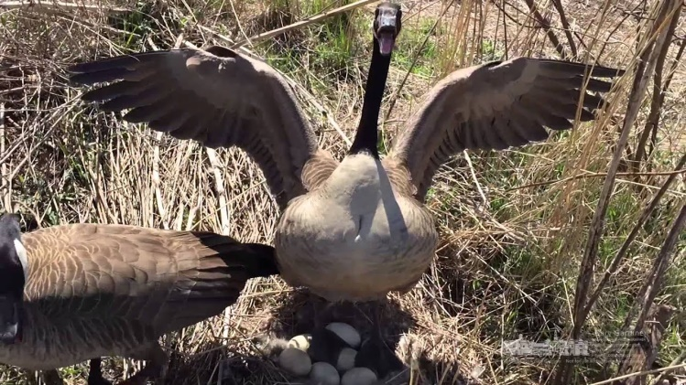

- They prefer to nest along the shores of the lakes in relatively open areas, but they are not particular and may choose other areas as long as they are open and provide a clear view of potential predators.

- You will typically see the males standing guard nearby; also known as the sentinel male.

- They will go after you if you wander too close to the nest, so steer clear. Just as we don’t allow strangers or other dangers near our children, similarly, they are protective of theirs.

- Please take note of this nesting activity, and the specific location. Let the office know what you’ve seen and where you have seen it.
- Do not try to address nests in any way on your own. It is illegal for citizens to perform nest depredation without registering and utilizing methods allowed by regulations.

- We have volunteers who are registered to take care of this. Let them do it by informing the office and they will provide that information to the volunteers who are trained to do so.

- We have made the choice to live in a community with multiple retention ponds and the reservoir nearby. We will never be completely free of waterfowl.

- Be aware that our covenants do not allow feeding of the ducks and geese so please do not do so. It makes our area that much more inviting and will lead to an increase in the resident population in the area.

- Do not harm, harass, or kill the geese or ducks. It is illegal and carries fines of up to $2,500.

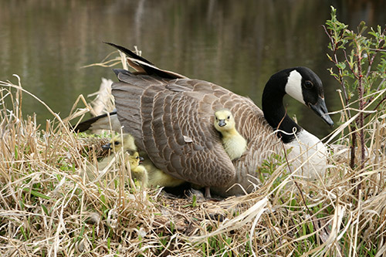

Small Business Support
(adopted from visityorktown.org)

Small businesses have been in survival mode this year. But with your support, they’ll be a little closer to ending the year on a joyful note. Visityorktown.org has a nice list of some fun ideas of places to stop by when strolling through Historic Yorktown! Many businesses also offer online shopping and gift card options so you don’t have to leave the comfort and safety of your home.

- The Watermen’s Museum
  - Nautically and patriotic-themed jewelry, books for young and adults, t-shirts and hats, and shipwreck/ship-style home decor
- Yorktown Bookshop
  - Antique and vintage items and a variety of militaria and maritime, presidential and historical items with a kid’s section
- Auntie M’s American Cottage
  - Artist and owner “Auntie M” has filled her shop with handcrafted work from American artists and craftspeople from Yorktown and across the country
- The Gallery at York Hall
  - Handcrafted items by local artists. Children’s books, paintings, quilts, photography, and a portion of the proceeds goes back into the community.
- Patriot Tours and Provisions, LLC
  - Consider a gift card for a socially distanced Segway tour of Historic Yorktown
- Water Street Grille
- Mobjack Bay Coffee Roasters and Petite Café
- Yorktown Pub
- The Original Larry’s Hard Lemonade Brewing Co
- Ben and Jerry’s and the Green Mountain Coffee Café
- Hornsby House Inn B&B
- Marl Inn Bed & Breakfast
- York River Inn Bed & Breakfast
- Yorktown Cottages

Pool Opening

Now hiring lifeguards for Coventry pools. Visit High Sierra Pools.com

Coping During Covid-19 with Music

Music can benefit both physical and mental health in adults and children. Studies show that music can help cognitive performance, help reduce stress, improve endurance and performance, and even help you sleep better at night. During this unprecedented time of Covid, adults now more than ever are hit with depression, stress, and unrealistic expectations having to juggle being a full time parent, teacher, and maintain their full time jobs. Even more, because of Covid, families are not able to get out and have down time away from one another. But, music can help. Studios like The Music Post help give opportunities for parents and children to bond together over something. And more importantly, there are opportunities to fit everyone's needs both virtually and in person. Music classes can start as young as a year old and go up through adulthood. Baby music classes allow bonding time for new parents with their children. Students learn how to connect with parents, how to communicate their needs, and early socializing skills. Adolescents and adults taking private lessons gain the ability to have an outlet, learn endurance and determination by mastering new skills, and are given the opportunity to be free with composing and improvising. Music is about connecting the human soul, and it provides a universal language.

Here's some articles to consider:
https://www.verywellmind.com/surprising-psychological-benefits-of-music-4126866

https://www.aarp.org/health/brain-health/info-2020/music-mental-health.html

https://au.reachout.com/articles/how-to-use-music-for-mental-health
Contributed by Julianne Post, Owner & Founder of The Music Post

Cars

Please remember that in order for cars to be parked in Coventry they must have a tag, registration and inspection and must be operable.

Geese

Your HOA is aware of the current increase in candian geese on the property. An person experienced in managing these geese has been hired to come and try to decrease the geese population. These geese have been identified as neighboring or migratory geese and are not native to our Coventry neighborhood. They have been tracked to actually residing in a neighboring community and are coming to our location to feed. No nests have been found at this time and the geese are being coaxed back to their home regularly by the person hired. However, please notify the HOA staff if you are noticing an increase of geese or have any concerns.

