

Coventry Chronicles

July-Sept 2021

***Calendar of Events***

All meetings begin at 7:00 p.m. at the Coventry Clubhouse unless otherwise noted. Master Board Meetings begin at 6:00 p.m. for Executive Session and 7:00 p.m. for Open Session. Homeowners are **welcomed and encouraged** to attend.

**July Activities**

12 CHOA Meeting

13 Ferguson Glade Meeting

16 Food Trucks

26 ARC Meeting

27 Smithy Glen Meeting

29 & 31 Food Trucks

**August Activities**

2 CHOA Meeting

4 FT Meeting

10 Ferguson Glade Meeting

12 Food Truck

23 ARC Meeting

24 Smithy Glen Meeting

26 Food Truck

**Sept Activities**

6 CHOA Meeting

**7 HL POOL CLOSED**

9 Food Truck

14 Ferguson Glade Meeting

**20 CH POOL CLOSED**

23 Food Truck

27 ARC Meeting

28 Smithy Glen Meeting

*.*

***Coventry Board Members***

Tony Collins – President

David Wilson – Vice President

John Rogne – Treasurer

Brian Kross- Secretary

Kelly Burleson - Director

***Coventry Office Staff***

Annette Sauer

Rachael Falls

***Hours***

Tuesday – Friday 10:00 am – 5:00 pm

***How to Reach Us***

Phone…………...……..(757) 867-9200 FAX…………...………….(757) 766-0249

E-Mail………coventryhoa@verizon.net

Web...www.coventryhoaofyorktown.org

[www.facebook.com/CoventryNeighborhoodHOA](http://www.facebook.com/CoventryNeighborhoodHOA)

[www.facebook.com/groups/CoventryWatch](http://www.facebook.com/groups/CoventryWatch)

*If you have an idea for an article or would like to submit an article or picture, please send to our editor: Leah Greene at* [*leahgreene1013@gmail.com*](mailto:leahgreene1013@gmail.com) *or the CHOA office at coventryhoa@verizon.net for submission. CHOA Board approval may be required*

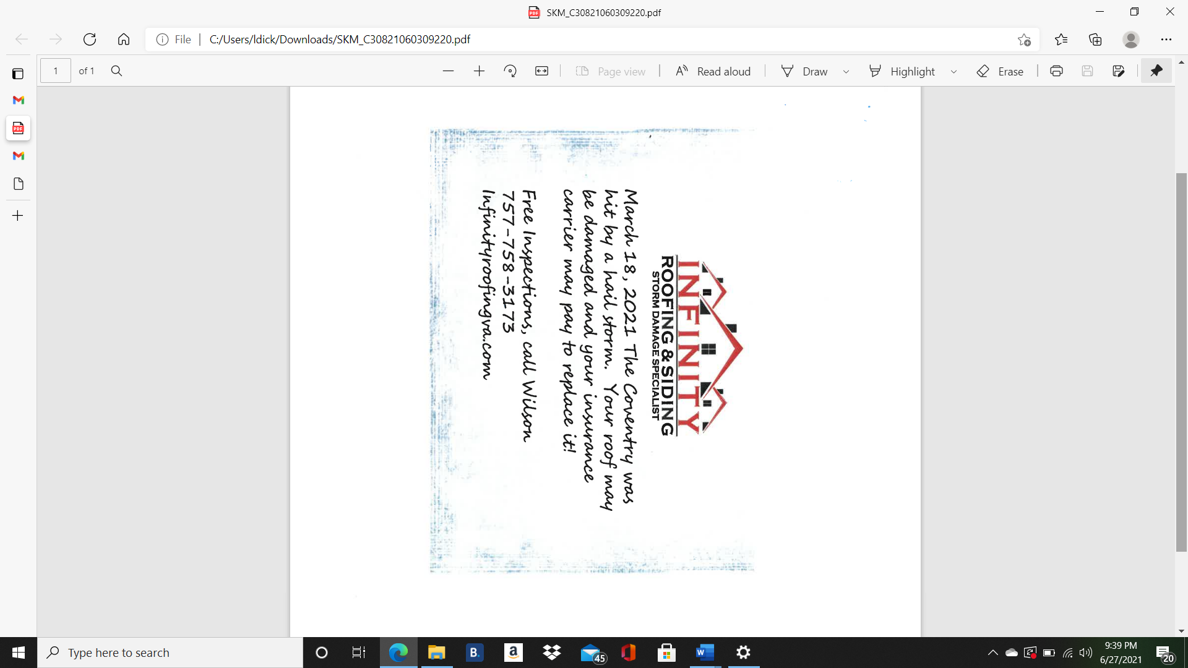

***Food Trucks***

Food trucks are scheduled to visit Coventry several times monthly throughout the summer at the Clubhouse. Take a night off from cooking! Please check the Calendar of Events on the website at [www.coventryhoaofyorktown.org](http://www.coventryhoaofyorktown.org) or Facebook for updated details.

**Food Trucks:**

* July 16: Flame & Pie and Sweet Frog
* July 29: Coastal Thirsty
* July 31: Polar Snow
* Aug 12: Flip Side
* Aug 26: Bali Bali
* Sept 9: Nosh
* Sept 23: Chesapeake Concessions

***Dear Homeowners,***

“WOW, Summer is here!” As we have entered into the New Year, we’ve encountered 2 issues that have become a challenge within our community. As your elected president, I am asking for your cooperation, help, and understanding related to each issue.

1. **Our pool’s**, both pools have had some challenges this year due to the Covid-19 virus. We have been working with our pool company patiently as they have worked hard in trying to get enough qualified lifeguards as needed for each of our two pools. We also had some concerns with the walls and base of our Harvest lake pool that has delayed the opening of the Harvest Lake pool due to taking the time to be sure the resurfacing of the walls and base could wait until this season ends without causing any harm to anyone using the Harvest Lake pool. Our hope and goal is to have both pools up and running by Monday June 28, 2021. We very much appreciate your patience with your office and Board as we have faced many delays and challenges due to the state laws and recommendations related to public and community pools and our responsibility to our community neighbors wanting to have fun and be safe.
2. The fact that we have all been created with different personalities, interests, likes and dislikes, is what makes life so much fun and interesting. Together, when we value those differences with respect, we create within our community a place with great worth and friendship. It has been brought to the attention of your Master Board that some neighbors, when walking their dogs, will allow their “best friend” to use a neighbor’s yard as a place to go to the bathroom. There is a code within the County of York that gives a homeowner the legal right to file a complaint with the county that could become a Class-4 felony. As your elected president, I am asking that we all strive to respect the differences in each other and the properties related.

In my 38 years involved in community service, I must say, I feel so blessed to be part of the Coventry team of volunteers. It’s the variety of ideas, a mixture of different talents, passions aimed in different directions, a willingness to give, a desire for improvement, and a heart to serve, that produces such a successful team. Each person can help in making a difference.

With so much to be thankful for in our community, I would like to encourage you and your family to have fun using the many amenities available within our community, such as the pools, walking trails, tennis, pickle ball, volley ball, swings, fishing, boating and more. For more information, please call the Coventry office.

Thank you all for the opportunity to serve you. Your feedback is helpful and necessary in helping your Board find solutions to your concerns. ***We need YOU!***

Tony D. Collins Sr.

President, Coventry Homeowners Association



**--NEW SCHEDULE—**

***FREE* COVENTRY INDOOR ZUMBA**® **CLASSES**

**@ COVENTRY CLUBHOUSE – ALL ARE WELCOME!**

**TRY CLUBHOUSE – ALL ARE WELCOM**

**Every Thursday from 6:30 – 7:30 PM**

New schedule begins July 22 indoors at the Coventry Clubhouse located at 100 Wrought Iron Bend. These classes are *FREE!*  There may be times I will want to hold the class outdoors on the tennis courts due to ideal weather conditions. Make sure you contact me to get on my Zumba® email distribution list to be notified weekly. I also hold indoor Zumba® classes on Tuesdays and Saturdays in Hampton. If you have any questions, feel free to contact me at (757) 508-4587 or at [collije2@gmail.com](mailto:collije2@gmail.com). Keep your eye on the Coventry marques or look for the large pink Zumba® flag.

**WHAT IS ZUMBA® YOU ASK?**

Zumba® is a workout featuring movements inspired by various styles of Latin American dance, performed to music. It’s become a popular and trendy workout across the globe. And since Zumba® involves movement of the entire body — from your arms to your shoulders and to your feet — you’ll get a full-body workout that doesn’t feel like work. You’ll burn calories, burn fat, build endurance, and have fun doing it. And, there’s no right or wrong way to do Zumba®. As long as you move to the beat of the music, you’re participating in the exercise.

Thank you from your Zumba® Instructor,

*--Jenny Collins*

Remember . . . Keep Zumba’ng! 💜

***Coventry Chronicles Ad Information***

The Coventry Chronicles is published four times a year. If you would like to get the word out about your business to over 1100 families living in Coventry, please consider advertising in the neighborhood newsletter.

Ads must be digital ready or an additional fee may apply. Make checks payable to Coventry HOA. They can be dropped off at the office or mailed to Coventry HOA, 100 Wrought Iron Bend, Yorktown, VA 23693.

***Critter Corner***

**Black Vultures vs. Turkey (red-headed) Vultures**

Black headed vultures are more aggressive than their red headed cousins so identifying them is important. How to differentiate the birds:

In the air

* Black vultures have a wingspan which is approximately 4.5 ft. to 5.5 ft. They have dark feathering with the exception of the wingtips, which are gray.
* Black vultures will tend to hold their wings in a flat formation while soaring, but will be seen beating their wings more often than a turkey vulture.
* When in the air, the legs of the black vulture will reach the end of the tail.
* Red headed vultures have silver gray feathering on the underside of the entire wingspan and a slim stretch of black along the bone structure of the wing. Wings are long and narrow, and they span 6 ft. on average
* Red headed vultures will hold their wings in a very slight V-formation when soaring which is a graceful but teetering motion. They beat their wings less often.
* The legs of the red headed vulture do not reach the end of their tails.

On the ground

* Black vultures are just that, black; they have gray heads and the legs are long and while not white, they look whitish (shush….it’s because they tend to poop on their own legs).
* Black vultures have short tails, so their wings cover their tails when grounded.
* The feathers of the red headed vultures are a dark brown with light brown edges; their legs are shorter and red but are also often whitish; the tail and wings are longer, and the wings also cover the tail when on the ground.

The black vulture is not shy about being around humans so you may see them perched on poles in treetops, roof tops, etc. The turkey vultures are generally shy, and steer clear of humans.

Both typically feed on carrion and serve the important purpose of keeping nature clean and clear of deceased animals. Black vultures used to be a southern resident. However, warmer winters to the north have allowed the bird to spread northward. The red headed vultures continue to prefer their traditional diet of carrion, but black headed vultures have started attacking livestock on farms in Kentucky and Ohio bringing down lambs, calves and full-grown sheep. It is not out of the question for pets to be endangered. While not seen in our area regularly, they have been spotted on limited occasions. There is no need to be unnecessarily fearful. Know the difference and take precaution with your pets if you see them in the area. Do not leave your pets unattended outside if you have spotted them nearby.

~~~~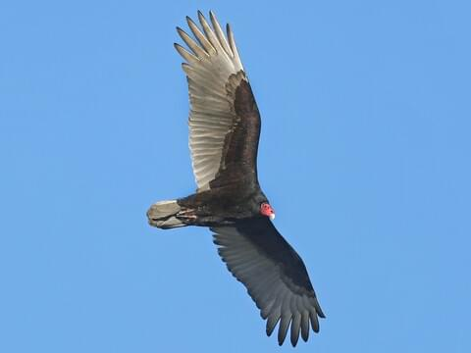

Whether you like them or not, these birds are covered by the Migratory Bird Act of 1918 which covers all migratory birds. It is illegal to kill them or disturbs nests without a permit that can result in a fine and possible jail time.

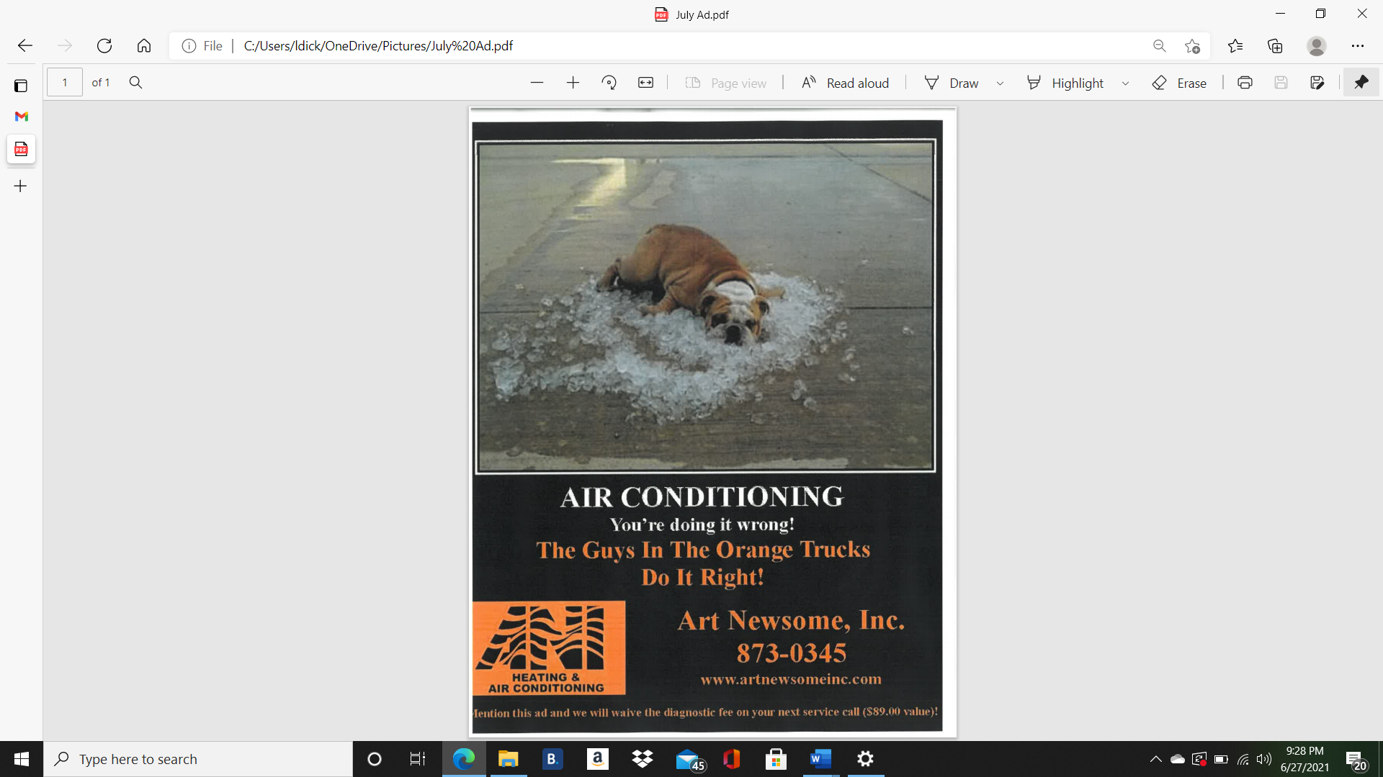



***Volunteer Opportunities***

**Coventry Neighborhood Facebook**

The Coventry Neighborhood Watch Facebook page is run by volunteers. It is not always possible for these volunteers to keep the Facebook updated in a timely fashion due to work/life/children, etc. Please remember to call the HOA office with concerns or issues as the Facebook page volunteers would not be able to speak to many concerns as well as may not respond immediately. The Facebook page is looking for additional volunteers to help run the page designed more for safety and neighbor concerns. If you are interested, the volunteer must reside in Coventry, have a basic understanding of social media, and understand some basic marketing/copyright rules with making original posts. If interested please email the Coventry HOA or the editor and you will be put in touch with our volunteers.

**Coventry Cougars PTA**

Open chair positions to help lead the Coventry Elementary school PTA program are now available!

Please contact the PTA at CoventryPTA@gmail.com

The PTA is THRILLED to be planning a more regular year of programming in 2021-22 school year, but they some help to make these events happen!! They are requesting passionate volunteers for PTA school programs! School programs provided by the PTA, support school staff and Coventry students all year long!

The Coventry PTA provides family events such as the Snowball Dance, BINGO night and the Cougar Dash 5K. When PTA gets involved, children benefit. When you get involved with PTA, the child who benefits most is your own. During the 2020-21 school year the PTA was especially excited to offer virtual events to keep students and families connected like Paint Night, martial arts, cookie decorating and a Virginia 529 presentation.

The Coventry PTA also supports students and teachers throughout the year by providing supplemental classroom resources like iPads and agendas, reimbursement for classroom supplies, teacher meals, appreciation events and recess equipment.



***Veterans Crisis Line***

The Veterans Crisis Line is a toll-free, confidential resource that connects Veterans in crisis and their families and friends with qualified, caring U.S. Department of Veterans (VA) responders.

Veterans and their loved ones can call **1-800-273-8255 and PRESS 1,** chat online at VeteransCrisisLine.net or send a text message to 838255 to receive free, confidential support 24 hours a day, 7 days a week, 365 days a year, even if they are not registered with VA or enrolled in VA health care.

The responders at the Veteran Crisis Line are specially trained and experienced in helping Veterans of all ages and circumstances from coping with mental or physical health issues to relationship struggles or the transition back to civilian life. Veterans Crisis Line responders provide support when these and other issues- such as chronic pain, anxiety, depression, sleeplessness, anger, and even homelessness- reach a crisis point. Some of the responders are Veterans themselves and understand what Veterans and their families and friends have been through.

Since its launch in 2007, the Veterans Crisis Line has answered nearly 4.9 million calls and initiated the dispatch of emergency services to callers in crisis more than 159,000 times. The Veterans Crisis Line anonymous online chat service, added in 2009, has engaged in more than 565,000 chats. In November 2011, the Veterans Crisis Line introduced a text-messaging service to provide another way for Veterans to connect with confidential, around the clock support and since then has responded to nearly 176,000 texts.

In 2011, The National Veterans Suicide Prevention Hotline was renamed the Veterans Criss Line to encourage Veterans and their families and friends, who may be the first to realize a Veteran is in emotional distress, to reach out for support when issues reach a crisis point, even if it is not a suicidal crisis.

VA is working to make sure that all Veterans and theirs loved ones are aware of the Veterans Crisis Line. To reach as many Veterans as possible, VA is coordinating with communities and partner groups nationwide, including community-based organizations, Veterans Service Organizations, and local health care providers, to let Veterans and their loved ones know that support is available whenever, if ever, they need it.

The Crisis Line responders provide support when these or other issues reach a crisis point.

Whether you’re a Veteran or a friend or a family member concerned about one, confidential assistance is only a call, click or text way.

For more information about the Veterans Crisis Line, visit VeteransCrisisLine.net.

For more information about VA/s mental health resources, visit [www.mentalhealth.va.gov](http://www.mentalhealth.va.gov)

Confidential crisis chat at VeteransCrisisLine.net or text 838255

