

Coventry Chronicles

October-December 2020

***Calendar of Events***

All meetings begin at 7:00 p.m. at the Coventry Clubhouse unless otherwise noted. Master Board Meetings begin at 6:00 p.m. for Executive Session and 7:00 p.m. for Open Session. Homeowners are **welcomed and encouraged** to attend.

**October Activities**

5 CHOA Meeting

10 Fall Yard Sale

13 Ferguson Glade Meeting

19 Swim Team

**25 Halloween Parade**

26 ARC Meeting

27 Smithy Glen Meeting

**November Activities**

4 Finch Terrace Meeting

10 Ferguson Glade Meeting

23 ARC Team

24 Smithy Glen Meeting

**December Activities**

**5 Holiday Party**

8 FG Annual Meeting

9 Light Contest

**11 Adult Mixer**

22 Smith Glen Meeting

28 ARC Meeting

*.*

***Coventry Board Members***

Tony Collins – President

David Wilson – Vice President

John Rogne – Treasurer

Brian Kross - Secretary

Kelly Burleson - Director

***Coventry Office Staff***

Annette Sauer

Rachael Falls

***Hours***

Tuesday – Friday 10:00 am – 5:00 pm

***How to Reach Us***

Phone…………...……..(757) 867-9200 FAX…………...………(757) 766-0249

E-Mail………coventryhoa@verizon.net

Web...www.coventryhoaofyorktown.org

[www.facebook.com/CoventryNeighborhoodHOA](http://www.facebook.com/CoventryNeighborhoodHOA)

[www.facebook.com/groups/CoventryWatch](http://www.facebook.com/groups/CoventryWatch)

*If you have an idea for an article or would like to submit an article or picture, please send to our editor: Leah Greene at* [*leahgreene1013@gmail.com*](mailto:leahgreene1013@gmail.com) *or the CHOA office at coventryhoa@verizon.net for submission. CHOA Board approval may be required*

***Coventry HOA Meetings***

**Dear Homeowners:**

Due to the Coronavirus pandemic, the Coventry Elementary School has asked that the Coventry Annual Meeting not be held this year in their gym. There are concerns related to having such a large group of people in one area.

After speaking with the school, the office staff researched other places where the annual meeting could be held. Our findings were not very positive due to the high cost associated with renting a local place that would be large enough to hold a large number of homeowners, and adhere to the recommended social distance of six feet between each person. In addition, many people still are very hesitant to attend a large gathering of any kind. Taking all this into consideration, and our concern for the health of the homeowners and the board, your Master Board has voted to move forward into 2021 using the 2020 budget, as well as keeping the same Master Board members until an Annual Meeting can be safely convened.

Your Master Board met and reviewed the 2020 budget and we have all agreed that the 2020 budget will work for 2021. The HOA worked within the 2020 budget covering all necessary expenses based on the budgeted income from assessments. We feel confident that this budget will work perfectly for 2021.

In the event any Homeowner has any questions or thoughts related to the 2021 year moving forward, please contact the office.

Please continue to stay safe and healthy and remember that your HOA is always in need of volunteers for the many committees we have. We believe everyone has something to offer.

Thank you, Homeowners,

Tony D. Collins Sr., President of CHOA



***Thank you, Carl!***

An era of a legend at Coventry has come to an end. Carl has been the Maintenance Supervisor for Coventry for the past almost eleven years. He has worked so hard completing his job of maintenance as well as going above and beyond, working around the clock, on call for emergencies and on the weekends. Carl supervised and completed projects, took care of the neighborhood landscaping, electrical, plumbing, contacting referrals and contracts, and over all took care of the property while providing support to our residents and our neighborhood. We will forever be grateful for his hard work and dedication and will certainly miss him. Best of luck in your new career Carl! Be sure to give him a wave and “Thanks” when you see him around the neighborhood as he is still seen giving a hand.

***Welcome, BJ***

We would like to welcome the new maintenance supervisor to Coventry. BJ brings a wealth of knowledge and energy to our community and we look forward to getting to know him as he learns the needs of the neighborhood. Welcome BJ!

***Virtual Learning***

As we are all in this virtual learning together, here a few tips to get through the upcoming months as the weather starts to change and outside recess will be shorter.

Join the Coventry PTA to see if there is a POD your children may be able to join. These are small groups of kids in your class or in your child’s grade so kids can work together and also enjoy safe social interaction with the same children. This will also help for those parents whom need to return to in-person work.

Keep a set schedule as our children return to school. Follow the same schedule on the days of in-person learning as virtual learning to keep consistent.

Consider hanging a sign on your door “E-learning in progress” to deter visitors from stopping by or delivery drivers from ringing the doorbell.

Consider using “Genius Hour” for the older learner. This is time for the student to answer a question they are interested in or learn something how they need/prefer to learn. The rules are unstructured, use research or “new learning” and creation of a end product that can be shared.

Set up an indoor carnival around the house for children to complete in different locations. Have children earn tickets from each activity they can turn in for treats.

For example:

* bean bag toss
* throwing socks in the laundry basket
* the floor is lava room
* toss a hoop/ring on soda bottles
* bob for apples
* balloon pop with body or by a pillow
* knock down the cans
* pillow case races
* face painting
* make candy apples
* photo booth
* pumpkin painting
* egg drop
* seasonal coloring contest
* pin the tail on the donkey

 

.

***Dear Homeowners,***

“WOW,” it’s almost time to say goodbye to 2020. As we prepare for the New Year, I would like to ask that everyone put their thinking caps on and allow your imagination to venture into ways that we might improve our community. There has been some discussion on the desire to have a “dog park.” If so, where might a good location be? What all will a dog park consist of and how do we meet the needs of the many breeds, personalities and sizes of dogs we have in our community? Again, your feedback is necessary in order to help make decisions on what types of equipment and the locations as to where to have such equipment set up.

We are presently having a “FREE” Zumba class on Tuesday afternoons that starts at 6:30pm and goes until 7:30pm. The Zumba class is free to all age groups and is held on the tennis court in Harvest Lake. We are in the process of adding overhead lighting to the courts to provide opportunity for our community to use the tennis court and pickle ball courts at night time until 9:00pm. In the last few years, Zumba and the pickle ball sport has become one of the more popular and fun games of all ages. Study up on these two sport events and be ready for some great fun and exercise.

I would be remiss if I did not thank the many volunteers that give their time, dedication and passion to improving and making a difference in our community. In my 35 years involved in community service, I must say I feel so blessed to be part of the Coventry team of volunteers. It is the variety of ideas, the mixture of various talents, the willingness to give, the desire for improvement, and a heart to serve, that produces such a successful team. The more people we have like that, the more we can accomplish. Come join the team . . . *We need YOU!*

Thank you all for the opportunity to serve you. Your feedback is helpful and necessary in helping your Board find solutions to your concerns.

Tony D. Collins Sr.

President, Coventry Homeowners Association

***Pumpkin Patches in Hampton Roads***

* Cullipher Farm, VA Beach
* Bergey’s Breadbasket, Chesapeake
* Chubby’s Pumpkin Festival and Christmas Trees, Chesapeake
* Clarke Farm 3, Chesapeake
* Great Bridge Pumpkin Patch, Chesapeake
* Greenbrier Farms, Chesapeake
* Hickory Ridge Farm Fall Festival, Chesapeake
* Lilley Farms, Chesapeake
* Mount Pleasant Farms, Chesapeake
* Darden’s Country Store, Smithfield
* College Run Farms, Surry
* Pumpkinville, Toano
* Flanangan Farms, VA Beach
* Henley Farms, VA Beach
* Hunt Club Farm, VA Beach
* Skipper Farms at the Farmer’s Market, VA Beach
* Bush Neck Farm, Williamsburg



***Indoor Museums for the Winter weather***

Try making a reservation for one of these local museums during the cooler months. Call ahead to confirm COVID-19 protocol.

* Virginia Air and Space Museum
* Virginia Living Museum
* Jamestown settlement and American Revolution Museum at Yorktown
* Virginia War Museum
* US Army Transportation Museum
* Chrysler Museum of Art
* The Mariners Museum and Park
* The Newsome House and Museum and Cultural Center
* Lee Hall Mansion
* Cape Henry Lighthouse
* Nauticus
* Military Aviation Museum
* Children’s Museum of Virginia
* Hermitage Museum and Gardens
* Aberdeen Gardens Historic Museum
* Air Power Park
* Bacon’s Castle
* Chesapeake Planetarium
* Esther Atkinson Museum of Hampden Sydney College
* Portsmouth Colored Community Library Museum
* Norge Depot Museum
* Frances Land House
* Endview Plantation Museum
* Hampton History Museum
* Hampton Roads Naval Museum
* Jewish Museum and Cultural Center
* Norfolk Police and Fire Museum

***Nurse’s News***



***COVID-19 Update***

The CDC continues to respond to an outbreak of respiratory illness caused by a new coronavirus. The best way to prevent illness is to avoid exposure and maintain precautions.

***VACCINE UPDATE***

Currently, the best way to overcome the COVID-19 crisis is the creation of a vaccine. There is much information in the news regarding clinical trials and the purpose of this section is to help better explain this information.

Clinical trials are set into 4 phases and an additional preclinical trial. The preclinical trial

Phase I evaluates the safety of the vaccine, determines a safe dosage and identifies any side effects from the medication. Side effects are problems that occur when treatment goes beyond the desired effect or problems that occur in addition to the desired therapeutic effect. Side effects are common with all medications and clinical trials of medication help determine what these will be and the severity. The FDA will stop any clinical trial with significant negative side effects and not allow for resumption of testing until a complete analysis has been completed. This often occurs in the Phase II of a trial and where the majority of medication trials are stopped. Phase II focuses on the effectiveness of the medication or vaccine and evaluates the safety. An increase from less than 100 participants to between 100-300 participants are enrolled. This phase can take up to two years to complete. In Phase III, the effectiveness of the vaccine is confirmed. 1,000-3,000 participants are typically enrolled and the length of time is based on the efficacy of the vaccine. Side effects are closely monitored here and the FDA is heavily involved. The effect of the vaccine is compared to other treatments that are available or being tested. Phase IV provides additional information after approval including the risks, benefits, long-term effects, and how the vaccine should best be used.

As you can see, getting a vaccine through the FDA is not an easy or quick process, and with good reason. The FDA needs to be sure 1. The vaccine is safe, 2. The vaccine is effective, and 3. The vaccine will do no serious harm or cause long-term side effects.

There are situations, such as a pandemic, in which the FDA approves medications for use without completing entire clinical trials or for a “fast track” approval of a vaccine. The only time this occurs for vaccines is when there is an emergency need during a pandemic, like COVID-19. Clinical testing is still completed but the process is dramatically shortened. For example, the exploratory stage, which occurs before any human testing at all can take 2-4 years. If a vaccine is being introduced fast track, this stage may be skipped because other vaccines already exist that can fight similar viruses. Fast tracking a vaccine does not mean that clinical trials are not completed. Several vaccines for COVID-19 have already been stopped in the clinical trial period due to questionable side effects that needed to be further investigated. Once a drug is designated as “fast track,” the company is subject to more frequent meetings and communications with the FDA to ensure safety and efficacy. Because of this increase in communication, questions and issues can be resolved at a much quicker pace, leading to earlier drug approval and access by patients.

An important note to remember is that once a vaccine is approved, manufacturing, distribution, and administration still need to occur. As we are familiar, during influenza season you may see local pharmacies with a low supply due to waiting for manufacturing or distribution. The system is never perfect, and as the flu vaccine needs to be adjusted yearly to meet the most common strain of flu, this can take time.

All of that said, a vaccine for COVID-19 will be trialed, proven effective and produced. It is important to remember that vaccines have been around since 1885 when Louis Pasteur was trialing his rabies vaccine on “mad dogs.” A nine-year-old boy was bitten in 14 places by a mad dog and his mother, in a desperate attempt to save his life, fled her home town to seek out Mr. Pasteur. This boy was the first ever human being to be injected with a vaccine, the material from the spinal cord of a rabbit that had died from rabies, and survived. Vaccines are tried and true and clear in the potential for side effects. The scientists will follow the guidelines that are in place in order to provide an effective vaccine and we will be ready to do our diligence to the community to vaccinate ourselves to help life get a little closer to normal.

Flu Vaccines are now available for free at pharmacies and Walmart. Do your part to protect our country.



We’re a local agency, and we’re here to help you navigate your insurance, save money on your premiums, and make sure that you have the best protection available for your family, home, mortgage, vehicles, and/or business needs.

Call or e-mail me to request an obligation-free analysis.

Phone: (757)930-2014 * Email: theresa@revolutioninsuranceva.com

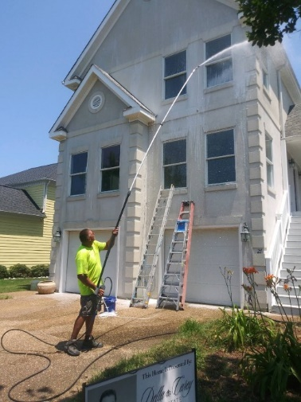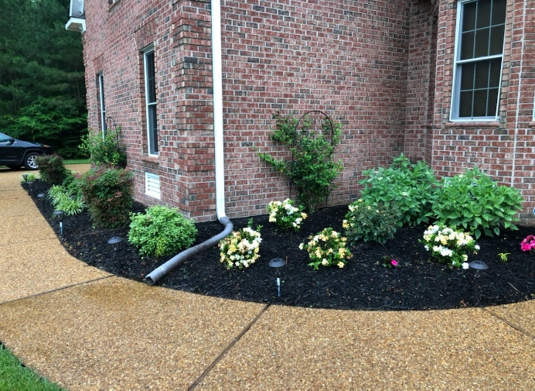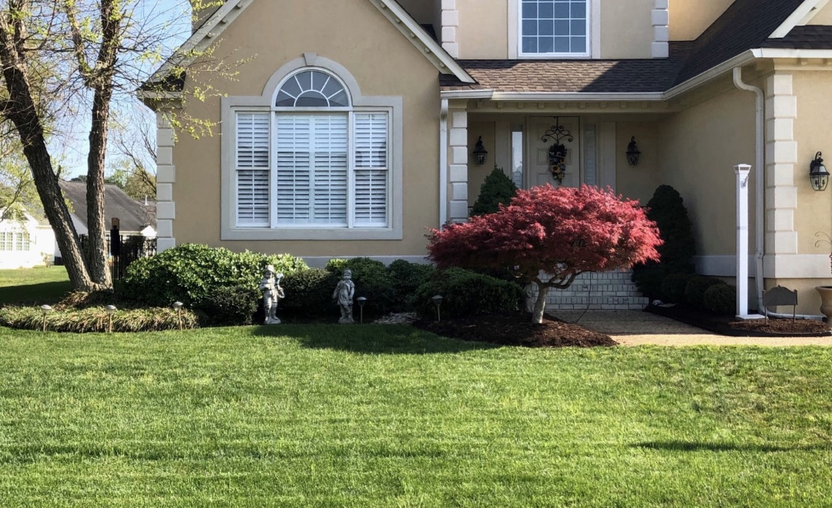

**Quality S e rvi ce At Great Rates**

•

•

•

•

•

•

Landscape Design

Mowing & Trimming Hedge Trimming Edging & Blowing

Fertilizer & Seeding Program

Lawn Thatching & Aeration

Sod Installation

•

•

•

•

•

Leaf Removal

Tree Trimming & Pruning

Cutting Trees Stump Grinding & Removal

* Power Washing
* Yard Debris Removal



***Thanksgiving***

Thanksgiving Day is a national US holiday celebrated on 11/26. In 1621, the Plymouth colonists and Wampanoag Indians shared a harvest feast that is recognized as one of the first celebrations in the colonies. A small ship called the Mayflower left Plymouth, England in September 1620 with a group of religious separatists seeking a new home to freely practice their faith. After a 66 day journal, they landed near the tip of Cape Cod, far north of their intended destination at the Hudson River. One month later, the Mayflower crossed Massachusetts Bay, where the “Pilgrims” began to establish a village at Plymouth. The first winter brought exposure, scurvy and disease and only half of the crew lived to the spring. In March, the settlers moved ashore and were greeted by an Abenaki Indian, whom spoke English. He returned with Squanto, a member of the Pawtuxet tribe who had been kidnapped by an English sea captain and sold into slavery before he escaped and returned to his homeland. Squanto taught the Pilgrims how to cultivate corn, extract sap, catch fish, and avoid poisonous plants. He helped the settlers form an alliance with the 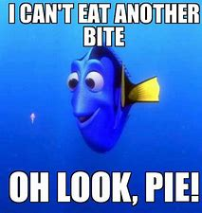 Wampanoag, a local tribe. In November 1621, after the Pilgrims’ had their first successful corn harvest, Governor William Bradford organized a celebratory feast with a group of Native American allies, including the Wampanoag chief Massasoit. This festival last for three days and is now recognized as our “first Thanksgiving.” It is suggested the dishes were likely prepared using traditional Native American spices and cooking methods.

Consider a traditional dish at your table this year using suggestions in the “Spotlight on your Health” section.

***Critter Corner***

**Piping Plovers and the Sanderlings**

We just returned in early September from our annual sojourn to Avon on Hatteras Island. Since we are all still very close to the Atlantic Ocean even here in Yorktown, I wondered how many of us are familiar with the Piping Plover. I am sure many of you have heard of them, but have you ever actually seen a Piping Plover? I haven’t and I have been traveling to the Outer Banks for almost five decades. Would you even know you were seeing one if it was strutting across the sand in front of you? The Sanderling and the Piping Plover look very similar and a person might mistake one for the other. Both are small stocky birds that wander along the water’s edge searching for food, they both have brown feathers on their back and a white underbelly. Key differences are the much shorter black beak that the Piping Plovers have in contrast to the long black beak the Sanderlings have. A couple of other key differences are the distinct black band of feathers on the neck and head of the Plovers that the Sanderlings do not have and the orange legs of the Plover versus the black legs of the Sanderling. During mating season, the Plover will have orange beaks. The Sanderling’s feathers during mating season are a dark mottled brown, but off-season they are more of a light silvery brown.

The reason people have been pushing so hard to protect the beaches is because of the way the Plovers nest. They nest exclusively on dry sandy beaches; the very same places people like to sit, walk and drive. They prefer sand that has shells and gravel that create uneven color to camouflage their eggs and young chicks. Pure white “groomed” beaches are no good. It leaves the eggs and young exposed to predators. While Plovers do exist on Hatteras Island, they are not there in great numbers because they prefer naturally changing beaches that create pools of water that make for perfect nesting sites. Since anytime there are breaches in the barrier islands, they are filled back in to save Highway 12 and surrounding homes the pools of water they like to nest near do not exist. Last year they counted a total of eight pairs on the island. While Sanderling numbers have not declined at the same rate of concern that the Plovers have, they are still a species of concern because their numbers are declining as well. These are all beautiful little birds that are a joy to watch while sitting on the beach. If you are a beach goer, please do your part to leave the beaches a natural place that provide a relief to eyes weary of cities, suburbia and all of the manmade trappings.



*FREE* Outdoor Zumba® in Coventry has been a wonderful opportunity for me, and I hope those of you who are participating are finding it helpful in your fitness journey. As the weather gets colder, the time is drawing near to move Zumba® indoors. However, we are not quite there yet. When the time comes, Zumba® will be moved to the Coventry Clubhouse located at 100 Wrought Iron Bend. Due to social distancing guidelines, the clubhouse will only hold 15 people per class. There will be a registration process, along with Rules and Regulations to follow. I will continue to keep you updated as things change. This weekly Zumba® class will continue to be *FREE*. Thank you again for this opportunity, and I am looking forward to continuing to help you stay fit, healthy, to lose weight and keep it off.

~ Jennifer Collins

Zumba® Instructor

**FREE** **COVENTRY** **OUTSIDE** **ZUMBA** **CLASSES**

**AT HARVEST LAKE – ALL ARE WELCOME!**

**EVERY** **TUESDAY** **NIGHT**

**6:30 – 7:30 PM**

**WEATHER PERMITTING**

Contact Jennifer Collins with any questions at

(757) 508-4587 or at [collije2@gmail.com](mailto:collije2@gmail.com)

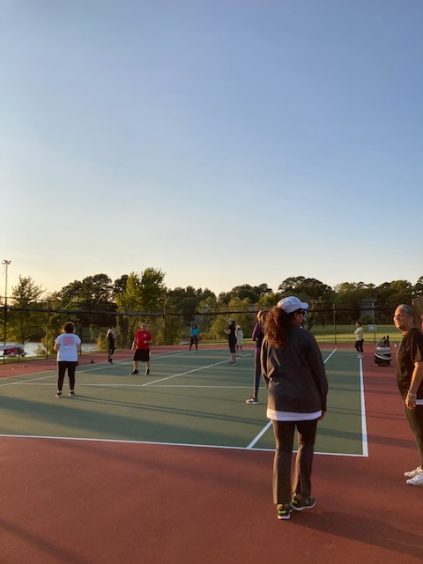

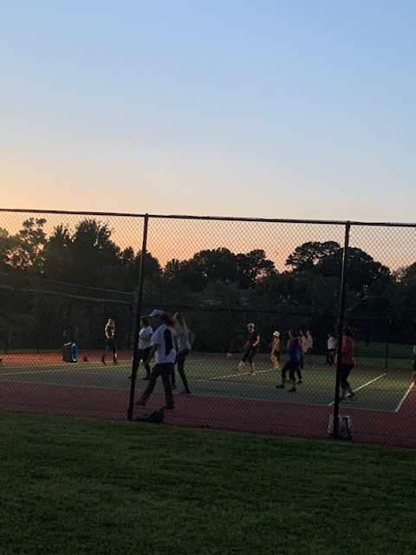

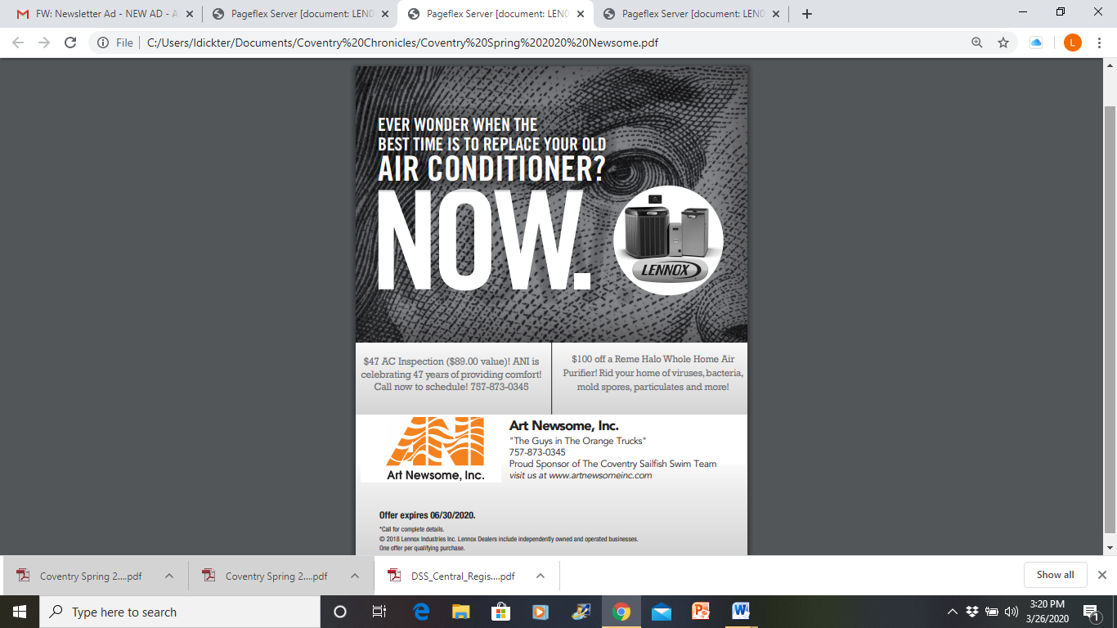

***Kids Korner***

Our Coventry kids answer the question:

How did you feel about your first week of school?

Answer by Leah, age 7

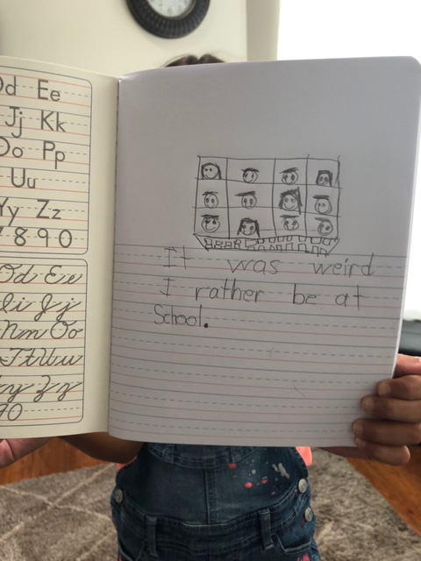

* I was excited and nervous. -Sophia, 9
* It was good to learn and bad because I miss my friends. – Chaos, 5
* I love my first day of school because I got to see my new friends. -Josie, 4
* It was good. I like my teacher. -Vincent, 7

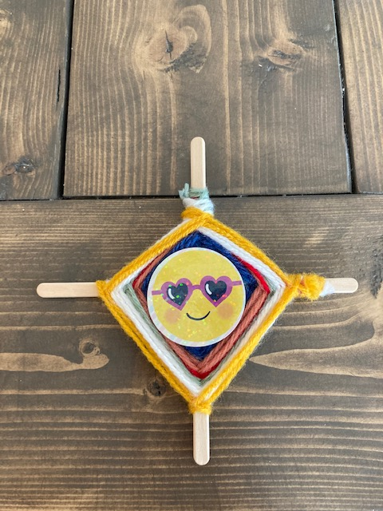

Traditional Native American craft

by Sophia, age 9

Submit your child’s artwork, photography, or original story to *coventryhoa@verizon.net*, or email for drop-off information.

***Winter***

According to the Guinness World Records, the largest snowflake in the world was **15 inches wide and 8 inches thick**. This was recorded on 28th January 1887 by Matt Coleman at [Fort Keogh](https://www.bing.com/search?q=Fort+Keogh&filters=sid%3a397e91cf-c9f1-6339-9545-bac640c6abd5&form=ENTLNK), Montana.

The coldest day ever recorded in the state of Virginia was on January 22, 1985 at 30 degrees below zero.



***Coventry Chronicles Ad Information***

The Coventry Chronicles is published four times a year. If you would like to get the word out about your business to over 1100 families living in Coventry, please consider advertising in the neighborhood newsletter.

Ads must be digital ready or an additional fee may apply. Make checks payable to Coventry HOA. They can be dropped off at the office or mailed to Coventry HOA, 100 Wrought Iron Bend, Yorktown, VA 23693.

***Spotlight on Your Health***

***Traditional Native American-style dishes***

**Algonquin Nut Soup**

1. Toast 1 cup hazelnuts in the oven at 350 degrees for 15 mins. Coarsely chop.
2. Saute 3 large diced shallots in 1 tBsp vegetable oil. Pour in 4 cups vegetable stock. Add nuts, 1 ½ tBsp chopped parsley, ½ tsp salt and pinch of black pepper. Then simmer on low heat for 1 ½ hours to soften the nuts and blend.
3. Soup can be served as is or can be processed in a food processor and blended until smooth.

**3 Sisters Soup**

1. Preheat oven to 350 degrees.
2. Slice 4 lbs winter squash and scoop out the seeds. Roast squash for 40 mins.
3. Allow to cool and scrape out the flesh and save the liquid for later. Blend until smooth.
4. Saute 2 small diced onions in olive oil until brown.
5. Add ¼ cup garlic, 2 tsp thyme, 1 tsp black pepper until garlic turns brown.
6. Pour in 4 quart of vegetable stock, 1 bay leaf, ½ cup white wine, and squash.
7. Simmer for a few minutes then add 4 cans cannellini beans, 1 lb frozen corn kernels, 1 bunch slice green onions.
8. Simmer for 20 mins.



**Acorn Bread**

1. Mix 6 tBsp cornmeal with ½ cup cold water. Then add 1 cup boiling water and allow to cook for 2 mins while blending.
2. Stir in 1 tsp salt and 1 tBSp butter. Let mixture cool until lukewarm.
3. With a separate bowl of ¼ cup lukewarm water, soften 1 packet of active dry yeast. Add 1 cup mashed potatoes, 2 cups all-purpose flour, 2 cups finely ground leached acorn meal.
4. Mix all dough together until a sticky dough forms, then cover and let rise until it has doubled in size.
5. Shape into loaves and let it rise again.
6. Bake at 375 degrees for 45 mins.

