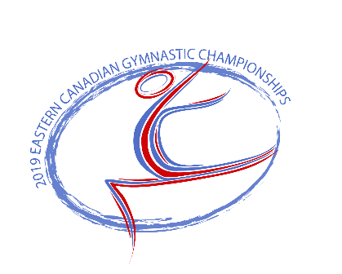

***2019 Eastern Canadian Artistic Gymnastics Championships***

Hosted By Saultos Gymnastics Club

May 9-12, 2019

Bulletin #2

Saultos Gymnastics Club alongside Gymnastics PEI is very excited to welcome everyone to the 2019 Eastern Canadian Gymnastics Championships.

**Competition Venue:**

Credit Union Place

511 Notre Dame St

Summerside PE C1N 1T2

**Tentative Schedule:**

See attached schedule.

**Registration Information:**

Athletes : $90.00

Coaches/Judges/Managers: $45

*HST is included

**Registration:**

Registration will be done by Province using the Sportzsoft system. The registration deadline is Friday April 26, 2019. A late fee of $500.00 will be charged if this deadline is missed. An additional $200.00 will be charged for each day after the deadline until the entire registration package is received. Payment of registration fees can be made by Cheque payable to Saultos Gymnastics Club.

Please use the following link to complete your Provinces registration.

[https://www.sportzsoft.com/meet/meetWeb.dll/MeetLogin?Id=887](https://eur01.safelinks.protection.outlook.com/?url=https%3A%2F%2Fwww.sportzsoft.com%2Fmeet%2FmeetWeb.dll%2FMeetLogin%3FId%3D887&data=02%7C01%7C%7Cf5e741167b6245b62fc308d6a55d65ef%7C84df9e7fe9f640afb435aaaaaaaaaaaa%7C1%7C0%7C636878217887363493&sdata=5C%2FEG8dRzQV2H1nhjnAh%2Bia0f9IMJftySmkVT0ogB9s%3D&reserved=0)

All coaches, judges, managers must be registered on the system as well. The manager category will give you one free manager.

All WAG music is to be submitted on the Sportzsoft system. We recommend teams bring an electronic backup copy to the meet as insurance.

Waiver and medical forms are also required. Please see attached form and waiver.

**Judges:**

Please submit the names of all your judges to [saultos@gmail.com](mailto:saultos@gmail.com) as soon as possible.

**Athletes Banquet and Activities:**

The athletes banquet will take place on Saturday May 11 beginning at 7:30pm. The location will be at the Credit Union Place. There will be a DJ, games, snacks and bowling.

**Judges and Coaches Social:**

The adult social will also take place on Saturday May 11 beginning at 8pm. There will be food, drinks, music and good conversations. Location TBA.

**Medical:**

There will be a medical table on the competition floor available to athletes should they need it. Keep in mind that if an athlete requires taping for an existing condition to please bring their own tape.

**Opening Ceremonies:**

Opening Ceremonies will take place before the first session on Friday May 10. You will be asked to provide 3 MAG and 3 WAG athletes for the ceremonies. The chosen athletes must wear their team march in attire for the ceremonies. First session will begin immediately following the ceremonies.

**Admission:**

|  |  |  |
| --- | --- | --- |
|  | Day Pass | 2 Day Pass |
| Adults (18+) | $10.00 | $15.00 |
| Students (6-17) | $5.00 | $8.00 |
| Children (5 and under) | Free | Free |

**Contact Information:**

Saultos Gymnastics

PO Box 146

Slemon Park, PE

C0B 2A0

Email: [saultos@gmail.com](mailto:saultos@gmail.com)

Phone: 902-888-3700

Contact Person: Jeff MacRae