COACH EDUCATION

HANDBOOK

(

Coaching, NCCP,

Certification)

2024

-

2025

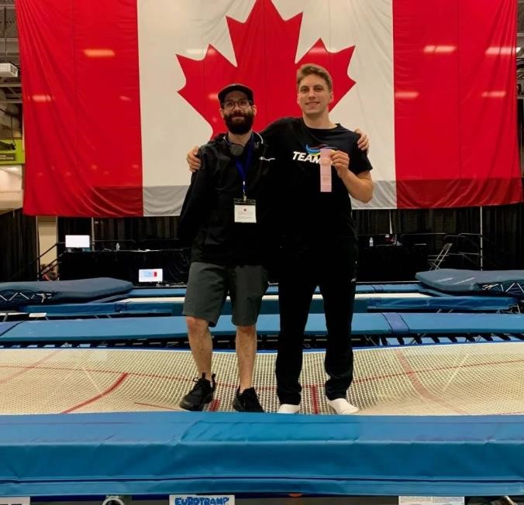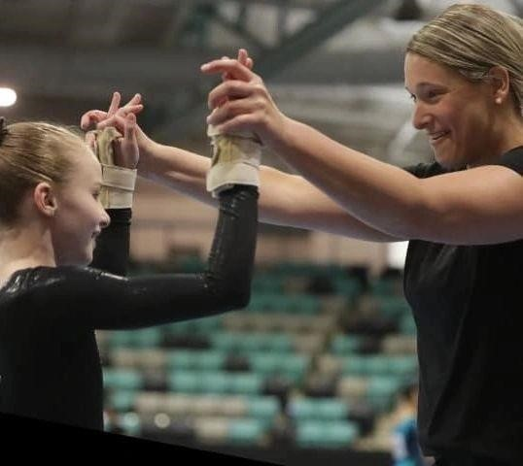

Version 2.0 (Updated January 15, 2025)

# Special Credit

Gymnastics NL would like to extend a huge thank-you to both Gymnastics BC and Gymnastics AB for allowing us to use and combine a significantly large portion of their Coach Education Policy Manual and Handbook, respectively, in the development of this, GNL’s, Coach Education/NCCP Handbook.

# Related Links

Gymnastics Canada - GymCan: <http://www.gymcan.org/>

Gymnastics Canada – GymCan Trello Board: https://trello.com/w/gymcan

Coaching Association of Canada (CAC): <https://coach.ca/>

# Supporting Documentation

GymCan Coaching Website: <http://www.gymcan.org/programs/coaching/coach-resources>

Including:

NCCP Operations Manual:

<http://www.gymcan.org/uploads/content/coaching/gcg_nccp_operations_manual_2018_en.pdf>

And NCCP Code of Ethics:

<https://coach.ca/sites/default/files/2020-03/NCCP_Code_of_Ethics_2020_EN.pdf>

Contents

Special Credit 1

Related Links 1

Supporting Documentation 1

SECTION 1: COACHING REQUIREMENTS FOR GYMNASTICS NL COACHES AND CLUBS 4

1.1 Coach Registration with Gymnastics NL 4

1.2 Responsible Coaching Movement – Rule of Two 4

1.2 Responsible Coaching Movement – Background Screening 4

1.3 Respect in Sport (RiS) 5

1.3 Make Ethical Decisions (MED)– Online Evaluation 5

1.4 Emergency Action Plan (EAP) Module 5

1.5 Concussion Training – Making Headway. 6

1.6 Drug-Free Sport Training - True Sport Clean 101. Change this to Safe Sport 6

1.7 Requirements for Coaching Staff/Member Clubs 6

1.8 Team NL Coaches – additional requirements 7

SECTION 2: NATIONAL COACHING CERTIFICATION PROGRAM (NCCP) 7

2.1 National Coaching Certification Program (NCCP) Status 7

2.2 NCCP Coach Education Pathways and Course Descriptions 8

2.2.1 Gymnastics Canada Pre-Coach in Training (Pre-CIT) Program 9

2.2.2 Gymnastics Foundations Pathway 9

2.2.3 Competition Introduction (C1) Pathway 11

2.2.4 Competition Introduction Advanced (C2) Pathway 13

2.3 NCCP Training vs Certification 13

SECTION 3: NCCP COACHING REQUIREMENTS 14

3.1 Minimum Coach Training Requirements 14

3.2 Coach to Participant Ratio Guidelines 15

3.3 NCCP Course Hours and Fees 15

3.4 NCCP Course Registration, Invoicing, and Payment 16

3.5 Completing Missed Modules of NCCP Courses 16

3.6 Auditing a Course 16

3.7 Requesting an NCCP Course 17

SECTION 4: THE NCCP COACH CERTIFICATION PROCESS 17

4.1 How to Certify 17

4.2 Applying for GNL Temporary Coaching Certification Exemptions 18

APPENDIX A: MINIMUM COACHING REQUIREMENTS FOR NCCP TRAINING/CERTIFICATION LEVELS 18

5.1 Minimum Coaching Requirements for Pre-Coach In-Training through to Gymnastics Foundations (GF) Certified. 18

5.2 Minimum Coaching Requirements for Competition Introduction (C1) and Competition Introduction Advanced (C2). – WAG/MAG. 19

5.3 Minimum Coaching Requirements for Competition Development (C3) and Competition Development Advanced (C4). – WAG/MAG 20

5.4 Minimum Coaching Requirements for Trampoline from GF to C2 21

# SECTION 1: COACHING REQUIREMENTS FOR GYMNASTICS NL COACHES AND CLUBS

## 1.1 Coach Registration with Gymnastics NL

All coaches must be registered as GNL members prior to actively coaching.

In order to coach in a GNL member club and at GNL sanctioned events, an individual must be a registered member of GNL. Attending coaching courses also requires appropriate GNL membership.

To coach any gymnastics discipline, individuals must hold the minimum NCCP certification level required for the athletes that they supervise.

## 1.2 Responsible Coaching Movement – Rule of Two

## 

All coaches must complete the Understanding the Rule of Two e-learning module. The goal of the Rule of Two is to ensure all interactions and communications are open, observable and justifiable. It is one of three pillars of the Responsible Coaching Movement (RCM), along with background screening and ethics training. This free module will take approximately 30 minutes to complete and can be accessed through CAC’s Locker under the E-LEARNING tab.

## 1.2 Responsible Coaching Movement – Background Screening

Background screening ensures that applicants to your sport organization such as employees, coaches and volunteers meet the important requirements to participate in sport activities. Screening includes comprehensive job postings, visible policies and processes, criminal record checks, interviews, and reference checks. All are equally important. Organizations are encouraged to determine the level of risk of an applicant and define/document how they will undertake the screening of coaches. NOTE: Any coaches representing Team NL at any competition must be a minimum 19 years of age and have a cleared Criminal Record Check with Vulnerable Sector Check within the last three years from the date of the competition.

## 1.3 Respect in Sport (RiS)

Respect in Sport (RiS) is a mandatory online training course for all coaches and sport/activity leaders. It is designed as a tool to assist coaches in identifying and dealing with abuse, neglect, harassment and bullying in sport.

As mandated by Gymnastics Canada (GymCan), all registered GNL coaches are required to complete this course as part of their NCCP Foundations Theory Training Course requirements.

New coaches registering with GNL will be granted a 30-day (from date of when their Theory course is recorded as completed in the Locker) grace period to complete the RiS module. Failure to complete the course after 30 days may result in suspension of membership and insurance coverage for the coach(es) until they complete the program, and a $35 per coach fee will be billed to the club.

It is the member club’s responsibility to keep a record of all their coaches completed certificate numbers and completion dates.

GNL recommends that Pre-CIT coaches also complete the RiS training.

Access to the RiS training will be emailed to new coaches shortly after completing the Foundations Theory training. Otherwise the RiS training can be found online through Gymnastics Canada’s website or by clicking [here.](https://gymnasticscanada.respectgroupinc.com/koala_final/)

Individuals and organizations can verify someone’s RiS status using the [online validation tool.](https://validation.respectgroupinc.com/)

1.3 Make Ethical Decisions (MED)– Online Evaluation

Upon completion of the Gymnastics Foundations Theory course (see section 2.2.2), coaches must complete the online MED evaluation. The MED online evaluation can be accessed through the Locker under the e-learning tab. This course is available at no cost only after completing the Theory course. Coaches who do not have the MED evaluation completed will be considered “In Training”. Once the MED evaluation is completed a coach’s status will be automatically updated to “Trained”.

1.4 Emergency Action Plan (EAP) Module

In order to fully complete the Gymnastics Foundations Theory course coaches must also complete the Emergency Action Plan (EAP) module (see section 2.2.2) This course is accessed through the Locker under the e-learning tab and is also free. Coaches who do not complete this module will not be considered fully trained.

1.5 Concussion Training – Making Headway.

It is recommended that all coaches complete the NCCP Locker eLearning module ‘Making Headway’. This free module teaches the knowledge and skills required to ensure the safety of athletes where there may be a concussion related situation. The Making Headway module is accessed through the Locker. NOTE: For coaches representing Team NL at any GymCan sanctioned event is required to complete this module.

## 1.6 Safe Sport

Gymnastics NL recommends that all coaches complete the CAC’s Safe Sport Training. Safe Sport training is an accredited program of the Abuse-Free Sport Program and will help anyone involved in sport identify and prevent situations of maltreatment. The Safe Sport training is accessed through the Locker under the e-learning tab and is also free. NOTE: For coaches representing Team NL at any interprovincial or national GymCan sanctioned event, completion of the Safe Sport module is mandatory and must be retaken every five years.

## 1.7 Requirements for Coaching Staff/Member Clubs

## 

For **ALL** gymnastics-related activities in member clubs, there must be **ALL** of the following present in the gym at **ALL** times:

|  |  |
| --- | --- |
|  | A coach that is at least NCCP Gymnastics Foundations or Competition Intro (C1) Certified. (Specific certification level required is determined by the highest level of athletes who are training). |
|  | All coaches must have completed the RiS program, regardless of the program or age and level they coach. |
|  | One adult 19 years of age or older. |
|  | One person that holds a valid certification in Standard First Aid from a government approved provider such as St. John’s Ambulance, Eastern Safety Services, or Red Cross. |

The above noted responsibilities may be held by one person or a combination of persons.

## 1.8 Team NL Coaches – Additional Requirements

Along with the above requirements, any coach representing Team NL at any competition or event must also:

* be minimum 19 years of age,
* have a cleared criminal record check within the last three years from the date of the competition. Note: some GymCan events may require a more recent criminal record check.
* meet any other requirements set by the competition’s hosting PSO and/or committee,
* and, complete any and all necessary documentation by the deadline set by the competition’s hosting committee.

# SECTION 2: NATIONAL COACHING CERTIFICATION PROGRAM (NCCP)

Gymnastics Canada’s Coach Education Program adheres to the standards of the National Coaching Certification Program (NCCP) as set out by the Coaching Association of Canada (CAC). With the Provincial/Territorial Gymnastics Organizations (PTO’s), Gymnastics Canada (GymCan) mandates that any individual coaching in a Gymnastics Canada member club must be a trained or certified coach under the NCCP for the gymnastics discipline in which they are coaching.

## 2.1 National Coaching Certification Program (NCCP) Status

Coaches should always be aware of their NCCP status which can be found by logging into their Locker through the Coaching Association of Canada (CAC) website,[coach.ca](https://www.coach.ca/),and viewing their transcript under the certifications tab.

NCCP numbers are created by coaches upon registration for their first NCCP course. Here’s a step-by-step guide on how to get an NCCP#:

1. Go to [www.coach.ca](http://www.coach.ca/)
2. Click on tab called The Locker.
3. Click on “Don’t have an account? Create one now!”
4. Check the box “I agree”.
5. Check the box “I want to create a Locker account for access to my transcript, eLearning opportunities, to sign up for coaching events, and more!”
6. Fill in your information and click “Register”
7. Login to your email account and open the verification email that was sent to you.
8. Click on the “click here” at the very end of the email.

Coaches can visit [CAC’s - The Locker](https://thelocker.coach.ca/) and log in with their NCCP# to access coaching records, update personal information, obtain an official transcript, and more.

Note: Please wait at least two weeks from the date of completion of an event (course or evaluation) before expecting to see it show up in the locker.

## 2.2 NCCP Coach Education Pathways and Course Descriptions

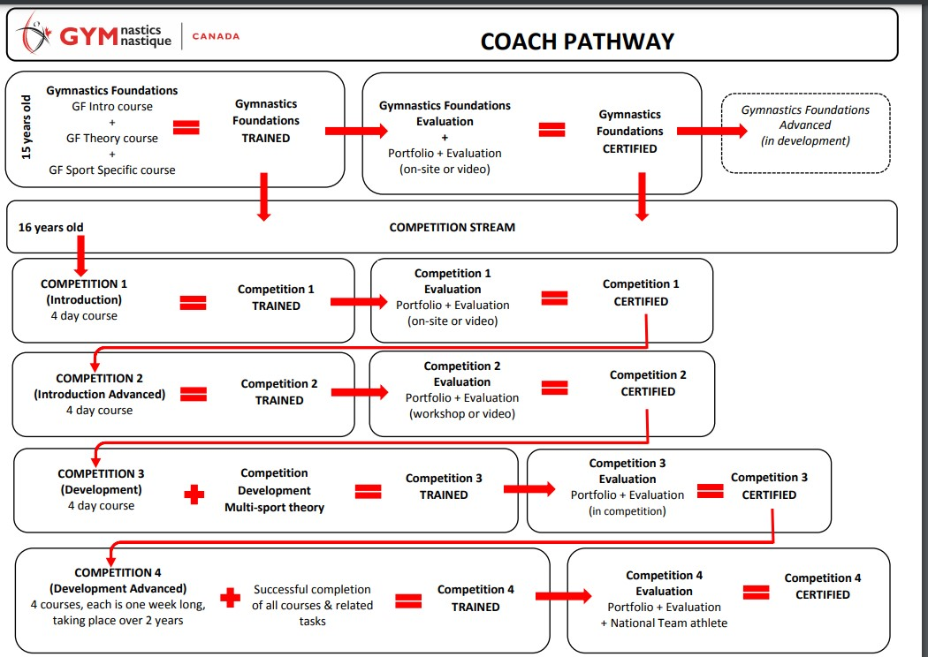

## 2.2.1 Gymnastics Canada Pre-Coach in Training (Pre-CIT) Program

The GymCan Pre-CIT program is a two-year program for participants ages 13-14 years old. The program can be completed in one year if a coach enters the program at age 14 (they would complete the full two-year course in one). This program allows young would-be-coaches to gain the experience and knowledge necessary to excel as coaches as soon as they are old enough to be trained. GymCan’s Pre-Cit Workbook can be found [here](https://trello.com/c/sSxNofFZ/35-pre-cit-coach-in-training).

A candidate for this program is someone who wants to coach and is a minimum of 13 years old but less than 15 years old.

This person can act as an assistant to a certified coach, but cannot have sole responsibility of a group. A Pre-CIT must always be under the direct supervision of a certified coach. Direct supervision is defined as one certified coach supervising one Pre-CIT coach.

## 2.2.2 Gymnastics Foundations Pathway

## 

In order to become a trained Gymnastics Foundations (GF) coach, a participant must attend a series of three training courses as described below. The minimum age for a coach candidate is 15 years old as of the weekend of the course.

As per the Coaching Association of Canada (CAC) policies, a person must be a minimum of 16 years old at the time of taking a course for the course to be credited. As an exception, GymCan has gained approval form the CAC to allow coaches 15 years of age to gain trained status at the Gymnastics Foundations (GF) level, by completing GF courses. However, a coach cannot complete the GF evaluation to become certified until they reach the age of 16.

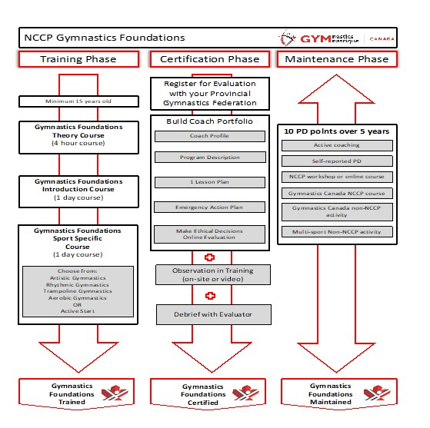

**1. Gymnastics Foundations (GF) Introduction course**

Coaches will learn the components of Gymnastics Canada’s 3F philosophy (Fun, Fitness, and Fundamentals), as well as common safety tips and fundamental movement patterns in this 7.5hour course that covers common topics for all gymnastics sports.

**2. Gymnastics Foundations (GF) Theory course**

During this 4-5-hour theory course, coaches will learn how to apply an ethical decision-making process to coaching and how to effectively plan a lesson.

**Make Ethical Decisions (MED) Online Evaluation** - Upon completion of the GF Theory course, coaches must complete the online MED evaluation. The MED online evaluation can be accessed through your Locker under the e-learning tab. This course is available at no cost once you have completed the Theory course. Coaches who do not have the MED evaluation completed will be considered “In Training”. Once the MED evaluation is completed your status will be automatically updated to “Trained”.

**Emergency Action Plan (EAP)** -In order to fully complete the theory course coaches must also complete the EAP online module. This course is accessed through the Locker under the e-learning tab and is also free. Coaches who do not complete this module will not be considered fully trained.

**3. Gymnastics Foundations (GF) Discipline-Specific Courses:**

**Active Start (AS)** - Designed for coaches that work with preschool aged children, this 7.5-hour in-gym course is an introduction to the Active Start (AS) approach, the AS child, the AS lesson, and the AS program.

**Artistic Gymnastics (AG)** – During this 8-hour in-gym training coaches will learn fundamental movement patterns and basic skills that are specific to artistic gymnastics and learn how to teach young participants in a fun and exciting environment.

**Trampoline Gymnastics (TG)** – During this 8 hour in-gym training, coaches learn fundamental movement patterns and basic skills that are specific to trampoline gymnastics and learn how to teach young participants in a fun and exciting environment.

## 2.2.3 Competition Introduction (C1) Pathway

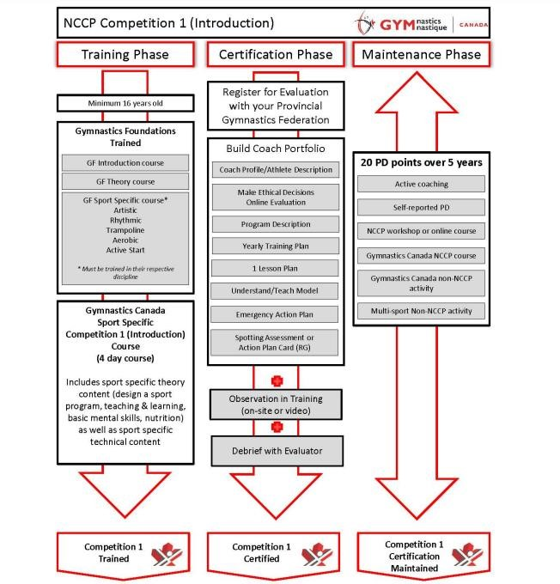

* A coach must be 16 years of age in order to participate in a C1 course. Exceptions will be considered on an individual basis for coaches who are a few months shy of turning 16.
* A coach must be Gymnastics Foundations (GF) Trained in the discipline of the C1 course they wish to participate.
* To become C1 trained a coach must complete a series of three training courses; competition Introduction Theory, Competition Introduction and one of three sport specific Competition Introduction modules: Women’s Artistic, Men’s Artistic or Trampoline Gymnastics.

**Competition Introduction Theory (C1 Theory)**

This is an 8-hour classroom style course dedicated to theoretical knowledge and will cover multi-sport topics such as, designing a sport program, teaching and learning, basic mental skills, and nutrition. The C1 Theory course may be run as an additional day in conjunction with the technical component, or on its own which is generally done virtually.

**Competition Introduction Technical (WAG and MAG)**

The technical modules of the C1 course are taught over three full days. Two days are dedicated to the common components for both Men’s and Women’s Artistic Gymnastics; Tumbling/Floor, Vault and Bars. The third day can be either MAG (Pommel Horse, Rings, and Parallel Bars) or WAG (Beam and Artistry) specific.

**Competition Introduction Technical (TG)**

The technical modules of the C1 TG course are taught over three full days. One day is dedicated to Tumbling and some common components of the Men’s and Women’s Artistic Floor training. The second and third day cover specific technical training related to Trampoline Gymnastics. Currently GNL does not offer specific training in Double Mini Trampoline.

## 2.2.4 Competition Introduction Advanced (C2) Pathway

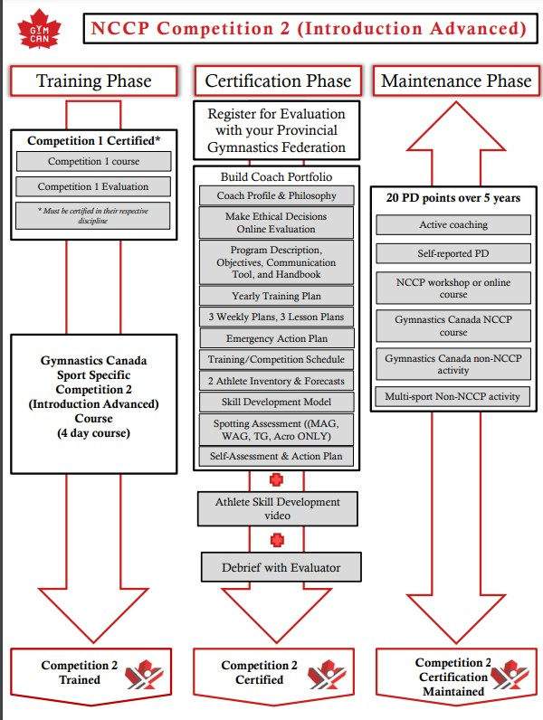

* A coach must be 16 years of age in order to participate in a C2 course.
* A coach must be C1 Certified in the discipline of the C2 course they wish to take.
* In order to become a trained C2 gymnastics coach in any discipline, a participant must attend a four-day training course, similar to those described for C1 training, but with higher level skills.

## 2.3 NCCP Training vs Certification

The NCCP model distinguishes between training and certification. Coaches can participate in training opportunities to acquire or refine the skills and knowledge required for a particular coaching context (i.e. Competition – Introduction) as defined by a sport (i.e. Gymnastics Canada) and be considered “trained”. To become “certified” in a coaching context, coaches must be **evaluated** on their demonstrated ability to perform within that context in areas such as program design, practice planning, performance analysis, program management, ethical coaching, support to participants during training, and support to participants in competition.

NCCP coaches are described as follows:

**In Training** – when they have completed some of the required training for a context. (Referred to as Coach-In-Training, CIT). For example, a coach has completed the Foundations Theory module but has not completed Foundations Introduction and one of the sport specific modules. They would be considered Foundations In-Training.

**Trained –** when they have completed all required training for a context. For example, a coach who has completed Foundations Theory, Foundations Introduction and one of the three sport specific modules such as Foundations Trampoline. This coach is considered Foundations Trampoline Trained.

**Certified** – when they have completed all evaluation requirements for a context. To learn more about the Certification Process see Section 4 of this manual.

Note: For coaches to take any C2 or higher training courses they must be Certified at the level prior of the same discipline.

# SECTION 3: NCCP COACHING REQUIREMENTS

## 3.1 Minimum Coach Training Requirements

GNL’s minimum coach training requirements are outlined in Appendix A. The minimum training requirements are founded based on recommendations from GymCan’s NCCP Operations Manual. These minimum training requirements are for GNL sanctioned events within the province. Coaches representing Team NL athletes at any interprovincial or national event must meet minimum training requirements of either the hosting province and/or Gymnastics Canada, for Gymnastics Canada sanctioned events.

**Special Notes:**

* At all levels, coaches should only coach/teach skills in which they have been specifically trained. Even if a coach has met the minimum training requirements outlined in the chart, they should never coach or spot a skill that is beyond their level of comfortability and/or scope of training, even if the skill is permissible in a given level.
* Head coaches/supervisors of recreational and/or competitive clubs must be minimum certified at the highest level of athlete training and a minimum of 19 years of age.
* To access competition floors at any GNL sanctioned event, coaches must possess the appropriate level NCCP certification with respect to the athletes they are coaching. If a coach does not have minimum coaching requirements they must apply to GNL for a [coach exemption](https://docs.google.com/forms/d/e/1FAIpQLSd6hSddo8VZNa6OvaUoeSIhPGP1rBjQ55OYCOO1x3OtE9m0lw/viewform).

## 3.2 Coach to Participant Ratio Guidelines

The recommended coach to participant/athlete ratios are:

|  |  |  |  |
| --- | --- | --- | --- |
| **Participant Age** | **Competitive Program** | **Recreational Program** | **Birthday Parties** |
|  | **coach:athlete** | | |
| 3-18 mos | N/A | 1:8-12 max (+ parent) | |
| 18 mos – 3yrs | N/A | 1:8-12 max (+ parent) | |
| 3-5 yrs | N/A | 1:5-6 | 1:8-10 max (+ parent) |
| 6-11 yrs | 1:6-12 The more advanced skills, the lower the ratio | 1:10 | 1:8-10 max (+ parent) |
| 12+ yrs | 1:8 | 1:10 | 1:8-10 max (+ parent) |

## 3.3 NCCP Course Hours and Fees

|  |  |  |  |  |  |
| --- | --- | --- | --- | --- | --- |
| **Gymnastics Foundations (GF) Courses** | | | | | |
| Course | Theory (GF Theory) | Introduction (GF Intro) | Artistic (GF AG) | Trampoline (GF TG) | Active Start (GF AS) |
| Length | 4 hr (in-person) | 8 hr (in-gym) | 8 hr (in-gym) | 8 hr (in-gym) | 8 hr (in-gym) |
| 5 hr (online) | 2 x 4.5 hr (online) |
| 2 x 2.5 hr (online) |  |
| Prerequisites | min. 15 yrs | min 15. yrs | min. 15 yrs | min. 15 yrs | min. 15 yrs |
| GF Theory | GF Intro | GF Intro | GF Intro |
| Cost | $110 | $75 | $90 | $125 | $75 |
| **Competition Introduction (C1) Courses** | | | | |  |
| Course | C1 Theory | C1 WAG | C1 MAG add-on | C1 TG |  |
| Length | 8 hrs (in-person) | 3 x 8 hr (in gym) | 8 hr (in gym) | 3 x 8 hr (in gym) |  |
| 2 x 4 hr (online) |
| Prerequisites | min. 16 yrs | min. 16 yrs | min. 16 yrs | min. 16 yrs |  |
| GF Trained | GF AG Trained | C1 Common | GF TG Trained |
| Cost | $60 | $300 | $150 | $300 |  |
| **Competition Introduction (C2) Courses** | | | | |  |
| Course | C2 Theory | C2 WAG | C2 MAG add-on | C2 TG |  |
| Length | Series of online modules | 4 days (in gym) | 4 days (in gym) | 4 days (in gym) |  |
| Prerequisites | C1 Certified | C1 Certified WAG | C1 Certified MAG | C1 Certified TG |  |
| Cost | $60 | $325 | $150 | $350 |  |

*Course fees for non-members are doubled.

## 3.4 NCCP Course Registration, Invoicing, and Payment

Registrations will be accepted until the posted deadline date. Once registration closes, GNL will determine if there are enough registrations for the course to proceed. If the decision is made to proceed with the course, there will be no cancellations allowed.

Pending availability, late registrations will be accepted up until two business days before the NCCP course begins. There will be a late registration fee of $50/per participant charged.

GNL will generate invoices from Sage Accounting and email to clubs once registration closes.

Payment is required one month from the date of the Sage Accounting invoice. Clubs can send payment earlier if they prefer!

Once payment is processed, GNL will email a receipt via Sage Accounting to the Club.

Course fees for non-members are doubled and they can only register if the course is not full. Registered GNL members will be given priority registration.

## 3.5 Completing Missed Modules of NCCP Courses

If a coach misses a module, they may make it up at another course providing there is space. GNL requires a $50 administration fee for making up a module. A coach who misses a module will be considered “In Training” until all modules are completed.

Missed modules must be completed within 3 years. After that time, if the coach has not made up the module(s) they must repeat the entire course and pay the audit registration fee.

## 3.6 Auditing a Course

Any coach who is currently registered with GNL may audit an NCCP course that they already successfully completed for 25% of the registration fee and providing there is space in the course.

## 3.7 Requesting an NCCP Course

Gymnastics NL plans and organizes all NCCP courses and is responsible for all logistics, including registration, facility rental, and the hiring and paying coach developers. If your club would like to request an NCCP course, please fill out the [online Request an NCCP form](https://docs.google.com/forms/d/e/1FAIpQLSdUf05zN_DFqrRepcn2wmnfYVA3DkTp4LBprc6nN9ToF7XLNA/viewform)

# SECTION 4: THE NCCP COACH CERTIFICATION PROCESS

A “Certified” coach means that you have demonstrated competency and have met professional guidelines within the National Coaching Certification Program (NCCP). Gymnastics NCCP education in Canada is highly regarded, and certification provides professional status. It provides the participants and their parent’s assurance that you have been evaluated within your specialty to provide safe, yet challenging programs (Gymnastics Canada, 2021).

## 4.1 How to Certify

Following completion of required training, coaches must assemble their "Coaching Portfolio" and complete the discipline-specific evaluation process to become certified. A full list of "Coaching Portfolio's" for the various NCCP Levels and disciplines is available below.

Completed portfolios are submitted to GNL along with payment of the evaluation fee. GNL will then match you with a suitable Coach Evaluator (CE). Coach Evaluation fees depend both on the level of certification you are applying for and on who and what province your CE is affiliated with, but approximate costs are indicated below.

Gymnastics Foundations (Artistic, Active Start and Trampoline) – [GF Evaluation Portfolio.](http://www.gymcan.org/uploads/content/coaching/gf_coach_evaluation_guide_en.pdf) ($110)

Competition Introduction (C1), WAG, MAG and TG – [C1 Evaluation Portfolio](https://img1.wsimg.com/blobby/go/19ad312a-f50c-4c00-bfc5-7f26beb582a7/downloads/Coach%20Evaluation%20Porfolio_Competition%20Intro%20(C.pdf?ver=1661354656984) ($150)

Competition Introduction Advanced (C2), WAG, MAG, and TG – [C2 Evaluation Portfolio](http://www.gymcan.org/uploads/content/coaching/c2_magwag_coach_evaluation_templates_en.pdf) ($200)

Note: There is no time requirement between a coach taking Gymnastics Foundation courses and completing the Gymnastics Foundations Evaluation, provided they are 16 years old.

Coaches wishing to take C2 training in any of the disciplines, must be C1 certified in that discipline.

## 4.2 Applying for GNL Temporary Coaching Certification Exemptions

Coaches must meet the minimum NCCP certification standard for the level of athletes they are assigned to (Appendix A: Minimum Coaching Requirements). This applies for both training (regular every day training) and competition environments. Coaches that do not meet the minimum standard can apply for an exemption.

If a coach needs to apply for an exemption from the NCCP minimum standards, they must fill out a written request form [Coach Certification/Training Exemption.](https://forms.gle/NE9eYDrcZ1wh72258) The exemption request form should be submitted at the beginning of the season, prior to training, or when the coach is assigned to their athlete(s).

Approved exemptions will be valid for training and GNL sanctioned events, only for that particular requested competition/membership season. Exemptions for a particular level may only be granted for one season or until an appropriate leveled course is offered for the coach to upgrade their training.

Coaching Certification Exemption inquiries and requests for specific GymCan competitions (Elite Canada, Canadian Championship, CWG, etc.), are at the discretion of GymCan’s Program Manager for the specific discipline and event. Requests may be subject to application fees (as determined by GymCan) and late applications may be refused.

APPENDIX A: MINIMUM NCCP COACHING REQUIREMENTS FOR NCCP TRAINING/CERTIFICATION LEVELS

(All minimum coaching requirements listed below are applicable for all training and competitive environments)

5.1 Minimum Coaching Requirements for Pre-Coach In-Training through to Gymnastics Foundations (GF) Certified.

|  |  |  |  |
| --- | --- | --- | --- |
| **Coaching Status** | **Minimum training requirements** | **Role and responsibilities** | **Athlete levels they can coach** |
| Pre-Coach In-Training **(Pre-CIT)** (No NCCP Training) | Min. 13 years old  Club directed program using the GymCan Pre-CIT Mentorship [Manual](https://trello.com/c/sSxNofFZ/35-pre-cit-coach-in-training) and [Workbook](https://trello.com/c/sSxNofFZ/35-pre-cit-coach-in-training) as a program guide. | May act as an assistant coach under one on-one direct supervision of a certified coach (supervisor must be Gymnastics Foundations certified in the appropriate age and level of class; C1 certification is highly recommended.  Supervisor must be min. 18 years of age. **May NOT supervise a group or spot any skill.**  Follow direction provided by their supervising coach. | Gymnastics For All programming. |
| Gymnastics Foundations **IN TRAINING** = Coach in Training (CIT) | Min 15 years old.  Refers to coaches who have only completed the NCCP Gymnastics  Foundations Introduction and/or Theory course(s). (Have only completed 1 or 2 of the 3-series mandatory Foundations courses.) | May act as an assistant coach under direct supervision of a certified coach  (minimum Gymnastics Foundations  Certified and min. 18 years old.)  **May NOT supervise a group or spot any skill.**  Follow direction provided by their supervising coach. | Levels as listed above. |
| Gymnastics Foundations (GF) **Artistic or Active Start - TRAINED** | Refers to coaches who have completed:  GF Theory, GF Introduction, and GF Sport-Specific (Artistic Gymnastics and/or Active Start). | May act as coach or assistant coach under indirect supervision (within reasonable proximity/withing eye sight) of a certified coach (minimum Gymnastics Foundations Certified, C1 highly recommended).  **May NOT teach any C1 NCCP skills or inverted skills with flight.** | Levels as listed above.  Artistic - CanGym badge levels: Burgundy – Purple  Active Start - coaches can work with athletes 0-5 years of age.  Pre-Competitive: WAG CCP 1 & 2, MAG P1 |
| Gymnastics Foundations (GF) Artistic **CERTIFIED** | Min. 16 years old.  Refers to coaches who have completed:  GF Theory, GF Introduction, GF SportSpecific (Artistic Gymnastics and/or  Active Start) and GF Evaluation. | May supervise their own group.  May act as a supervising coach to Pre-CIT or GF coach in Training or Trained. **May NOT teach any C1 NCCP skills or inverted skills with flight.** | Levels as listed above.    XCEL: Bronze & Silver |

5.2 Minimum Coaching Requirements for Competition Introduction (C1) and Competition Introduction Advanced (C2). – WAG/MAG.

|  |  |  |  |
| --- | --- | --- | --- |
| **Coaching Status** | **Minimum training requirements** | **Role and responsibilities** | **Athlete levels they can coach** |
| Competition Introduction (C1/Comp 1)  **TRAINED** in either Women’s Artistic  Gymnastics (WAG) and/or Men’s Artistic  Gymnastics (MAG) | Min. 16 years old.  Refers to coaches who have completed  Competition Introduction (C1) Theory  (including MED online evaluation the EAP online module) and Competition Introduction Technical Modules (WAG and/or MAG).  Prerequisite: Gymnastics Foundations (GF) Trained. | May act as coach or assistant coach under supervision (within reasonable proximity/within eye sight) of a C1/Comp 1 certified coach (minimum 18 years of age).  May spot athletes performing NCCP C1/Comp 1 skills.  **May not spot or teach C2 and C3 NCCP skills.**  May not coach beyond scope of training. Required to be on the field of play with the levels listed in the next column at Provincial meets. | Levels as listed above.    CanGym badge levels: Blue to Yellow.    Competitive Provincial events: WAG CCP 3-4, XCEL Bronze, XCEL Silver, XCEL GOLD, and MAG L2.  For Atlantics and above, coaches with athletes competing at levels CCP 4+ and Xcel Gold+ must be min. C1 Certified to be on the field of play. |
| Competition Introduction (C1/Comp 1)  **CERTIFIED** in either Women’s Artistic  Gymnastics (WAG) and/or Men’s Artistic  Gymnastics (MAG) | Min 16 years old.  Refers to coaches who have completed  Competition Introduction (C1) Theory  (including MED online evaluation the EAP online module) and Competition Introduction Technical Modules (WAG and/or MAG) **AND** C1 Evaluation in either WAG, MAG or both. | May act as a supervising coach to C1 coaches in Training/Trained.  May act as coach, not requiring direct supervision, for the athlete levels listed in the next column.  Required to be on field of play with levels listed in the next column at Provincial meets. | Levels as listed above.    Competitive: WAG CCP 5-6 and MAG L3 |
| Competition Introduction Advanced  (C2/Comp 2) **TRAINED** in either Women’s Artistic Gymnastics (WAG) and/or Men’s Artistic Gymnastics (MAG) | Refers to coaches who have completed C2 Theory and C2 Technical modules.  Prerequisite: C1 Certified. | May act as coach or assistant coach under supervision (within reasonable proximity/within eye sight) of a C2 certified coach.  May spot athletes performing C2 skills. Required to be on the field of play with the levels listed in the next column at Provincial meets. | Levels as listed above.  CanGym badge levels: Green – Gold  Competitive: WAG Levels 7-8 & Aspire, XCEL Platinum & Diamond, MAG Level  4.  *For provincial competitive events coaches with athletes at CCP 8+, XCEL Platinum and Diamond, and MAG L4+ must be min. certified C2 to be permitted on the field of play. |
| Competition Introduction Advanced  (C2/Comp 2) **CERTIFIED** ineither Women’s Artistic Gymnastics (WAG) and/or Men’s Artistic Gymnastics (MAG) | Refers to coaches who have completed  C2 Theory, all C2 Technical modules, **AND** C2 Evaluation in either WAG, MAG or both. | May act as a supervising coach to C1 and C2 coaches in training/trained. May act as coach, not requiring direct supervision, for the athlete levels listed in the next column.  Required to be on field of play with levels listed in the next column at Provincial meets. | Levels as listed above. |

5.3 Minimum Coaching Requirements for Competition Development (C3) and Competition Development Advanced (C4). – WAG/MAG

|  |  |  |  |
| --- | --- | --- | --- |
| **Coaching Status** | **Minimum training requirements** | **Role and responsibilities** | **Athlete levels they can coach** |
| Competition Development (C3/Comp 3)  **TRAINED** in either Women’s Artistic  Gymnastics (WAG) and/or Men’s Artistic  Gymnastics (MAG) | Refers to coaches who have completed C3 Theory and all C3 Technical modules.  Prerequisite: C2 Certified. | May act as a coach or assistant coach under supervision (within reasonable proximity – within eye sight) of a C3 certified coach.  May spot athletes performing NCCP C3 skills. | Levels as listed above.    Competitive: WAG CCP 9-10, MAG Open *For provincial competitive events coaches with athletes at this level must be certified C3 to be permitted on the field of play. |
| Competition Development (C3/Comp 3)  **CERTIFIED** in either Women’s Artistic  Gymnastics (WAG) and/or Men’s Artistic  Gymnastics (MAG) | Refers to coaches who have completed C3 Theory, all C3 Technical modules AND the C3 Evaluation in either WAG, MAG or both.  Required to be on the field of play at all National and International competitions. Trained coaches will not be permitted on the field of play without an exemption letter approved by GymCan. | May act as a supervising coach to C1-C3 coaches in training/trained. | All levels. |
| Competition Development Advanced  (C4/Comp 4) TRAINED in Women’s  Artistic Gymnastics (WAG) and/or Men’s  Artistic Gymnastics (MAG) | Refers to coaches who have completed C4 Theory and all C4 Technical modules.  Prerequisite: C3 Certified. | May act as a coach or assistant coach under supervision (withing reasonable proximity – within eye sight) of a C4 certified coach.  May spot athletes performing NCCP C4 skills. | All levels. |
| Competition Development Advanced  (C4/Comp 4) CERTIFIED in Women’s  Artistic Gymnastics (WAG) and/or Men’s  Artistic Gymnastics (MAG) | Refers to coaches who have completed  C4 Theory and all C4 Technical modules AND the C4 Evaluation in either WAG, MAG or both.  Required to be on the field of play at all International Competitions.  Prerequisite: C3 Certified. | May act as a supervising coach to C1-C4 coaches in training/trained.  No restrictions on competitive artistic roles and responsibilities. | All levels. |

5.4 Minimum Coaching Requirements for Trampoline from GF to C2

|  |  |  |  |
| --- | --- | --- | --- |
|  | **Minimum training requirements** | **Role and responsibilities** | **Athlete levels they can coach** |
| Gymnastics Foundations (GF) Trampoline **TRAINED** | Min. 15 years old.  Refers to coaches who have completed: GF Theory, GF Introduction, and GF Trampoline. | May act as a coach or assistant coach under supervision (within reasonable proximity – within eye-sight) of a C1 TG Certified coach.  May not coach beyond scope of GF TG training.  **May NOT teach any C1 TG skills or inverted skills.** | Recreation Beginner Levels only with focus on safety.    Coaches must be GF TG TRAINED to permit or take participants on trampoline, and tumble tracks/fast traks.    CanJump: Levels 1-4. |
| Gymnastics Foundations (GF) Trampoline **CERTIFIED** | Refers to coaches who have completed:  GF Theory, GF Introduction, GF Trampoline specific module AND GF Trampoline Evaluation. | May coach their own group under indirect supervision of a C1 TG Certified coach.  **May NOT teach any C1 TG skills or inverted skills.** | Levels as listed above. |
| Competition Introduction (C1) Trampoline **TRAINED**. | Min. 16 years old.  Refers to coaches who have completed: C1 Theory, C1 Introduction, and all C1 TG technical modules. | May act as a coach or assistant coach under supervision (within reasonable proximity – within eye-sight) of a C1 TG Certified coach.  May act as supervising coach for a GF TG trained coach. | Levels as listed above.  Competitive Provincial levels 1-4  PreProvincial levels 1-2  CanJump: Levels 5-12.  For provincial competitive events coaches with athletes competing at level 3-4 or who are performing double saltos must be min. certified C1 to be permitted on the field of play. |
| Competition Introduction (C1) Trampoline **CERTIFIED**. | Refers to coaches who have completed: C1 Theory, C1 Introduction, and all C1 TG technical modules.  Required to be on the field of play with the levels listed in the next column at Provincial meets. | May coach their own group under indirect supervision of a C2 TG Certified coach.  **May not coach beyond scope of C1 TG training.** | Levels as listed above. |
| Competition Introduction  Advanced (C2) Trampoline  **TRAINED/CERTIFIED**    (*C3 TG and C4 TG not GymCan/CAC approved NCCP courses) | Refers to coaches who have completed: C2 Theory, and all C2 TG technical modules.  Certification required to be on the field of play at National and International competitions.  Trained C2 TG coaches will not be permitted on the field of play without an  approved exemption letter from GymCan. | May act as supervising coach for GF TG – C1 TG trained coaches. | All levels.  For all national GymCan sanctioned (levels 5+) events coaches must be min. C3 certified. |