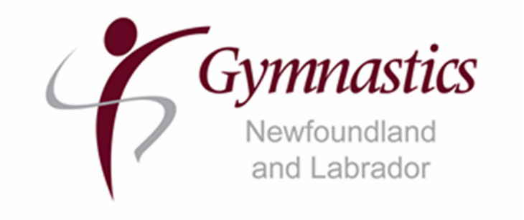

COACH CERTIFICATION EXEMPTION REQUEST
2021-2022
Any coach requesting a certification exemption for the 2021-2022 competition year, will not be eligible to request an exemption for the same level of training and/or certifications for the following year.

Coach Name: ___________________________ NCCP: _______________________

Current Level (please indicate trained or certified status): ______________________

Date of highest NCCP training/certification completed: _____________________________________

Discipline: MAG/WAG/TRA/GFA

Level of athlete being coached: _______________________

Competitions Attending (if applicable): ________________________________________________

Plan to attain certification before next season:

Signature: _____________________________ Date: _____________________________

