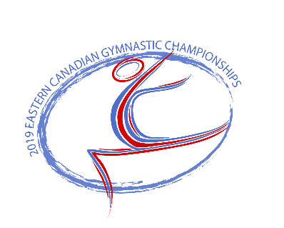

2019 Eastern Canadian Gymnastics Championships

Final Schedule

**WAG**

|  |  |  |  |  |  |
| --- | --- | --- | --- | --- | --- |
| Friday May 10, 2019 | | | | | |
|  | Session 1 | Session 2 | Session 3 | Session 4 | Session 5 |
| Levels | Tyro 7 | Novice 7 | Open 7 – Aspire 1 | Tyro & Open 8 | JO 10 (all) |
| Warm Up | 8:00-8:20 | 10:10-10:30 | 12:20-12:40 | 15:15-15:25 | 18:00-18:20 |
| Competition | 8:20-10:05 | 10:30-12:15 | 12:40-15:10 | 15:25-17:55 | 18:20-20:30 |

|  |  |  |  |
| --- | --- | --- | --- |
| Saturday May 11, 2019 | | | |
|  | Session 6 | Session 7 | Session 8 |
| Levels | Novice 8-Aspire 2 | Tyro & Novice 9 | Open 9 |
| Warm Up | 8:00-8:20 | 10:35-10:55 | 13:10-13:30 |
| Competition | 8:20-10:30 | 10:55-13:05 | 13:30-15:15 |

**MAG**

|  |  |  |  |
| --- | --- | --- | --- |
| Friday May 10, 2019 | | | |
|  | Session 1 | Session 2 | Session3 |
| Levels | Elite 3 & 4 | Level 4 (all) | Level 5 |
| Warm Up | 8:00-8:20 | 12:00-12:20 | 16:00-16:20 |
| Competition | 8:20-11:30 | 12:20-15:30 | 16:20- 19:30 |

|  |  |  |
| --- | --- | --- |
| Saturday May 11, 2019 | | |
|  | Session 4 | Session 5 |
| Levels | Level 3 (U13) | Level 3 (13+) |
| Warm Up | 8:00-8:20 | 12:00-12:20 |
| Competition | 8:20-11:30 | 12:20-15:30 |

*All awards ceremonies will take place in the Veterans Convention Center on the main floor of the Credit Union Place immediately after the completion of each session.