
Writing Center
Rules
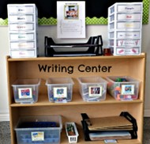



Be Kind and Respectful by taking turns and sharing
Be Safe, Kind, and Respectful by cleaning up when you are done
Be Safe, Kind, and Respectful by staying in your spot

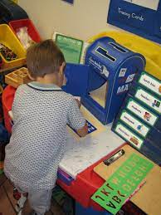
Be Safe and Respectful by using writing materials correctly

