One Call Now, ClassDojo, & Lillio Message Services
Dear Parents and Guardians,
It is important to us to keep you informed when a situation or event occurs that impacts your family.
When you complete the Child Release and Emergency Treatment Form, you are providing us with phone numbers for One Call Now, ClassDojo(HS/PreK), and Lillio(EHS)Message Services to notify you about important information.
To receive One Call Now messages, please make sure you text ALERT to 22300.
The One Call Now, ClassDojo, and Lillio Message Service enables us to notify you about situations, such as school delays, which will effect the start time of your classroom, or closings. We also want to keep you informed about parent meetings, parent trainings, workshops, and fun family events.
- Regarding your child’s daily attendance in Early Head Start, Head Start, and Pre-K Counts - We look forward to seeing your child every day! If your child is going to be late or absent, you need to contact your child’s classroom 15 minutes prior to the start of your class that morning. Early Head Start and Head Start families we do not hear from by an hour after your classroom start time, we will text you using the One Call Message Service.
- Regarding weather - The One Call Now Message Service will report school closings and delays to your phone. If the school district your classroom is in closes or delays, our programs will also close or delay.
Reminder: Please inform your child’s Teacher or Family Service Worker if your phone numbers and/or email addresses change. We want to make sure we can keep you informed!

Thank you,
Gina Young
Gina Young
(All Programs)
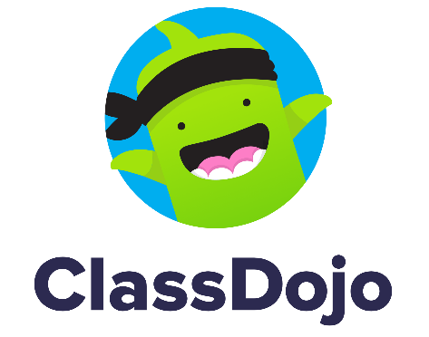
Family Engagement/ERSEA Director

(Early Head Start)
(Head Start and PreK Counts)

