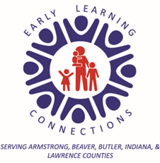

Enrollment Checklist
Deciding who cares for your children is an extremely important and sometimes very overwhelming decision for parents. Parents spend a lot of time on a thoughtful decision about who can best care for their child based on the needs of their child and the needs of their family.
Early Learning Connections is very thoughtful and deliberate about our ability to provide for your child and family’s needs as well. When making these decisions we consider these needs along with the needs of the current children enrolled in our programs and the competencies of our current employees and the resources of the organization. In order to make thoughtful decisions about meeting your child and family’s needs we need the below information.
- My child has been or is currently enrolled in an early intervention program and has an IEP or IFSP. | - My child frequently resists adult directions or requests.
- My child has participated in the past or participates at the present time in behavioral health/counseling services. | - My child has been or is currently placed outside of the home.
- My child has taken or takes medication to control mood and or activity level. | - My child has been or is currently under the care of a doctor for a chronic health condition.
- My child has been transitioned out of one or more childcare programs. | - My child has difficulty getting along with other children (ie hits, kicks or hurts others).
- My child has a history of trauma that impacts behavior. | - My child struggles with separation from caregivers.
- My child has been diagnosed with:

___________________________________

By signing this form, I confirm that I have provided all information necessary for Early Learning Connections to
Child’s Name: _______________________________________________________________
Print Name: _________________________________________________________________
Parent/Guardian Signature: _____________________________________________________
Date: _____________________________

