Discovery Rules
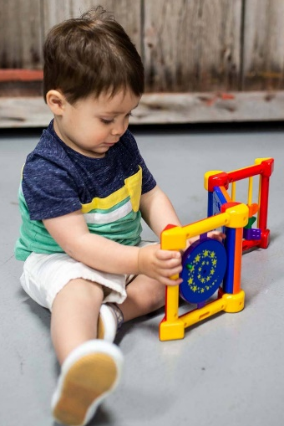
Be Safe, Kind and Respectful by taking Be Safe and Respectful by taking
taking turns and helping one another care of the items in the center


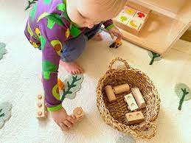
Be Kind and Respectful by raising Be Safe, Kind and Respectful by
your hand if you need something cleaning up when you are done

