Mindfulness Resources

Mr. Rogers Full Episodes
Talking About Making Mistakes When Friends Fight
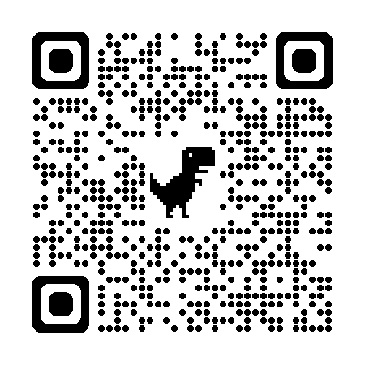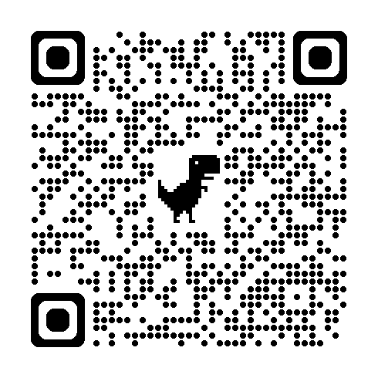

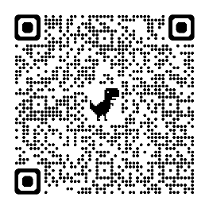
Talk About Divorce Giving and Receiving (Eric Carle Visit)
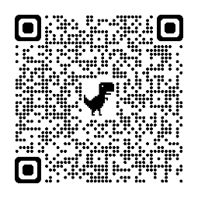

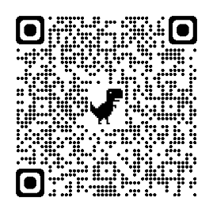
How People Make Crayons Music: Yo-Yo Ma Visits
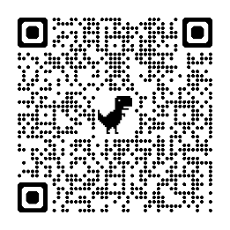

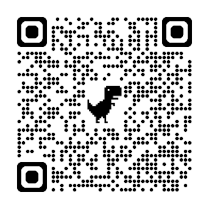
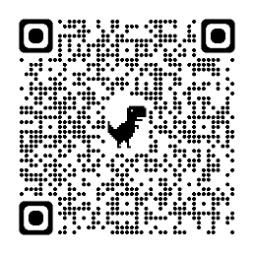
Pets and Birthdays Work: Mr. Rogers tells us about his work

Fred Rogers Short Clips
Daniel Wonders if He is a Mistake It’s You I Like
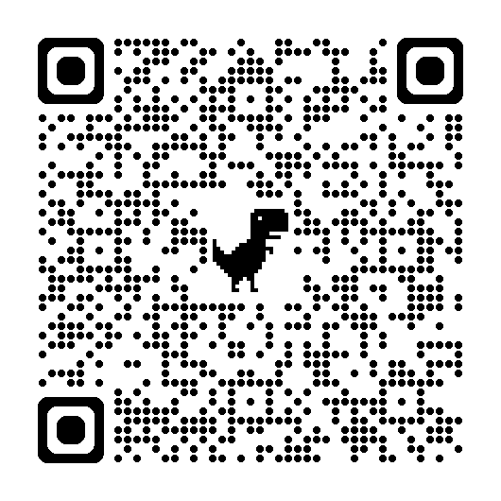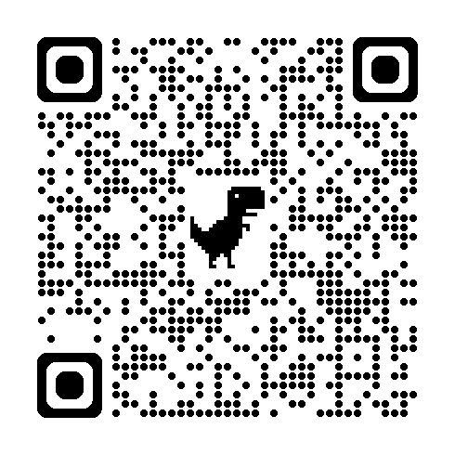

It Can Be Very Hard to Wait Lady Elaine Plans a Parade
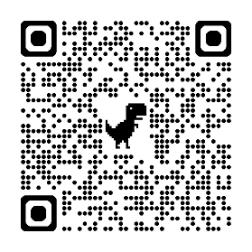
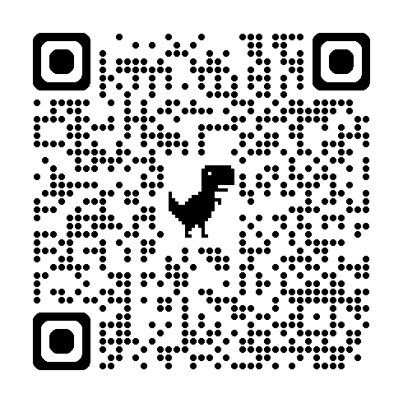

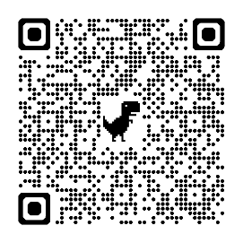
X The Owl and Henrietta Have a Fight Making Fortune Cookies
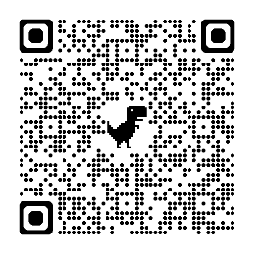

Lady Aberlin and Daniel Tiger Eric Carle Reads
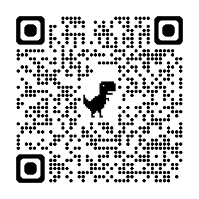
Talk and Sing about Mistakes (From Head to Toe)
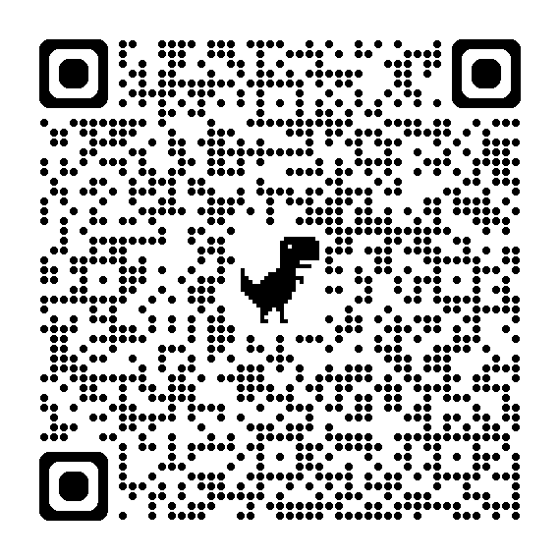
PBS Learning Media for Teachers PBS Kids Videos
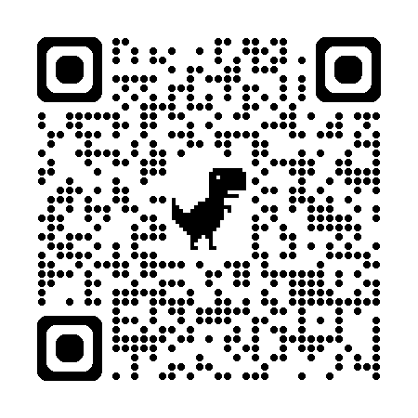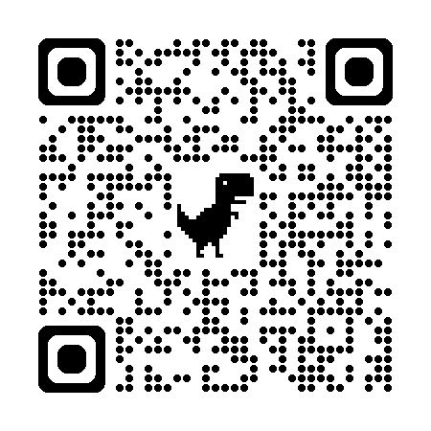

Mindfulness Activities

Cosmic Kids Finger Breathing Body Scanner
https://youtu.be/Wsy2L9VvX90 https://youtu.be/xLoK5rOl8Qk


Cosmic Kids the Listening Game Bubble Bounce
https://youtu.be/uUIGKhG_Vq8 https://youtu.be/UEuFi9PxKuo



Square Breathing Flower and Candle Breathing
https://youtu.be/PHQ7YZYRAms https://youtu.be/krGAMWv3rs0



Rainbow Relaxation Belly Breathing
https://youtu.be/IIbBI-BT9c4 https://youtu.be/RiMb2Bw4Ae8



Podcasts Found on ECLKC: Sesame Workshop Webinars: Mindfulness
Body Scan with Big Bird Bubble Breathing with Abby


Notice with Cookie Monster Self-Love with Grover

Whole Body Listening with Elmo Promoting Children’s Self-
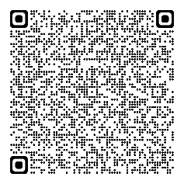
Regulation Tucker the Turtle
(Video)


