Library/Listening Rules

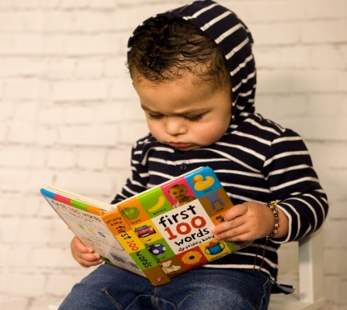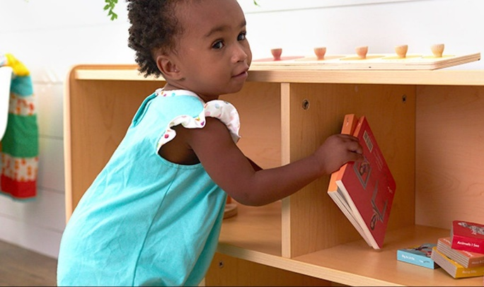
Be Kind and Respectful Be Safe and Respectful by
by sitting quietly putting the books away

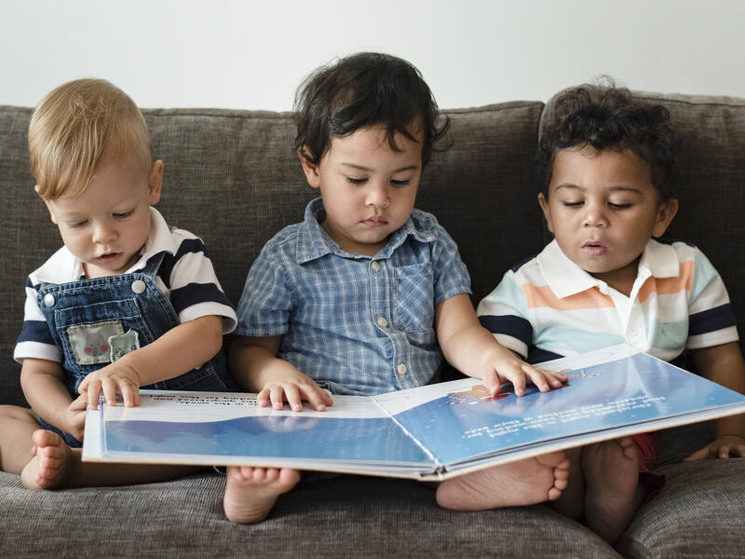
Be Kind, Safe and Respectful by Be Kind and Respectful
keeping your hands to yourself by reading with a friend

