Dramatic Play Rules


Be Kind and Respectful by Be Kind, Safe and Respectful by
listening to the speaker taking turns and sharing

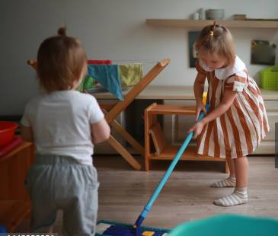
Be Kind and Respectful Be Safe and Respectful by
when pretending with friends cleaning up when you are done

