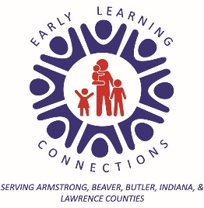

Hello Parents and Guardians!
This is your child’s “Home to School Connection Folder”. Each day your child will bring home this folder in his/her backpack. Please check the folder daily for valuable information. We will also send home creative art work that your child has made.
You, too, can use this folder to communicate with us. Send us notes and any other information that you want to share with us. Phone calls are also welcome.
This is just one of many ways that we will keep the lines of communication open between our classroom and your home.
Thank you,
Your Teaching Team
