
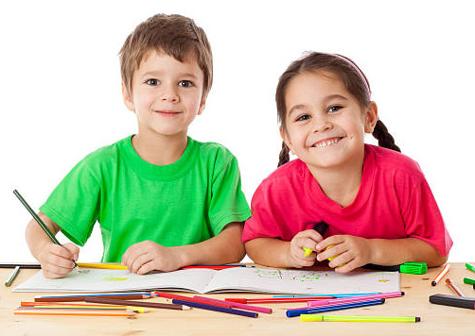

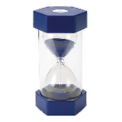
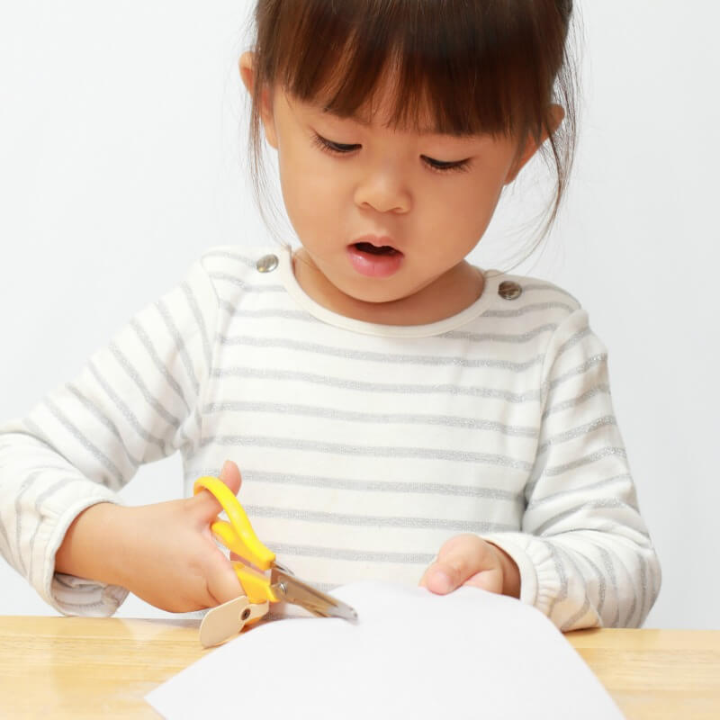
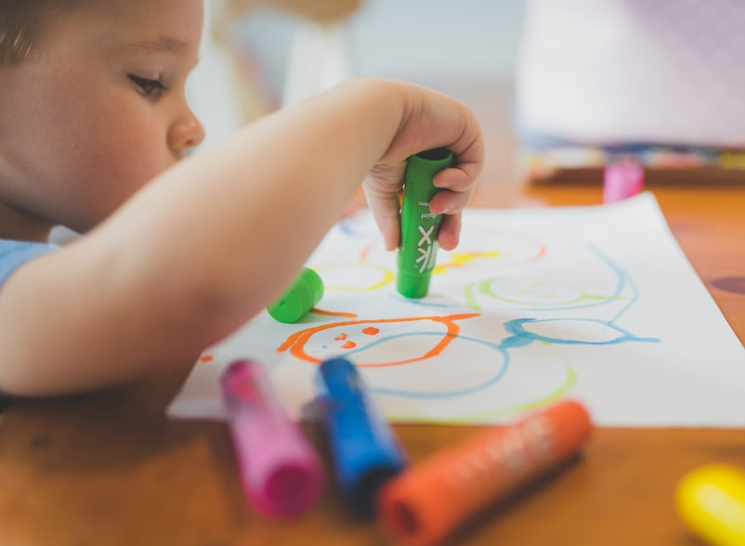
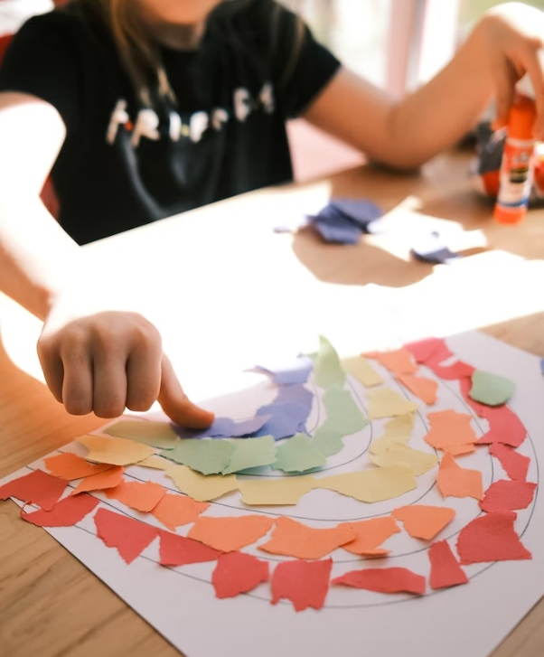
Be Safe, Kind, and Respectful by keeping your hands to yourself
Art
Rules
Be Kind and Respectful by taking turns and sharing
Be Kind and Respectful by drawing on paper
Be Safe, Kind, and Respectful by using scissors to cut paper
Be Safe and Respectful by gluing on paper

