
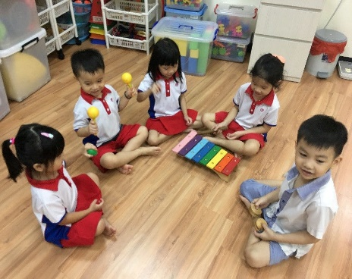
Music &
Movement
Rules
Be Respectful by listening to the teacher
Be Safe, Kind, and Respectful by sharing your instruments


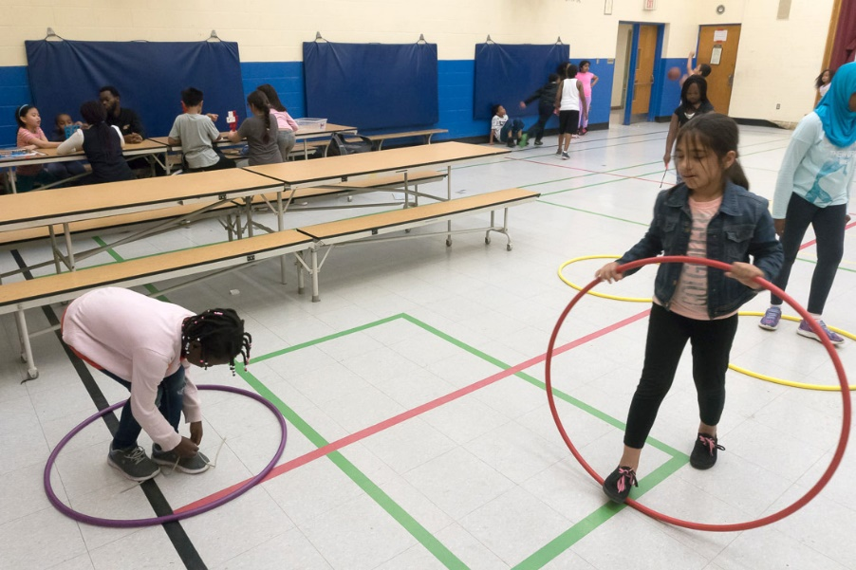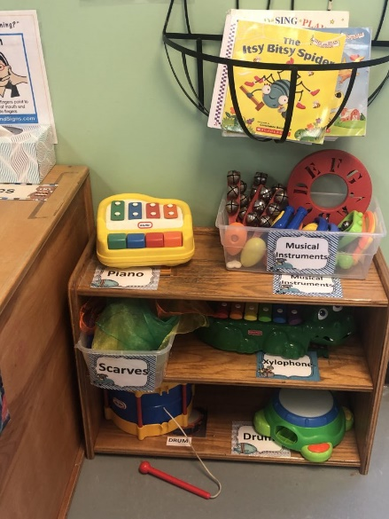
Be Safe, Kind and Respectful by keeping your hands to your body
Be Safe, Kind, and Respectful by staying in your own space
Be Safe by putting away the instruments

