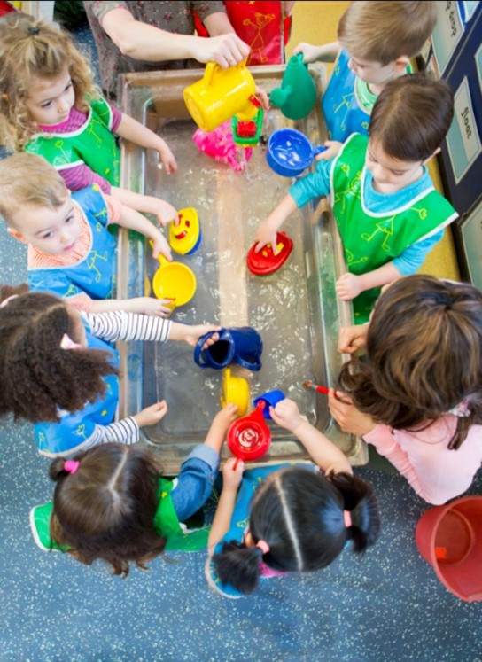
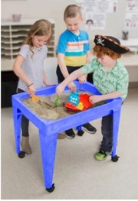


Sensory Table
Rules
Be Safe by washing your hands before and after playing in the sensory table
Be Safe, Kind and Respectful by keeping your hands to yourself

Be Safe and Respectful by keeping items in the table
Be Kind and Respectful by sharing with your friends

