Lesson Plan Template with Daily Schedule
Daily Schedule *This is an example
8:30-8:50 Arrival: Check In, Unpack, Wash Hands
8:50-9:20 Breakfast
9:20-9:35 Morning Meeting and QOTD
9:35-10:35 Intentional Teaching Experiences, Centers
10:35-10:50 Large Group Circle/Read Aloud
10:50-11:50 Outside/Gross Motor Play
11:50-12:00 Wash Hands/Drink/Restroom
12:00-12:30 Lunch
12:30-12:45 Rest Time/Quiet Reading/Quiet Activity
12:45-12:50 Mindfulness Activity
12:50-1:00 Small groups 1 (Heggerty Teal/Purple)
1:00-1:15 Small groups 2 (Math)
1:10-1:45 Afternoon Centers
1:45-2:00 Social Emotional Activity M/W/F PATHS T/Th
2:00-2:15 Wash hands/Snack
2:15-2:20 Toothbrushing
2:20-2:35 Music and Movement
2:35-2:50 Read Aloud/Daily Reflection
2:50-3:00 Pack up/Leave Room/Dismissal
2-hr Delay Schedule *This is an example
10:30-10:50 Arrival: Check In, Unpack, Wash Hands
10:50-11:00 Morning Meeting and QOTD
11:00-12:00 Centers/ Intentional Teaching Experience
12:00-12:30 Lunch
12:30-12:35 Mindfulness Activity
12:35-12:45 Small Groups 1 (Heggerty Teal/Purple)
12:45-12:55 Small Groups 2 (Math)
12:55-1:45 Gross motor play (if available space) Centers
1:45-2:00 Social Emotional Activity M/W/F PATHS T/TH
2:00-2:15 Wash hands/Snack
2:15-2:20 Toothbrushing
2:20-2:35 Music and Movement
2:35-2:50 Read Aloud/Daily Reflection
2:50-3:00 Pack Up/Leave Room/Dismissal

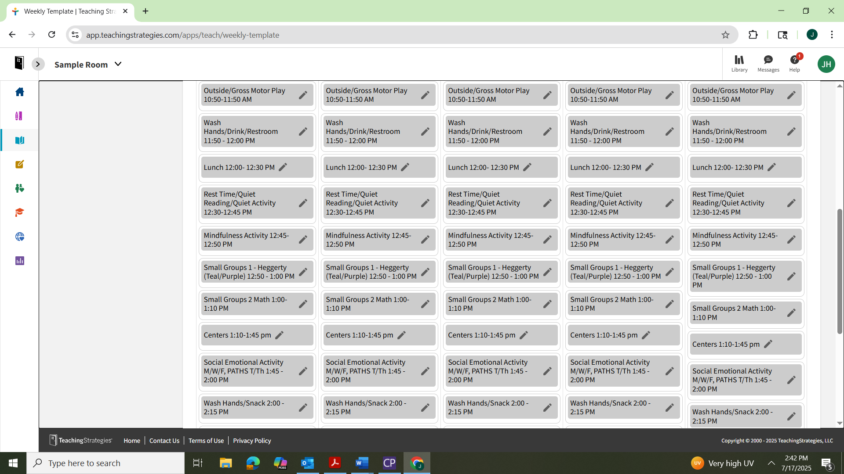
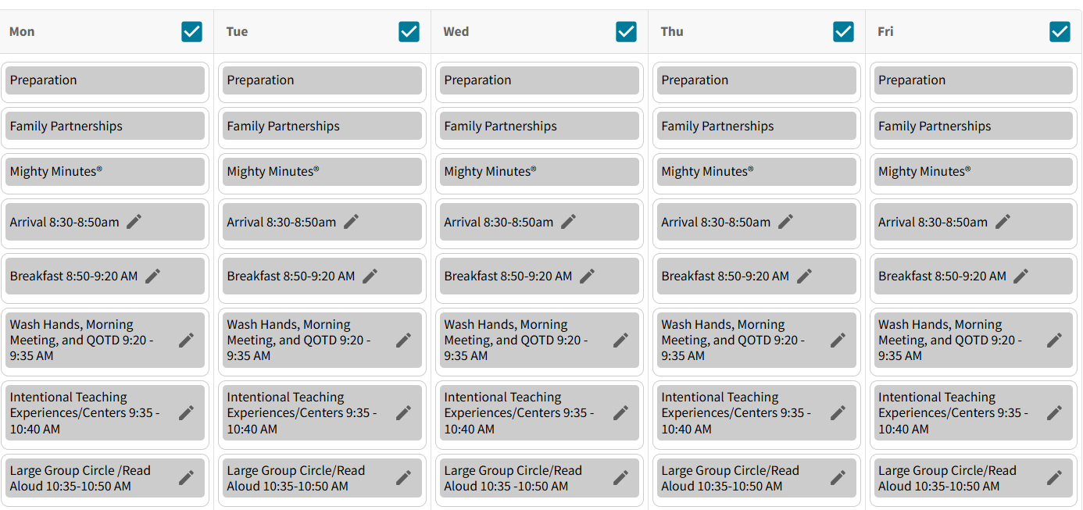
Template

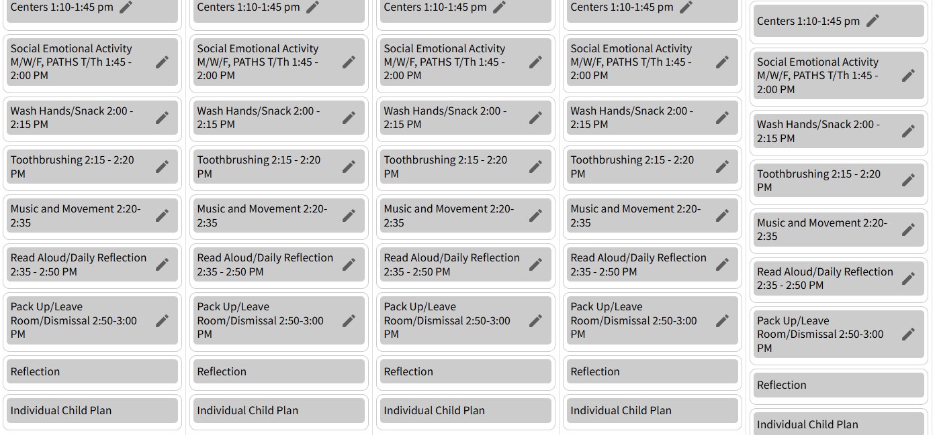

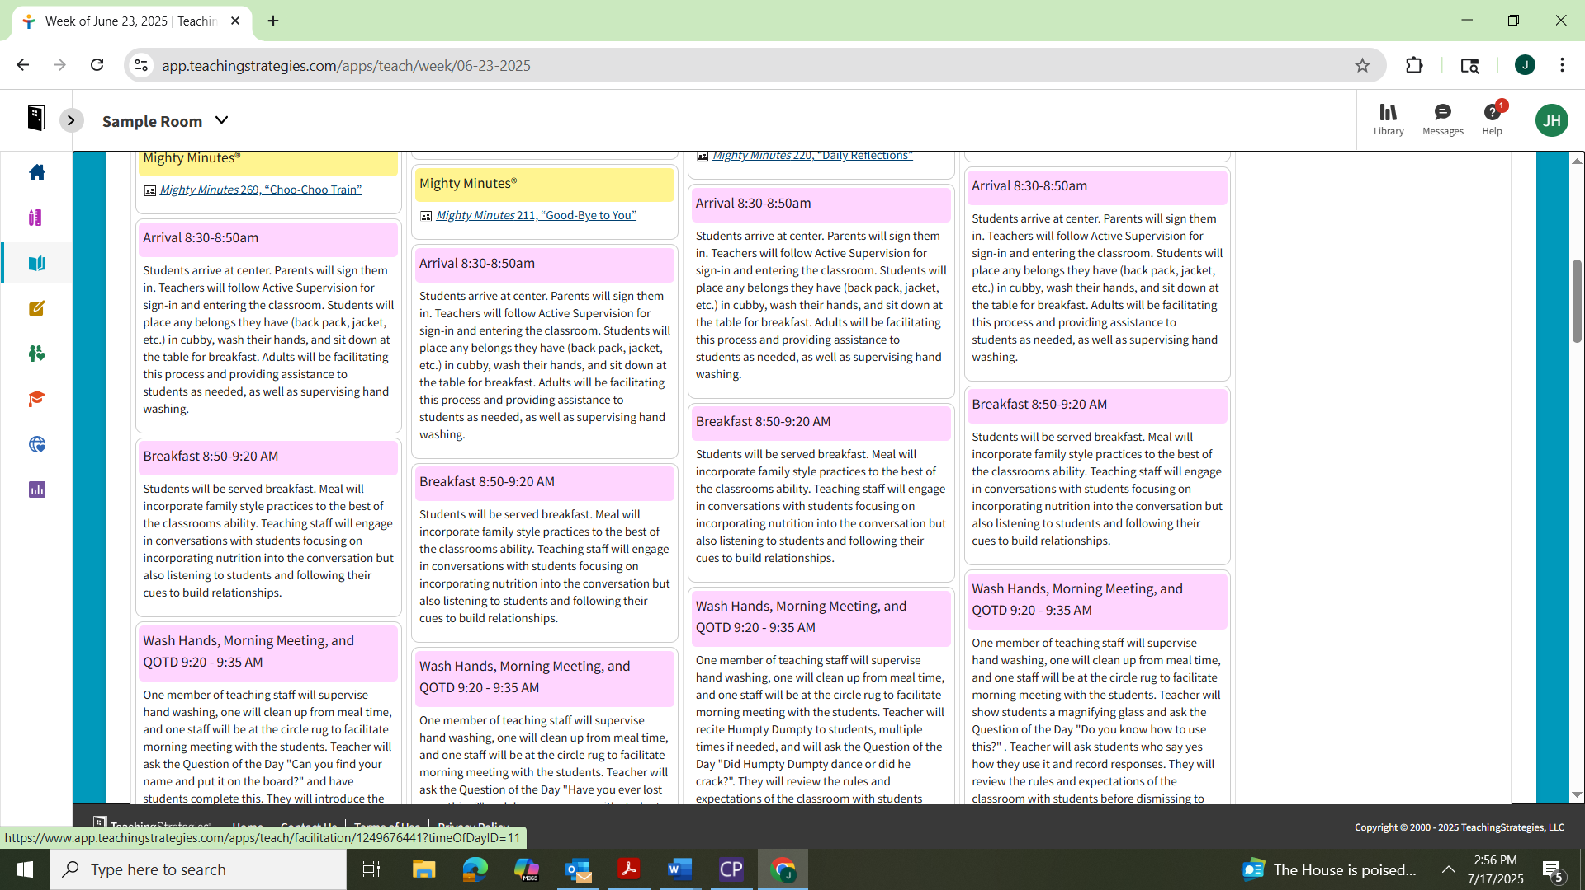
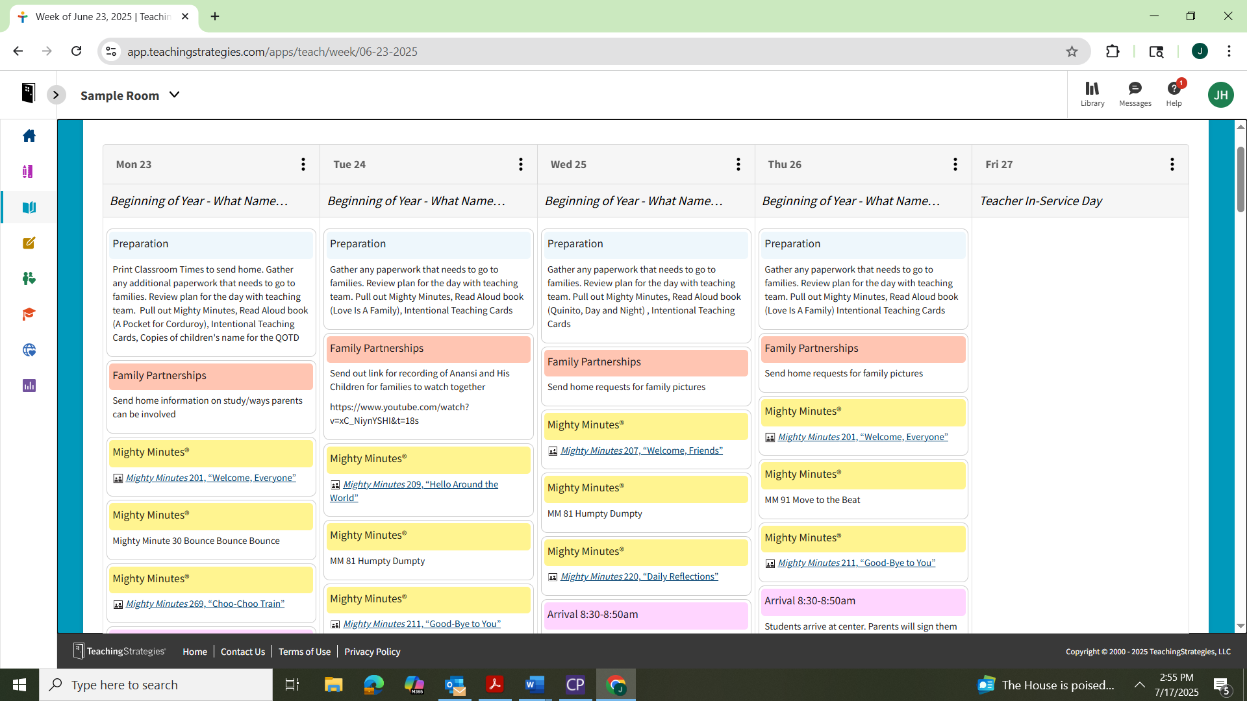
Sample Lesson Plans

