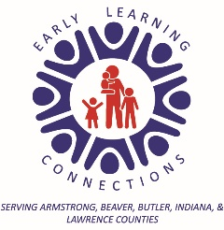

Dear Parent/Guardian,
In an effort to help you better understand the records our program must keep of you and your child. I have listed below the information we will maintain in your child’s family file.
- Child Health & Dental Records
- Child Health & Nutritional History
- Attendance Records for your child
- Adult attendance at trainings and volunteer activities
- Child Screening Results
- Child Education Plan
- Developmental Assessments
- Records of Parent Conferences
- Emergency contacts, permission to secure emergency medical care, and adults to whom your child may be released.
- Child work samples, drawings, artwork, printing samples, etc.
- Individualized Education Plan (IEP) (for children with a disability only)
- Plans for supporting behavior (if needed)
If you wish to see your family’s record, your teacher will be able to provide this information to you. If you wish for this information to be released to another agency, we will request that you sign our Authorization to Release Confidential Information form.

Sincerely,

Gina Young
Family Engagement/ERSEA Director

