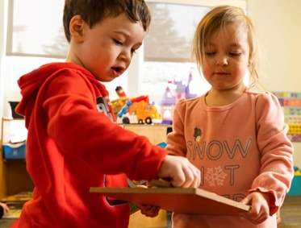
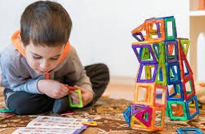
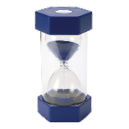
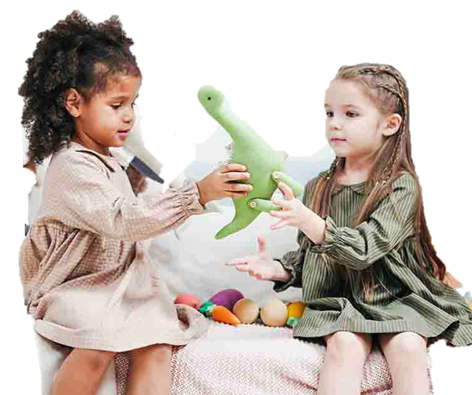
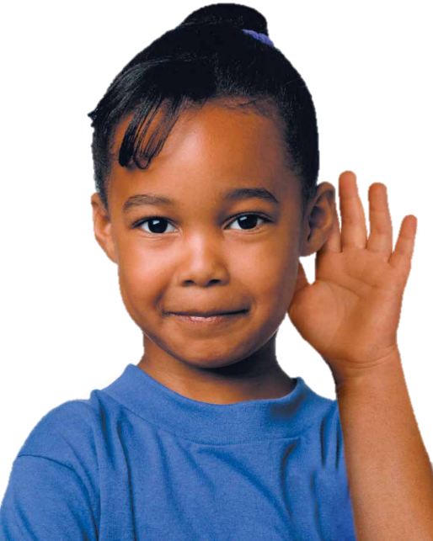
Be Kind and Respectful by taking care of the toys and games
Be Safe and Respectful by cleaning up when you are done
Be Safe, Kind and Respectful by taking turns and sharing
Be Kind and Respectful by listening to your friends
Toys and Games
Rules

