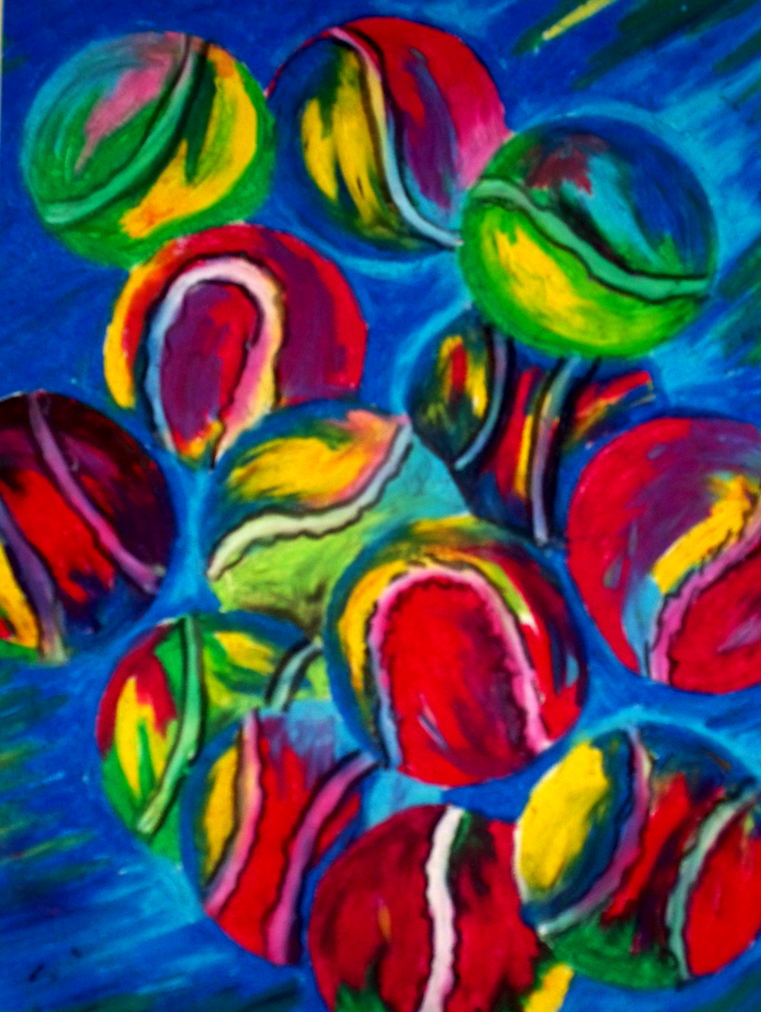

Tennis Ball Abstract- By: Jennifer Stedman

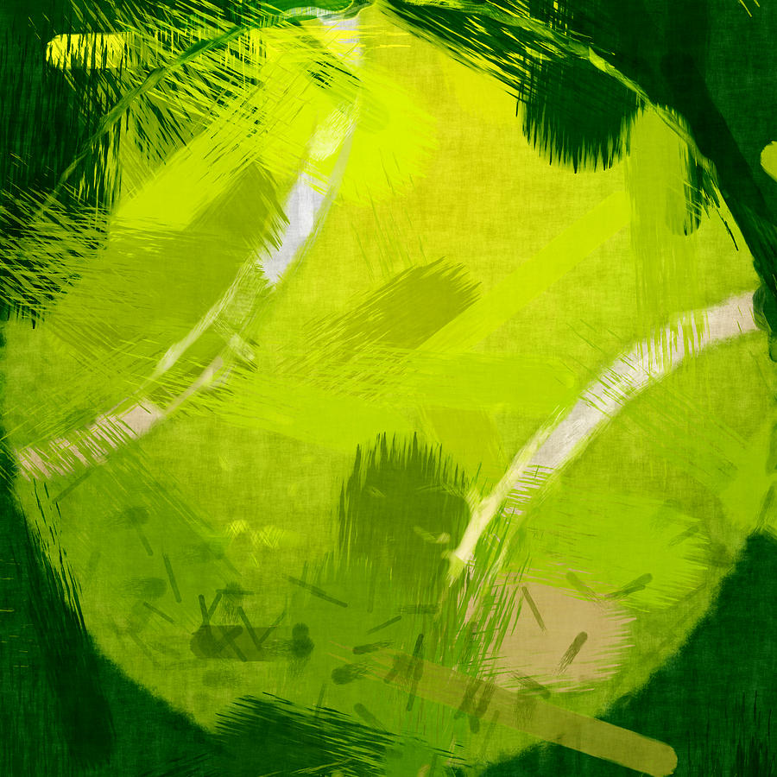

Abstract Tennis Ball- By: David G Paul

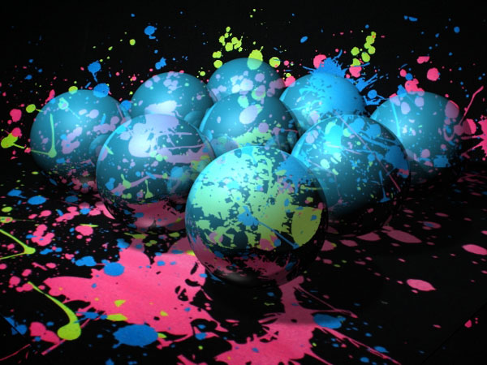

Abstract art pain balls reflection- Unknown

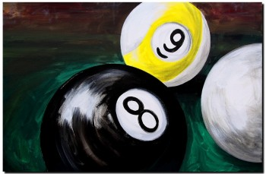

Eight, Nine and Cue Ball- By: J. Vincent Scarpace

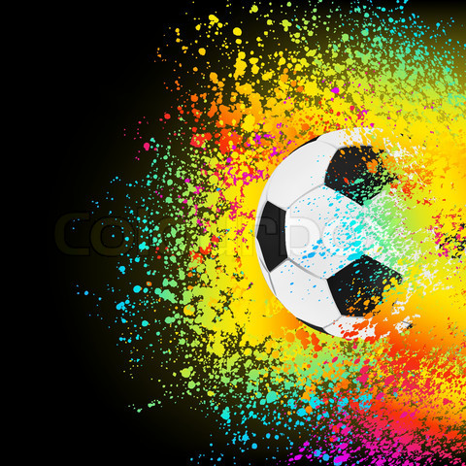

Abstract Soccer Ball- By: Unknown

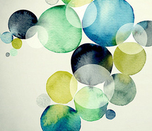

Inspiring- By: Unknown

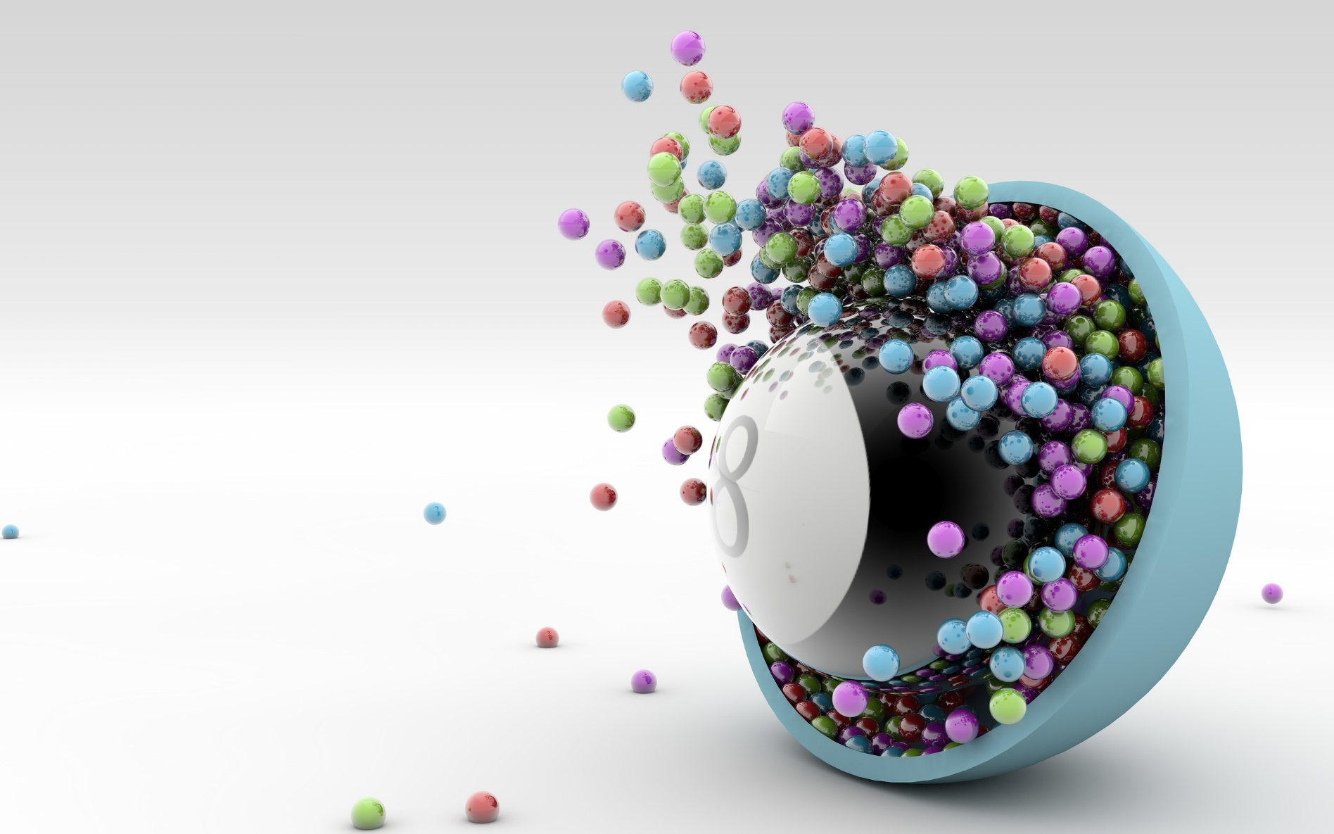

8 Ball Art- By: Unknown

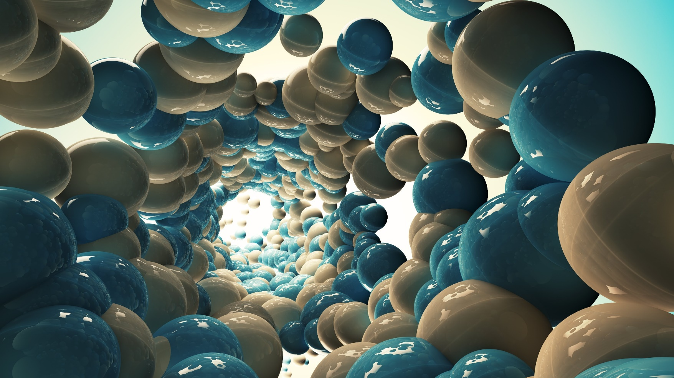

3d Ball Digital Art- By: Unknown

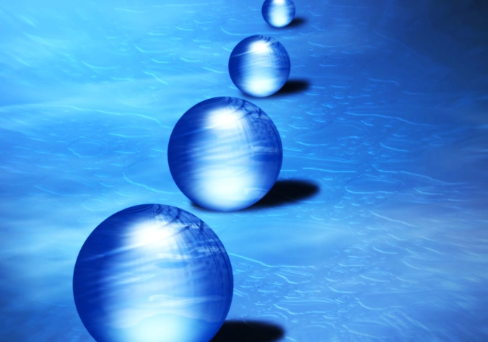

Blue Balls- By: Unknown

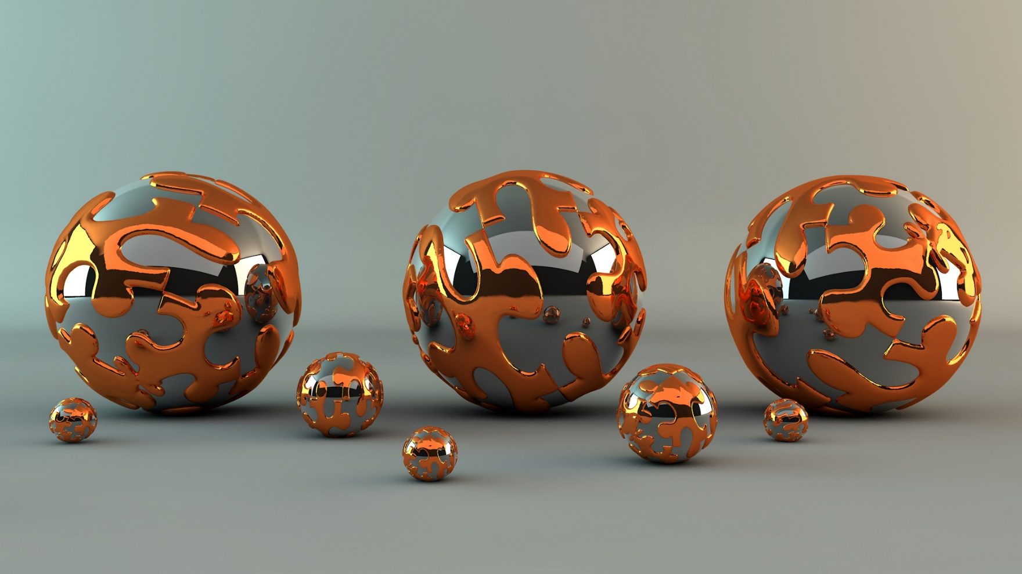

3D Rendering Artwork Abstract Ball Metal Pattern- By: Unknown