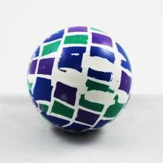



**Painting with Bouncy Balls**