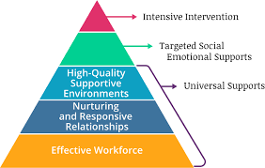
My Classroom Demonstrates TPITOS
- Teacher provides opportunities for Communication and Building Relationships
- Teacher Demonstrates Warmth & Responsivity to individual children
- Teacher promotes Positive Peer Interactions
- Teacher promotes Children’s Active Engagement
- Teacher is Responsive to children’s expressions of Emotions & teaches about Feelings
- Teacher Communicates & provides feedback about developmentally appropriate Behavioral Expectations
- Teacher Responds to children in Distress & manages Challenging behaviors
- Behavior Expectations are posted throughout the classroom

- Teacher uses specific Strategies or Modifications for children with Disabilities/delays, or who are Dual-Language learners
- Teacher conveys predictability through carefully planned Schedule, Routines, & Transitions
- Environment is Arranged to foster social-emotional development
- Teacher Collaborates with his/her Peers to support children’s social-emotional development
- Teacher has Effective strategies for Engaging Parents in supporting their child’s social-emotional development & addressing challenging behaviors
- Teacher has effective strategies for Communicating With Families & promoting family involvement

