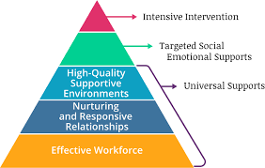
My Classroom Demonstrates TPOT
- Adults refer to children by name
- Adults attend to children who are distressed
- Adults talk to individual children
- Adults acknowledge and respond to children’s verbal and non-verbal cues
- Adults promote interactions between children
- Adults talk about emotions
- Adults tell children what to do rather than not what to do
- Interactions between adults are respectful and positive
- Adults follow the child’s lead when engaged in interaction
- Adults use re-direction to engage children in more appropriate behaviors
- Teacher uses a variety of strategies

- A variety of age-appropriate toys/materials are available
- Classroom is arranged so that children can easily access material
- Children have opportunities to make choices
- Classroom Rules/Expectations are posted and reviewed throughout the day
- Routines are predictable
- Teacher-directed activities are shorter than 20 minutes
- There is a balance of child-directed and teacher-directed activities
- Children are supported when working through the problem-solving process
- Teacher provides positive, descriptive feedback

