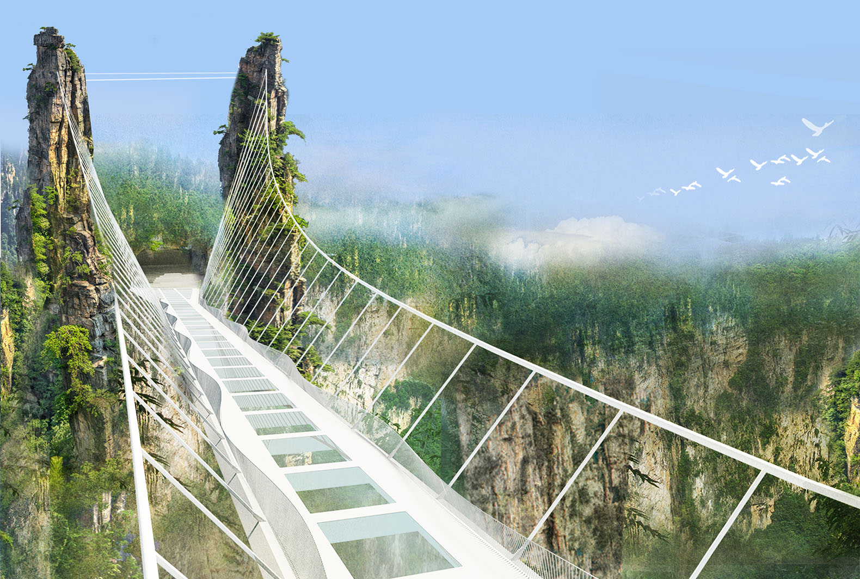

Glass Bridge Located in China.

**[Zhangjiajie Grand Canyon Glass Bridge](http://inhabitat.com/worlds-highest-glass-bridge-in-china-to-include-three-crazy-swings/)** is 984 feet high and 1,410 feet long.