I Can Be Kind!

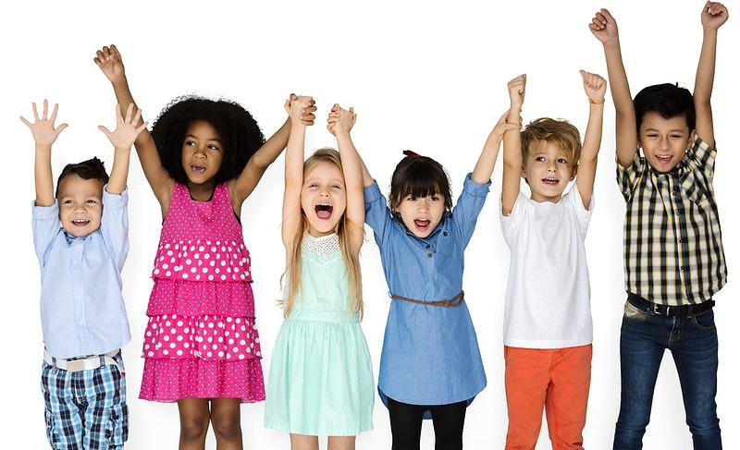
I can be kind at home and school.
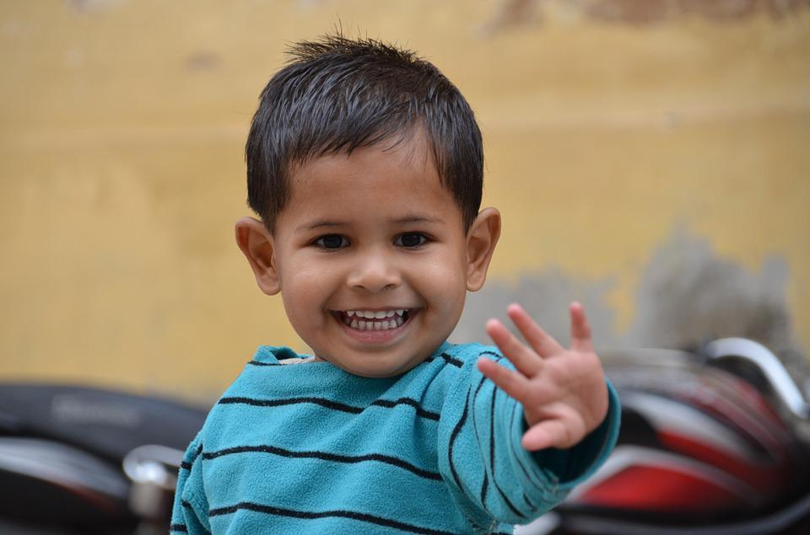
I am helpful to my friends, teachers, and family.
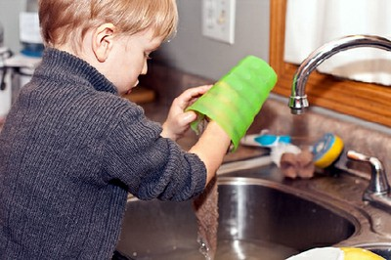

This Photo by Unknown Author is licensed under CC BY-SA-NC
I use kind words like please and thank you.
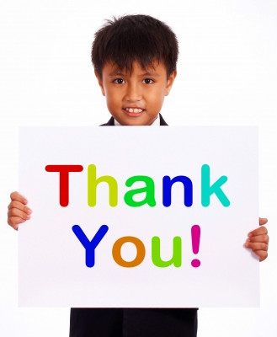

This Photo by Unknown Author is licensed under CC BY-SA-NC
I use gentle hands when I play.
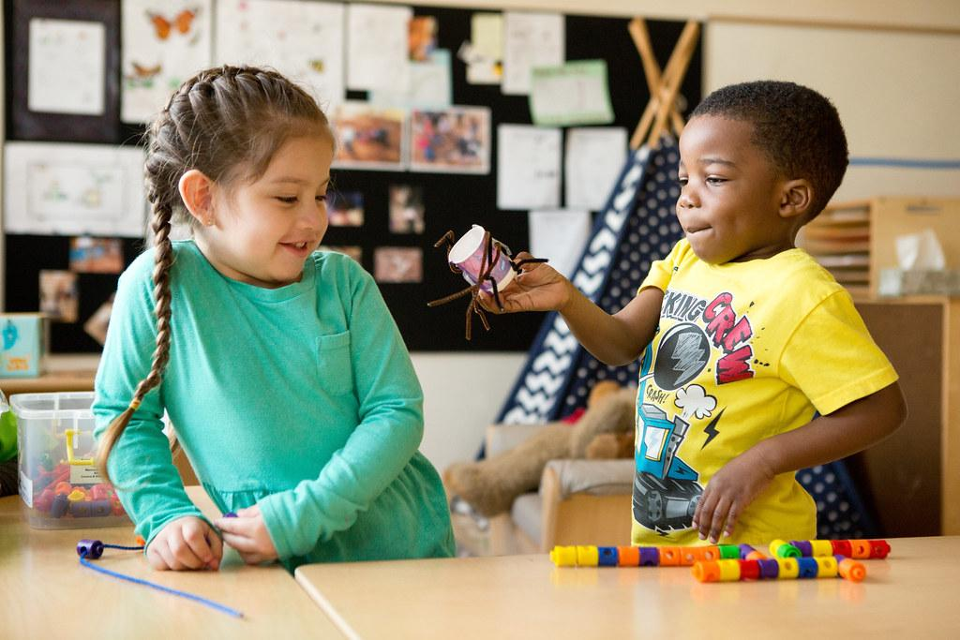

This Photo by Unknown Author is licensed under CC BY-NC
When I have a problem, I ask a grown up for help.
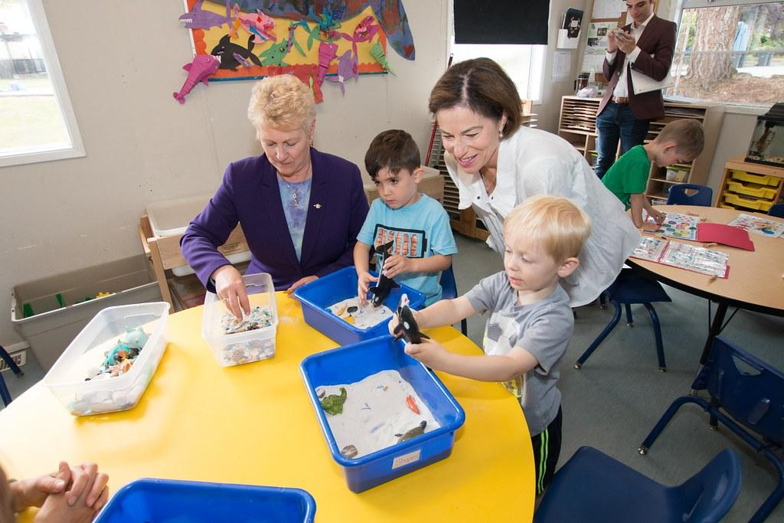

This Photo by Unknown Author is licensed under CC BY-NC-ND

