I Can Be Respectful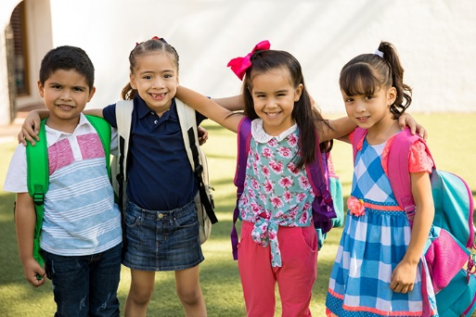

This Photo by Unknown Author is licensed under CC BY
I can be respectful at home and school by taking care of my things.
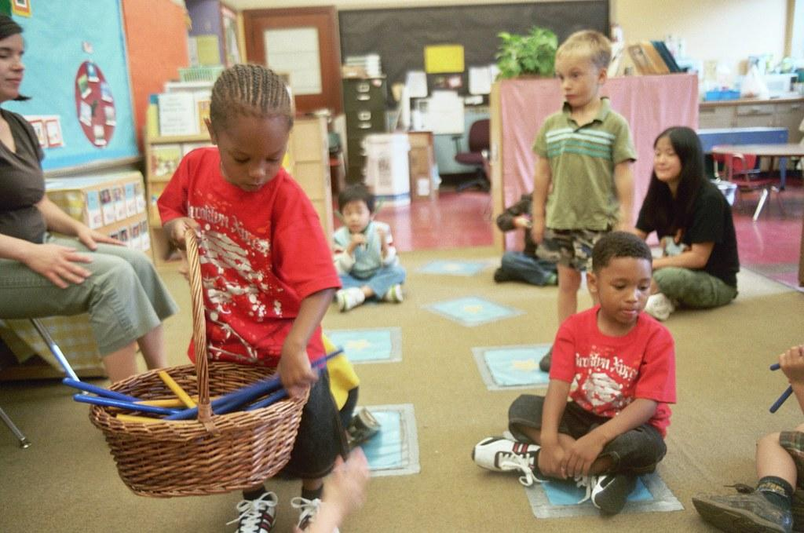

This Photo by Unknown Author is licensed under CC BY-SA-NC
I can be respectful by listening to my grownups.
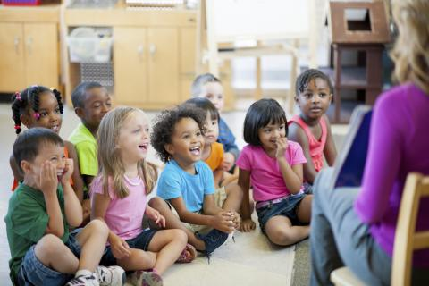

This Photo by Unknown Author is licensed under CC BY-SA-NC
I can be respectful by taking turns.
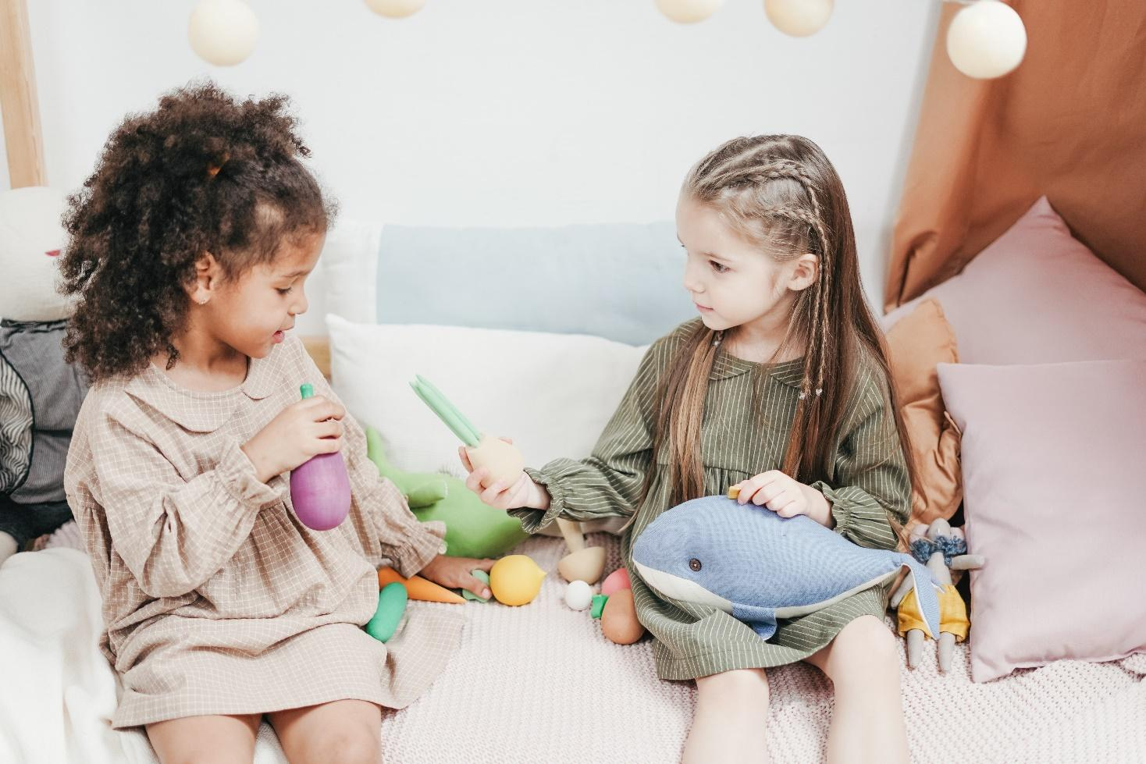
I can be respectful by using “please” and “thank you.”

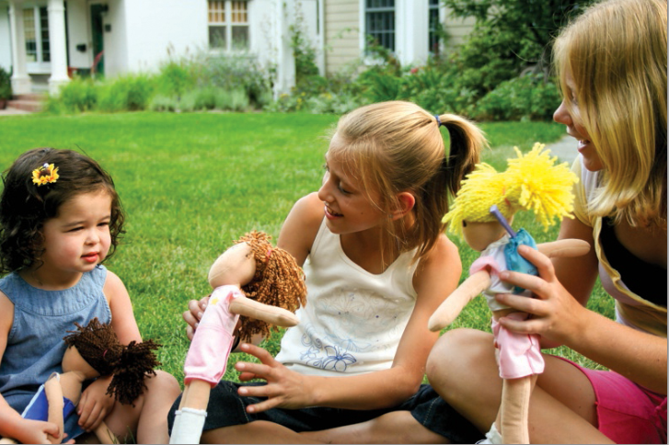

This Photo by Unknown Author is licensed under CC BY-NC-ND
I can be respectful by taking care of my home and school.
